**MINISTRY OF EDUCATION AND TRAINING**

**FPT UNIVERSITY**

Capstone Project Document

**Google Admin and HR System synchronization**

|  |  |
| --- | --- |
| **GROUP 15** | |
| **Group members** | Phan Văn Thành – SE62274 (Leader)  Nguyễn Đình Thông – SE61790  Nguyễn Công Sơn – SE62729  Đặng Phạm Thế Nguyên – SE62666 |
| **Supervisor** | Nguyễn Phan Quang Nhật |
| **Ext. Supervisor** | N/A |
| **Capstone Project code** | GmHRS |

- Ho Chi Minh City, ***20th May 2020*** –

# Table of Contents

Table of Contents 3

List of figures 7

List of tables 12

A. Introduction 17

1. Project Information 17

2. Introduction 17

3. Current Situation 17

4. Problem Definition 18

5. Proposed Solution 18

5.1. Feature functions 18

5.2. Values and Challenges 18

6. Functional Requirements 19

6.1. Unauthorized User 19

6.2. System admin 19

6.3. Company admin 19

6.4. System handler 20

7. Role & Responsibility 20

B. Software Project Management Plan 21

1. Problem Definition 21

1.1. Name of this Capstone Project 21

1.2. Problem Abstract 21

1.3. Project Overview 21

2. Project Organization 25

2.1 Software Process Model 25

2.2. Role and Responsibility 27

2.3. Tools and Techniques 30

3. Project Management Plan 30

3.1. Product Backlog 30

3.2. Sprint Backlog 30

3.3. All Meeting Minutes 30

3.4. Task sheet 31

4. Coding Conventions 31

C. Software Project Management Plan 32

1. User Requirement Specification 32

1.1. Guest Requirement 32

1.2. Company Admin Requirement 32

1.3. System Admin Requirement 32

2. System Requirement Specification 33

2.1. External Interface Requirement 33

2.2 System Overview Use Case 34

2.3 List of use case 35

3. Software System Attribute 127

3.1. Usability 127

3.2. Reliability 127

3.3. Availability 127

3.4. Security 128

3.5. Maintainability 128

3.6. Portability 128

3.7. Performance 128

5. Conceptual Diagram 128

D. Software Design Description 129

1. Design Overview 129

2. System Architectural Design 130

2.1. Web Application Architectural Description 130

3. Component Diagram 131

4. Detailed Description 132

4.1. Class Dictionary 133

4.2. Class Diagram Explanation 134

4.3. Interaction Diagram 144

5. Interface 163

5.1. Guest 163

5.2. Company Admin 166

5.3. System Admin 177

6. Database Design 184

6.1. Entity relationship diagram (ERD) 184

6.2. Data dictionary 184

7. Algorithms 185

7.1. Time base OTP 185

7.2 Comparing with merge sort 186

E. System Implementation and Test 189

1. Introduction 189

1.1. Overview 189

1.2. Test approach 189

2. Test plan 189

2.1. Features to be tested 189

3. Database Relationship Diagram 190

3.1. Physical diagram 190

3.2. Database diagram explanation 194

4. System Testing Test Case 209

4.1. Core Flow 209

4.2. Test Case 212

F. Software User Manual 231

1. Installation Guide 231

1.1. Setting up environment at server side 231

1.2. Deployment 231

2. User Guide 237

2.1. Signature template 237

2.2 Two factor 244

2.3. Synchronize manually 248

2.4. Setting 249

2.5. Auto reply mail 255

G. Appendix 257

# List of figures

Figure 1 - Scrum Model 26

Figure 2 - System overview use case 34

Figure 3 - <Guest> Overview Use Case 35

Figure 4 - <Guest> Register 36

Figure 5 - <Unauthorized User> Overview Use Case 39

Figure 6 - <Unauthorized User> Sign in 40

Figure 7 - <Unauthorized User> Reset password 43

Figure 8 - <System Admin> Overview Use Case 46

Figure 9 - <System Admin> View account company list 47

Figure 10 - <System Admin> Create account company 49

Figure 11 - <System Admin> View account company detail 52

Figure 12 - <System Admin>Update account company 54

Figure 13 - <System Admin> Delete account company 56

Figure 14 - <Company admin> View team list 60

Figure 15 - <Company admin> View team detail 62

Figure 16 - <Company admin> View department list 64

Figure 17 - <Company admin> View department detail 66

Figure 18 - <Company admin> View employee list 69

Figure 19 - <Company admin> View employee detail 71

Figure 20 - <Company admin> Create signature rule 73

Figure 21 - <Company admin> View signature rule list 76

Figure 22 - <Company admin> Update signature rule 78

Figure 23 - <Company admin> Delete signature rule 81

Figure 24 - <Company admin>View signature rule detail 83

Figure 25 - <Company admin> View signature template list 85

Figure 26 - <Company admin> Create signature template 87

Figure 27 - <Company admin> View signature template detail 90

Figure 28 - <Company admin> Update signature template 92

Figure 29 - <Company admin> Delete signature template 95

Figure 30- <Company admin> Create auto-reply mail template 97

Figure 31 - <Company admin> View auto-reply mail template detail 100

Figure 32 - <Company admin> Update auto-reply mail template 102

Figure 33 - <Company admin> Delete auto-reply mail template 105

Figure 34 - <Company admin> View schedule job 107

Figure 35 - <Company admin> Create schedule job 109

Figure 36 - <Company admin>Update schedule job 112

Figure 37 - <Company admin> Execute synchronization manually 114

Figure 38 - <Company admin> Log out 117

Figure 39 - <System handler> Overview Use Case 119

Figure 40 - <System handler> Auto checking validate rules of signature 120

Figure 41 - <System handler> Notification to company admin 122

Figure 42 - <System handler> Execute schedule job 124

Figure 43 - Conceptual Diagram 128

Figure 44 - System Architectural Design 129

Figure 45 - Component Diagram 131

Figure 46: Class Diagram 133

Figure 47 - < Sequence Diagram> - View employee list 145

Figure 48 - < Sequence Diagram>View department list 145

Figure 49 - < Sequence Diagram>View team list 146

Figure 50 - < Sequence Diagram>View list account company 146

Figure 51 - < Sequence Diagram>Create account company 147

Figure 52 - < Sequence Diagram> Create signature rule 147

Figure 53 - < Sequence Diagram>View schedule job 148

Figure 54 - < Sequence Diagram> Save schedule job 148

Figure 55 - < Sequence Diagram> Start schedule job 149

Figure 56 - <Sequence Diagram>Execute synchronization manually 149

Figure 57 - <Sequence Diagram>Delete signature rule 150

Figure 58 - <Sequence Diagram>Delete signature 151

Figure 59 - <Sequence Diagram> Get wrong signature employee 152

Figure 60 - <Sequence Diagram> Save signature rule 153

Figure 61 - <Sequence Diagram> Save signature 154

Figure 62- <Sequence Diagram> Send notify about rule to employee 155

Figure 63 - <Sequence Diagram> Send mail to wrong signature employee 156

Figure 64 - <Sequence Diagram> Specific apply signature 157

Figure 65 - <Sequence Diagram> Update signature for employee 158

Figure 66 - <Sequence Diagram>Update signature for only wrong signature employee 159

Figure 67 - <Activity Diagram> Approve access by phone 160

Figure 68 - <Activity Diagram> Load home screen 161

Figure 69 - <Activity Diagram> Scan QR 162

Figure 70 - <Guest> Login interface 163

Figure 71 - <Guest> Register interface 164

Figure 72 - <Company Admin> Company Admin Page interface 166

Figure 73 - <Company Admin> View Employee list interface 167

Figure 74 - <Admin Company> View Team list interface 169

Figure 75 - <Company Admin> Synchronize manually interface 170

Figure 76 - <Company Admin> Setting connection interface 171

Figure 77 - <Company Admin> Setting API endpoint interface 172

Figure 78 - <Company Admin> Con-fig G-Suite Authentication interface 173

Figure 79 - <Company Admin> Setting schedule synchronize interface 175

Figure 80 - <Company Admin> 2 Factor Authentication interface 176

Figure 81 - <System Admin>System Admin Navigation interface 177

Figure 82 - <System Admin> View account company list interface 178

Figure 83 - <System Admin> Create account company interface 180

Figure 84 - <System Admin> Update account company interface 181

Figure 85 - <System Admin> View account company detail interface 183

Figure 86 - Entity relationship diagram (ERD) 184

Figure 87 Comparing employees of G Suite and HRMS 187

Figure 88 <Flowchart> Comparing with idea from merge sort 188

Figure 89 - <Signature template> 210

Figure 91: <Company admin> Two factor authentication 210

Figure 92 <Company admin> Setting 210

Figure 93 <Company admin> Execute synchronize Gmail business 211

Figure 94 <Company admin> Manage vacation auto reply mail template 211

Figure 95 <Company admin> Assign vacation auto reply mail template 212

Figure 96 - Manage services page on vHost.vn 233

Figure 97 - Manage VPS service at manage product page 234

Figure 98 - Use Remote desktop application to remote to VPS server with IP and password had provided.. 235

Figure 99 This is desktop VPS 236

Figure 100 - Design signature template 237

Figure 101 - View list template signature 238

Figure 102 - View list template signature 238

Figure 103 Manage specific for apply template. 239

Figure 104 Manage specific for apply template. 239

Figure 105 - Synchronize on Gmail specific signature template just add for employee matched. 240

Figure 106 - Creating rules of signature template 241

Figure 107 - View list of rules for signature 241

Figure 108 - View/Delete rules of signature template. 242

Figure 109 - Notify to employees who have signature form did not follow rules of company signature. 242

Figure 110 - View all employee who did not follow rule of company signature. 243

Figure 111 - View detail signature of employees did not follow company rules. 243

Figure 112 - Set up application mobile and enable two-factor 244

Figure 113 - Disable two-factor 244

Figure 114 - Scan QR for dowload application two-factor on mobile 245

Figure 115 - Scan the secret key for authenticatate with web server 246

Figure 116 - Display OTP and time for expired code 247

Figure 117 - Click synchronize for first sync with G-suite by GmHRS 248

Figure 118 - System show list review data for execute synchronize 248

Figure 119 - Setting 249

Figure 120 - Enter all of fields required for database connection 250

Figure 121 Data response matched all of fields GmHRS required. 251

Figure 122 – Setting G-Suite credential 252

Figure 123 - Show list scope that is accessed on G-Suite. 253

Figure 124 - Set schedule for synchronize 254

Figure 125 - Design template for vacation auto-reply mail 255

Figure 126 - Add a specific apply vacation auto-reply mail template 256

# List of tables

Table 1 - Role & Responsibility 20

Table 2 - Hardware Requirements 25

Table 3 - Software Requirements 25

Table 4 - Roles and Responsibilities Details 29

Table 5 - Tools and Techniques 30

Table 6 - <Guest> Register use case specification 39

Table 7 - <Unauthorized User> Register use case specification 42

Table 8- <Unauthorized User> Reset password use case specification 45

Table 9 - <System Admin> View account company list use case specification 49

Table 10 - <System Admin> Create account company use case specification 51

Table 11 - <System Admin> View account company detail use case specification 54

Table 12 - <System Admin> Update account company use case specification 56

Table 13 - <System Admin> Delete account company use case specification 58

Table 14 - <Company admin> Overview Use Case 59

Table 15 - <Company admin> View team list use case specification 62

Table 16 - <Company admin> View team detail use case specification 64

Table 17 - <Company admin> View department list use case specification 66

Table 18 - <Company admin> View department detail use case specification 68

Table 19 - <Company admin> View employee list use case specification 70

Table 20 - <Company admin> View employee detail use case specification 72

Table 21 - <Company admin> Create signature rule use case specification 75

Table 22 - <Company admin> View signature rule list use case specification 77

Table 23 - <Company admin> Update signature rule use case specification 80

Table 24 - <Company admin> Delete signature rule use case specification 83

Table 25 - <Company admin> View signature rule detail use case specification 85

Table 26 - <Company admin> View signature template list use case specification 87

Table 27 - <Company admin> Create signature template use case specification 90

Table 28 - <Company admin> View signature template detail use case specification 92

Table 29 - <Company admin> Update signature template use case specification 94

Table 30 - <Company admin> Delete signature template use case specification 97

Table 31 - <Company admin> Create auto-reply mail template use case specification 99

Table 32 - <Company admin> View auto-reply mail template detail use case specification 102

Table 33 - <Company admin> Update auto-reply mail template use case specification 104

Table 34 - <Company admin> Delete auto-reply mail template use case specification 107

Table 35 - <Company admin> View schedule job use case specification 109

Table 36 - <Company admin> Create schedule job use case specification 111

Table 37 - <Company admin> Update schedule job use case specification 114

Table 38 - <Company admin> Execute synchronization manually use case specification 116

Table 39 - <Company admin> Log out use case specification 119

Table 40 - <System handler> Auto checking validate rules of signature use case specification 122

Table 41 - <System handler> Notification to company admin use case specification 124

Table 42 - <System handler> Execute schedule job use case specification 126

Table 43 - Component Diagram dictionary 132

Table 44 - Class Dictionary 134

Table 45- Account Attribute 135

Table 46 - Employee Attribute 136

Table 48 - Employee Method 136

Table 49 - EmployeeOperatorStatus Attribute 136

Table 50 - EmployeeOperatorStatus Method 136

Table 51 - Team Attribute 137

Table 52 - Team Method 137

Table 53 - TeamOperatorStatus Attribute 137

Table 54 - TeamOperatorStatus Method 137

Table 55 - Department Attribute 138

Table 56 - Department Method 138

Table 57 - DepartmentOperatorStatus Attribute 138

Table 58 - DepartmentOperatorStatus Method 138

Table 59 - Role Attribute 139

Table 60 - Role Method 139

Table 61 - EmployeeSignature Attribute 139

Table 62 - EmployeeSignature Method 139

Table 63 – SignatureTemplate Attribute 140

Table 64 - SignatureTemplate Method 140

Table 65 – SignatureRule Attribute 140

Table 66 - SignatureRule Method 141

Table 67 - Signature_Rule Attribute 141

Table 68 - Signature_Rule Method 141

Table 69 - SignatureTemplateStatus Attribute 142

Table 70 - SignatureTemplateStatus Method 142

Table 71 - EmployeeAutoReplyMail Attribute 142

Table 72 - EmployeeAutoReplyMail Method 142

Table 73 – AutoReplyMailTemplate Attribute 143

Table 74 - AutoReplyMailTemplate Method 143

Table 75 – AutoReplyMailStatus Attribute 143

Table 76 - AutoReplyMailStatus Method 143

Table 77 - Team_Employee Attribute 144

Table 78 - Team_Employee Method 144

Table 79 - <Fields> Login 163

Table 80 - <Buttons/Hyperlinks> Login 164

Table 81 - <Fields> Register 165

Table 82 - <Buttons/Hyperlinks> Register 165

Table 83 - <Button/Hyperlinks> Company Admin Page 167

Table 84 - <Fields> View Employee list 168

Table 85 - <Company Admin> View Department list interface 168

Table 86 - <Company Admin> Synchronize manually interface 170

Table 87 - <Fields> Setting connection 172

Table 88 - <Buttons/Hyperlinks> Setting connection 172

Table 89 - <Fields> Setting API endpoint 173

Table 90 - <Buttons/Hyperlinks> Setting API endpoint 173

Table 91 - <Fields> Con-fig G-Suite Authentication 174

Table 92 - <Buttons/Hyperlinks> Con-fig G-Suite Authentication 174

Table 93 - <Fields> Setting schedule synchronize 175

Table 94 - <Buttons/Hyperlinks> Setting schedule synchronize 176

Table 95 - <Fields> 2 Factor authentication 177

Table 96 - <Buttons/Hyperlinks> 2 Factor authentication 177

Table 97 - <Buttons/Hyperlinks> System Admin Navigation 178

Table 98 - <Fields> View list account company 179

Table 99 - <Buttons/Hyperlinks> View list account company 179

Table 100 - <Fields> Create account company 180

Table 101 - <Buttons/Hyperlinks> Create account company 181

Table 102 - <Fields> Update account company 182

Table 103 - <Buttons/Hyperlinks> Update account company 182

Table 104 - <Buttons/Hyperlinks> View account company detail 183

Table 105 - Entity relationship diagram dictionary 185

Table 106 - account attribute 195

Table 107 - employee attribute 197

Table 108 - department attribute 198

Table 109 - Team Attribute 198

Table 110 - team_employee Attribute 199

Table 111 - Accountoperatorstatus attribute 199

Table 112 - Employeeoperatorstatus Attribute 199

Table 113 - Departmentoperatorstatus Attribute 199

Table 114 - Teamoperatorstatus Attribute 200

Table 115 - Position_in_company Attribute 200

Table 116 - Email_templates Attribute 201

Table 117 - specific_mail Attriute 201

Table 118 - Specific_mail_employee Attribute 201

Table 119 - specific_mail_department Atrribute 202

Table 120 - Specific_mail_positon Attribute 202

Table 121 - Specific_mail_team Attribute 203

Table 122 - Role Attribute 203

Table 123 - signaturetemplate Attribute 203

Table 124 - signaturerule Attribute 204

Table 125 - signaturerule_content Attribute 204

Table 126 - specific_signature Attribute 205

Table 127 - specific_signature_department Attribute 205

Table 128 - specific_signature_employee Attribute 206

Table 129- specific_signature_team Attrubute 206

Table 130 - specific_signature_position Attribute 206

Table 131 - support_specific_by Attribute 207

Table 132 - Dynamic_rule Attribute 207

Table 133 - Sync_log Attribute 208

Table 134 - Sync_log_detail Attribute 208

Table 135: <Company admin> 217

Table 136 - Create signature template description 238

Table 137 - View signature template list description 239

Table 138 - Manage specific apply template description 240

Table 139 - System show list review data for execute synchronize description 249

Table 140 - Setting description 249

Table 143 - Setting G-Suite credential description 253

Table 144 - Set schedule for synchronize description 254

Table 145 – Vacation auto reply mail description 255

Table 146 - Assign template auto reply mail description 256

# Introduction

## Project Information

- Project name: Google Admin and HR System synchronization

- Project code: GmHRS

- Product type: Web-based system

- Start date: 16-5-2020

- End date: 30-08-2020

## Introduction

In this document, we introduce a system that help Human Resource (HR) to synchronize data of employees, teams, departments from the HRMS (human resource management system) of the organization up to G-Suite. The aim of this project, we also help to enforce some mail-related company policies. For example: Support design format company’s signature and design auto reply mail template.

## Current Situation

In most of organization, the G-Suite is managed independently from the HRMS (human resource management system). It means that every time a company gets a new employee, after entering his or her profile into the HRMS, the IT has manually creating an email account for him or her accordingly. Similar process is also needed when an employee leaves the company.

Otherwise, the most company have some mail-related policy but the company can’t handle at all of their employees that they have follow the policies of the company or not.

## Problem Definition

Analyze above situation, we noticed that current system is good at organizing data, the information is arranged quite clearly and comprehensible. But it leaves below problems:

IT manually create email Google on G-Suite after HR create new employees in HRMS, with a large organization so take more time to do this

Handling about mail-related policies from GmHRS.

## Proposed Solution

### Feature functions

The values and challenges of the proposed solution:

* **Values**:
* We support company to create their employees on G-Suite
* Reduce much of effort of IT when update employees processing
* **Challenges**:
* Users need to be trained to use mapping component and create formula function.



### Values and Challenges

The values and challenges of the proposed solution:

* **Values**:
* We support company to update employees on G-Suite automation.
* Reduce much of effort of staff in create employees Google account processing
* **Challenges**:
* Users need to be trained to use mapping component and create formula function.
* Users need set rule polices to check content email is valid

## Functional Requirements

Functional requirements of the system are listed as below:



### Unauthorized User

* Unauthorized user can register
* Unauthorized user can sign in

### System admin

* Manage company account (create, view all , view detail)



### Company admin

* User can manual and schedule time to synchronization data employees, teams, departments on G-Suite
* User can manage signature templates
* User can manage auto reply mail templates
* User set rule for signature
* User can view employees, teams, departments
* User can review employees change content out of signature rule.
* Log out

### System handler

* Auto synchronize data follow setting schedule time

## Role & Responsibility

|  |  |  |  |
| --- | --- | --- | --- |
| **No** | **Full Name** | **Position** | **Contact** |
| 1 | Nguyễn Phan Quang Nhật | Supervisor | nhatnpq3@fu.edu.vn |
| 2 | Phan Văn Thành | Leader | thanhpvse62274@fpt.edu.vn |
| 3 | Nguyễn Đình Thông | Member | thongndse61790@fpt.edu.vn |
| 4 | Nguyễn Công Sơn | Member | sonncse62729@fpt.edu.vn |
| 5 | Đặng Phạm Thế Nguyên | Member | nguyendptse62666@fpt.edu.vn |

Table 1 - Role & Responsibility

# B. Software Project Management Plan

## Problem Definition

### Name of this Capstone Project

* Official name: Google Admin and HR System Synchronization
* Vietnamese name: Đồng bộ hoá dữ liệu nhân sự với hệ thống Gmail doanh nghiệp
* Abbreviation: GmHRS



### Problem Abstract

To solve the mentioned problem, a system is provided which allows IT to perform automatically synchronizing on g suite. Synchronization can be done automatically via the daily time setting or by instant synchronization manually. Moreover, the system also supports auto-replying emails with templates, enforce email signatures for all employees Gmail account. To use the system, users must provide API endpoints or database for the system and G-Suite credential with role admin



### Project Overview

#### Current Situation

Below are the problems encountered in this project:

* Disadvantages:
  + Because the system is built to support HRMS system on the G-suite platform, team must research about the G-suite platform, as well as its provided APIs and policies.
* Advantages:
  + G-suite policy provides 24/7 support.

#### The Proposed System

According to the technology researches, the key of automatic processing features is using G-suite admin SDK to listen to a specific event. G-suite platform provides a set of APIs which are created to meet this demand.

We assign responsibility in vertical to make sure if any member in this problem cannot continue to work in our team there will be the least harmful to the project processes.

##### Web Site

Client is a web-app where authorized users, i.e. System Admin ,Company Admin and system handler performs their corresponding features.

* + System Admin:
    - Manage company accounts of the System
  + Company Admin:
    - Manage employee information
    - Manage team information
    - Manage department information
    - Manage auto-reply mail template
    - Manage signature template
    - Manage synchronize schedule
* Unauthorized user
  + Register
  + Sig in
* System handler
  + Auto Synchronize

#### Boundaries of the System

* Any HRMS wants to use GmHRS must complete registration and provide HRMS’ API endpoints or database and G-Suite credential.
* There are only 2 roles in GmHRS system:
  + System Admin: there is only 1 account belonged to this Role
  + Admin Company
* Guest is not a role in GmHRS system, instead Guest is a user who have not had an Account yet. After Guest has an account, he/she is no longer a Guest anymore.
* Currently, GmHRS only supports:
  + Synchronize employees list in HRMS with account in their G Suite (one-way only)
  + Synchronize email groups in G Suite with (one-way only):
    - Teams
    - Departments
  + Manage employee, department, team
  + Enforce auto response mail for employees during their leaves/vacations based on data from the leave management of HRMS if available
  + Manage signature, enforce email signatures for all employees Gmail account
  + Support large organization with multiple domains for multiple subsidiaries

#### Future Plans

* The current system only supports 2 connection methods (API endpoints or access direct database, we will upgrade so that users can provide the database by selecting the table in the user interface.

#### Development Environment

##### Hardware Requirements

|  |  |  |
| --- | --- | --- |
|  | **Minimum Requirements** | **Recommended** |
| **Internet Connection** | Cable, Wi-Fi (4 Mbps) | Cable, Wi-Fi (8 Mbps) |
| **Operating System** | Windows 10 | Windows 10 |
| **Computer Processor** | Intel® CORE i5 Quad core 2.1 GHz | Intel® CORE i7 Quad core 2.4 GHz |
| **Computer Memory** | 4GB RAM | 8GB or more |

Table 2 - Hardware Requirements

##### Software Requirements

|  |  |  |
| --- | --- | --- |
|  | **Name / Version** | **Description** |
| **Environment** | NodeJS 12.18.0 | Specification for developing GmHRS |
| **IDE** | Visual Studio Code 1.40.1 | Programming tools |
| **DBMS** | MySQL Server 80 | Used to create & manage the database for system |
| **Source control** | SourceTree 3.3.4 | Used for source control |
| **Web browser** | Chrome 83.0.4103.97 | Testing browser |

Table 3 - Software Requirements

## Project Organization

### Software Process Model

#### Overall Description

As the project problem which we mention above, we choose Scrum Model to manage project development with each sprint is 5 working days. This model will help us:

* Scrum team always work together to reach the project goal. Team member working progress is daily updated.
* Minimize risks when changing requirement.
* The working cycle “Learn - Revise – Apply” is done concurrently and continuously, a team member can apply new research and get the result quickly.
* Product coding is focused rather than document to deliver higher product value.

More information: <https://www.scrum.org/>

#### Scrum Development Method



Figure 1 - Scrum Model

*Reference*: <https://www.scrumviet.org/uploads/1/1/9/1/119155464/published/scrumframework-2000.png?1556106427>

#### Reasons for choosing

The project is developed under Evolutionary Development Model to capable with current situation of our team. We chose this model because of the following reasons:

* The team must study NodeJS, Angular and G-suite API while implement the project at the same time.

For those reasons, the requirements of the project cannot be stable, clear, fix. Moreover, they can be rapidly changed.



### Role and Responsibility

|  |  |  |  |  |
| --- | --- | --- | --- | --- |
| No. | Role in Scrum | Full name | Role in Group | Responsibilities |
| 1 | Product owner | Nguyễn Phan Quang Nhật | Project Manager – Technical Expert | - Specify the User Requirements  - Specify the business  - Control the development process  - Give advices on techniques, solutions and business analysis |
| 2 | Scrum master | Phan Văn Thành | Team Leader, Developer, Tester | - Clarifying requirements  - Assigning task for members  - Design database  - Reviewing the task result of members  - Creating/ Editing documents and reports  - Reviewing documents and reports  - Creating test plan  - Creating test case  - Coding Web client  - Coding Web server  -Testing |
| 3 | Scrum member | Nguyễn Công Sơn | Developer, Tester, Member | - Clarifying requirements  - Managing process  - Researching solutions and techniques  - Design architecture  - Researching solutions and techniques  - Coding Web service  - Design database  - Reviewing test plan  - Reviewing test case  - Testing |
| 4 | Scrum member | Nguyễn Đình Thông | Developer, Tester, Member | - Clarifying requirements  - Researching solutions and techniques  - Design database  - Coding Web service  - Coding Web client  - Reviewing test plan  - Reviewing test case  - Testing |
| 5 | Scrum member | Đặng Phạm Thế Nguyên | Developer, Tester, Member | - Clarifying requirements  - Researching solutions and techniques  - Design database  - Coding Web service  - Coding Web client  - Reviewing test plan  - Reviewing test case  - Testing |

Table 4 - Roles and Responsibilities Details

### Tools and Techniques

|  |  |
| --- | --- |
| **Tool / Technique** | **Name /version** |
| IDE | Visual Studio Code |
| Front-end technology | HTML5, CSS, JavaScript, Angular9 |
| Back-end technology | JavaScript, NodeJS, ExpressJS |
| Managing database | MySQL Workbench |
| Managing the project | SourceTree |
| Managing documents, reports, models and diagrams | Microsoft Office 365 |

Table 5 - Tools and Techniques



## Project Management Plan

### Product Backlog

All product backlogs could be found [here](https://onedrive.live.com/edit.aspx?cid=2c307c7ee4a7f57d&page=view&resid=2C307C7EE4A7F57D!4631&parId=2C307C7EE4A7F57D!4629&authkey=!AnF3Z1UvscGtnMM&app=Excel)

### Sprint Backlog

All sprint backlogs could be found [here](https://onedrive.live.com/edit.aspx?cid=2c307c7ee4a7f57d&page=view&resid=2C307C7EE4A7F57D!4630&parId=2C307C7EE4A7F57D!4629&authkey=!AnF3Z1UvscGtnMM&app=Excel)

### All Meeting Minutes

All meeting minutes could be found [here](https://1drv.ms/w/s!An31p-R-fDAsrBMDnWnIFxFv24cg?e=ym9vq7)

### Task sheet

All Task sheet could be found [here](https://onedrive.live.com/edit.aspx?cid=2c307c7ee4a7f57d&page=view&resid=2C307C7EE4A7F57D!5710&parId=2C307C7EE4A7F57D!4629&app=Excel)



## Coding Conventions

We use JavaScript ES6 Coding Convention

**JavaScript ES6 Coding Convention:**

* Naming:
  + Use camel Case when naming objects, functions, and instances
  + Avoid single letter names. Be descriptive with your naming
  + Use Pascal Case only when naming constructors or classes
  + Do not use trailing or leading underscores
* Import statement
  + Do not include JavaScript filename extensions
  + Only import from a path in one place
* Variable Assignments
  + Always use const or let to declare variables. Not doing so will result in global variables. We want to avoid polluting the global namespace
  + Don’t chain variable assignments
* Comments:
  + Use /** ... */ for multiline comments
  + Use // for single line comments
  + Start all comments with a space to make it easier to read
* Statement:
  + In case your control statement (if, while etc.) gets too long or exceeds the maximum line length, each (grouped) condition could be put into a new line. The logical operator should begin the line
  + Don't use selection operators in place of control statements
* Reference:
  + const, let is used for all of the references.
  + If reference is re-assign, let use let.
  + var is used for variables which are declared inner a for loop
* String:
  + String should be used with a double quote.
* Return Statements:
  + A return statement with a value should use parentheses.

*Reference*: <https://github.com/airbnb/javascript>

# C. Software Project Management Plan

## User Requirement Specification

### Guest Requirement

Guest is a person who doesn’t have access to the system. Guest just can use register function in the system. To use all functions, guest must login.

### Company Admin Requirement

Company admin is a person who logged in. There are function admin company can use

* Uploading file JSON G-suite-authenticated and primary email to server
* Setting connection or provide API endpoint by GmHRS formatted
* Set up time to schedule synchronize
* Manage Employee
* Manage Team
* Manage Department
* Manage auto-reply mail template
* Manage signature template
* Synchronize manually

### System Admin Requirement

* Manage account admin company

## System Requirement Specification

### External Interface Requirement

#### User Interface

General requirement for graphics user interface is the GUI should be simple, clear and easy to use.

#### Hardware interface

* Smart phone.
* Internet Connection with minimum requirement: Cable, Wi-Fi (4 Mbps).
* Operating system: windows 10.
* Computer Processor with minimum requirement: Intel® CORE i5 Quad core 2.1 GHz.
* Computer Memory with minimum requirement: 4GB RAM.

#### Software interface

* Web application: Chromes (v83 or above) browse.
* Mobile application: Android operating system (v 4.0 or above).

#### Communication Protocol

* Use HTTP protocol 1.1 for communication between the web browser and the web server

### System Overview Use Case

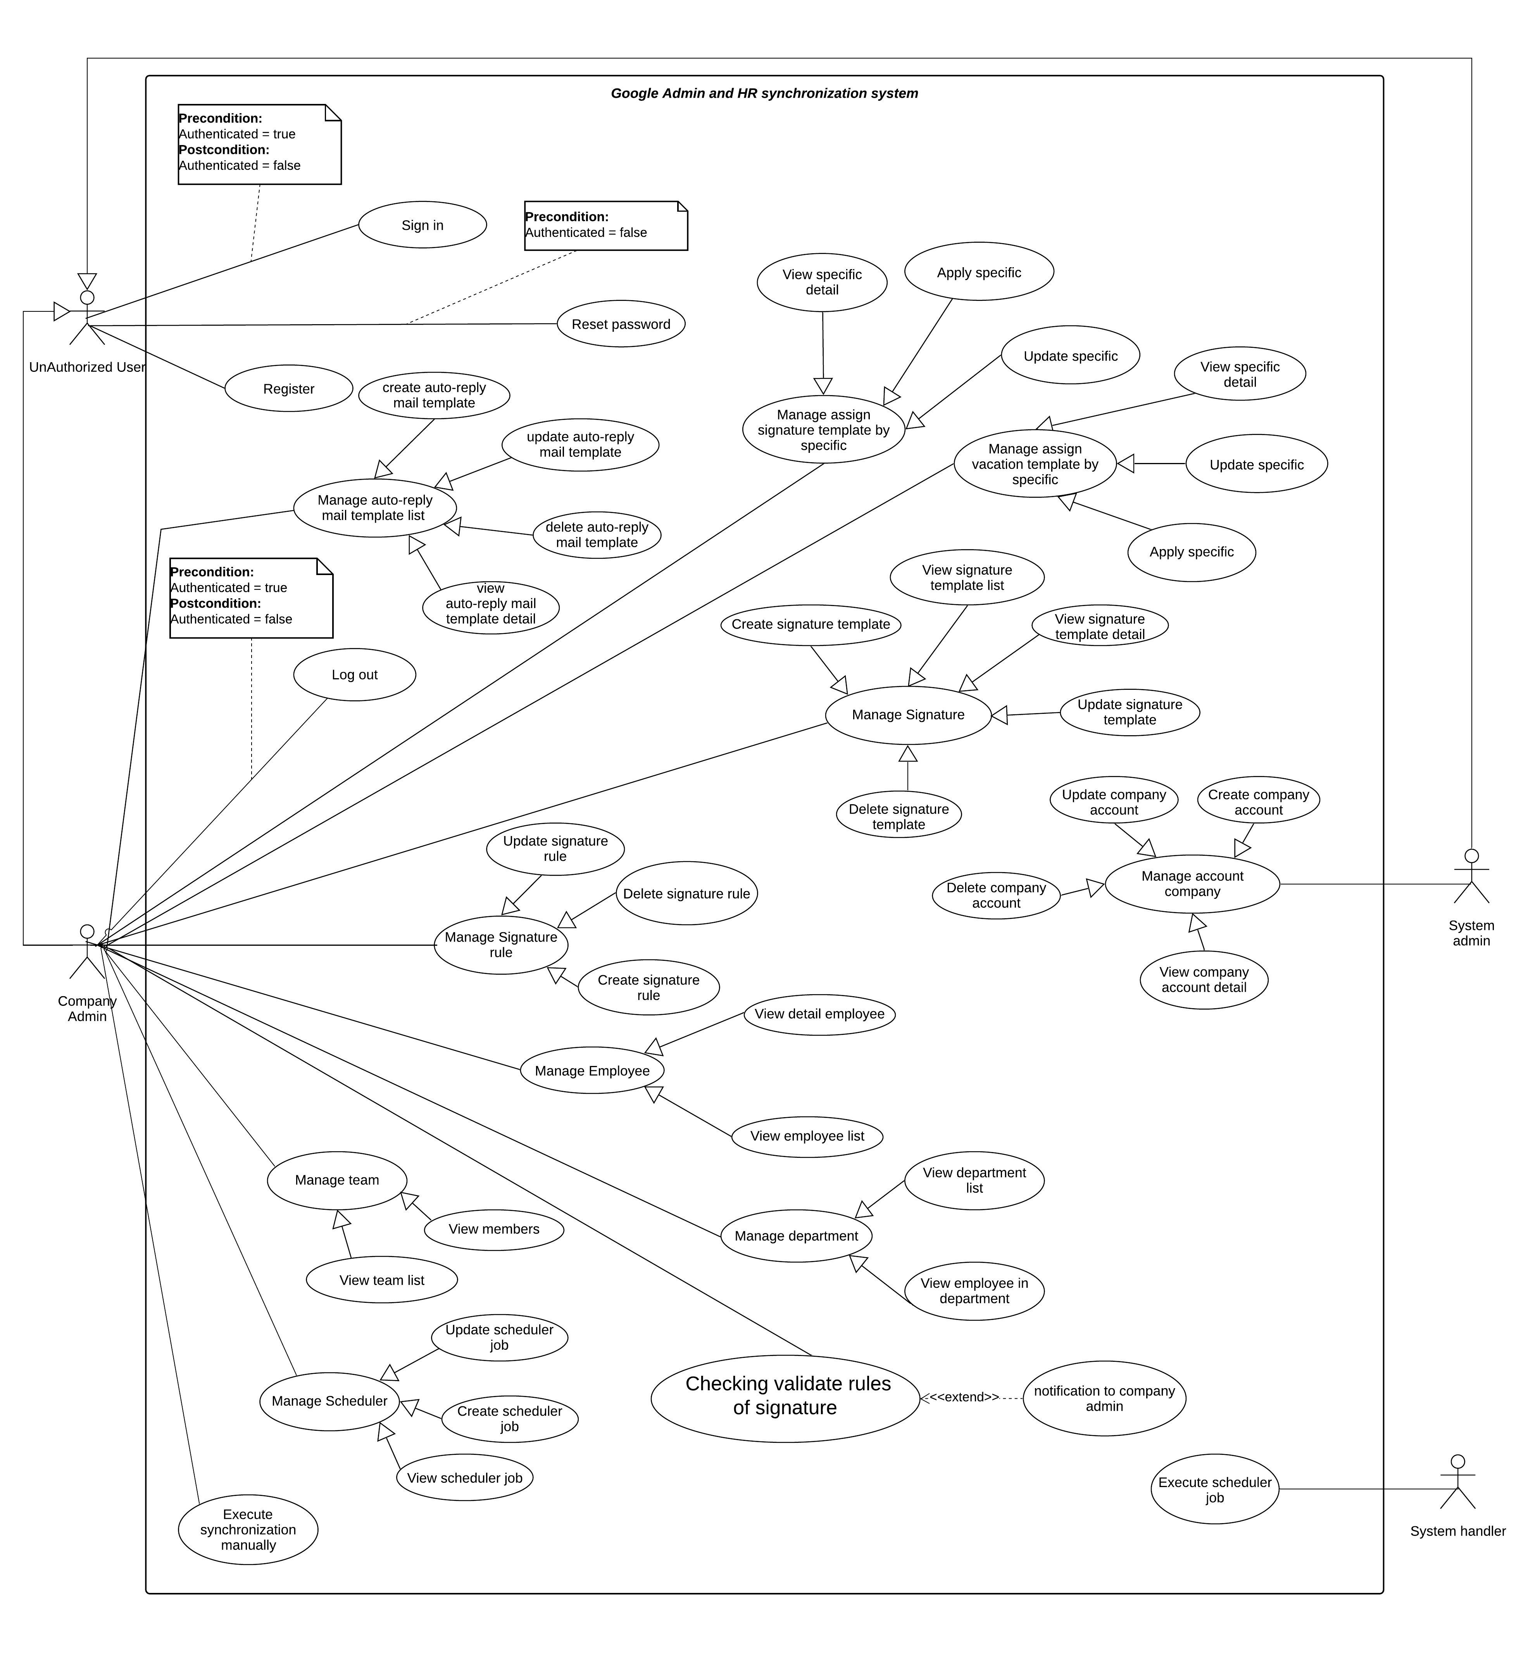

Figure 2 - System overview use case

### List of use case

#### <Guest> Overview Use Case

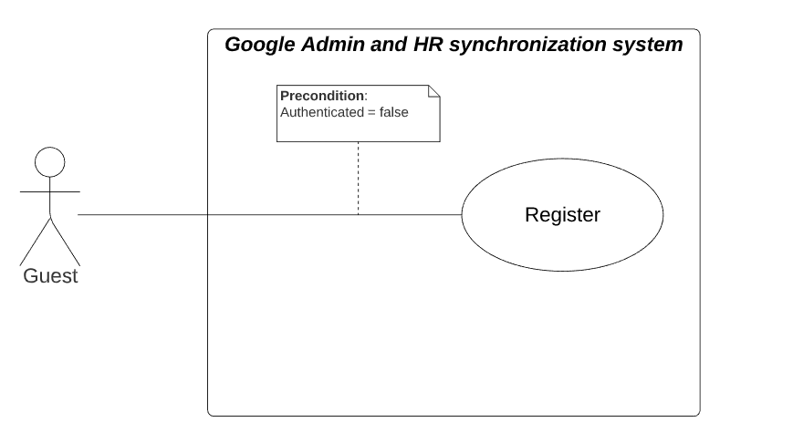

Figure 3 - <Guest> Overview Use Case

##### Register



Figure 4 - <Guest> Register

|  |  |  |  |
| --- | --- | --- | --- |
| **USE CASE – GmHRS_G_01** | | | |
| **Use Case No.** | GmHRS_G_01 | **Use Case Version** | 2.0 |
| **Use Case Name** | Register | | |
| **Author** | ThanhPV | | |
| **Date** | 24/06/2020 | **Priority** | Normal |
| **Actor:**   * Guest   **Summary:**   * This use case allows guest to register account into the system   **Goal:**   * Guest can register into the system   **Trigger:**   * Guest click “Register” link in login page   **Precondition:**   * Guest not logged in the system   **Post condition:**   * Guest register successfully and the system redirect guest to the login page   **Success**: Guest success to register account.  **Fail**: System show error message.  **Main Success Scenario:**   |  |  |  | | --- | --- | --- | | **Step** | **Actor Action** | **System Response** | | 1 | Guest goes to login view. |  | | 2 | Guest clicks “Register Account” on login page. | System redirect guest to register view | | 2 | Guest inputs information. | System requires identity information from Guest:  -User name: blank text input  -Your email: blank text input  -Password: blank text input  -Confirm Password: blank text input  -Phone: blank text input  -Address: blank text input | | 3 | Guest click “Register” button to register to system. | Guest registers into system with his/her specific role and redirect guest to login page [Exception 1,2,3,4,5,6,7] |   **Alternative Scenario: N/A**  **Exceptions:**   |  |  |  | | --- | --- | --- | | **No** | **Actor Action** | **System Response** | | 1 | Guest does not enter, enter blank or enter username not be between 6 and 15 characters. | System shows error message “Username must be between 6 and 15 characters” | | 2 | Guest does not enter, enter blank email | System shows error message “Email is required” | | 3 | Guest does not enter, enter blank or enter password less than 8 characters. | System shows error message “Password must be more than 8 characters” | | 4 | Guest does not enter, enter blank confirm password or do not match with password | System shows error message “Password mismatch” | | 5 | Guest enters email is not validated with email standard form | System shows error message “Invalid email address” | | 6 | Guest enters an username used by another account | System shows error message ”This username is already registered | | 7 | Guest enters an email used by another account | System shows error message ”This email is already registered |   **Relationships:** **N/A**  **Business Rules:**   * Username must be between 6 and 15 characters. * A username is only used to register for one person. * Email must be validated email standard. * Email must not be blank. * An email is only used to register for one person. * Password must be more than 8 characters. | | | |

Table 6 - <Guest> Register use case specification

#### <Unauthorized User> Overview Use Case



Figure 5 - <Unauthorized User> Overview Use Case

##### Sign in



Figure 6 - <Unauthorized User> Sign in

|  |  |  |  |
| --- | --- | --- | --- |
| **USE CASE – GmHRS_U_01** | | | |
| **Use Case No.** | GmHRS_U_01 | **Use Case Version** | 2.0 |
| **Use Case Name** | Sign in | | |
| **Author** | ThanhPV | | |
| **Date** | 24/06/2020 | **Priority** | Normal |
| **Actor:**   * Unauthorized User   **Summary:**   * This use case allows unauthorized user to login into the system   **Goal:**   * Unauthorized user can login into the system   **Trigger:**   * Unauthorized user clicks “Login” button in login page   **Precondition:**   * Unauthorized user is not authenticated   **Post condition:**   * Unauthorized user is authenticated   **Success**: Unauthorized user login with the specific role in the system  **Fail**: System show error message  **Main Success Scenario:**   |  |  |  | | --- | --- | --- | | **Step** | **Actor Action** | **System Response** | | 1 | Unauthorized user goes to login view. | System requires identity information from Unauthorized user:  -Username: blank text input.  -Password: blank text input. | | 2 | Unauthorized user inputs information. |  | | 3 | Unauthorized user click “Login” button to login to the system | User is authenticated and redirected to specific pages depending on his/her role. [Exception 1, 2] |   **Alternative Scenario: N/A**  **Exceptions:**   |  |  |  | | --- | --- | --- | | **No** | **Actor Action** | **System Response** | | 1 | Unauthorized user enters wrong username or password | System shows error message “Username or password invalid” | | 2 | Unauthorized user enters username and password of an account that is deactivated by administrator | System shows error message “Your account has been locked. Please contact the administrator” |   **Relationships:** **N/A**  **Business Rules:**   * After login to system, guest will be redirected to specific view based on their role on the system: user, administrator or system administrator * If role is “Company Admin”, the system will display company admin page * If role is “System Admin”, the system will display system admin page | | | |

Table 7 - <Unauthorized User> Register use case specification

##### Reset password



Figure 7 - <Unauthorized User> Reset password

|  |  |  |  |
| --- | --- | --- | --- |
| **USE CASE – GmHRS_U_02** | | | |
| **Use Case No.** | GmHRS_U_02 | **Use Case Version** | 2.0 |
| **Use Case Name** | Reset password | | |
| **Author** | ThanhPV | | |
| **Date** | 24/06/2020 | **Priority** | Normal |
| **Actor:**   * Unauthorized User   **Summary:**   * This use case allows unauthorized to reset password   **Goal:**   * Unauthorized user can reset password   **Trigger:**   * Unauthorized user clicks “Forgot Password” button in login page   **Precondition:**   * Unauthorized user is not authenticated   **Post condition:**   * Unauthorized user can change password.   **Success**: Unauthorized user change password successfully.  **Fail**: System show error message  **Main Success Scenario:**   |  |  |  | | --- | --- | --- | | **Step** | **Actor Action** | **System Response** | | 1 | Unauthorized user clicks “Forgot Password” button | System redirect to Reset password view: | | 2 | Unauthorized user input information | System requires identity information from Unauthorized user:  -User Name: blank text input  -Phone: blank text input  -Your email: blank text input | | 3 | Unauthorized user clicks “Reset” | System show message “Password reset successfully” , send code to use reset password and redirect to change password view | | 4 | Unauthorized user input information | System show:  -Your new password: blank text input  -Confirm Your new password: blank text input  -Code: blank text input | | 5 | Unauthorized user click button “Change password” | System show success message and redirect to login page.[Exception:1,2,3] |   **Alternative Scenario: N/A**  **Exceptions:**   |  |  |  | | --- | --- | --- | | **No** | **Actor Action** | **System Response** | | 1 | Unauthorized user input wrong username ,email or phone | System show error message: “Input information again”. | | 2 | Unauthorized user input new password less than 6 characters | System show error message: “Password must be more than 6 characters” | | 3 | Unauthorized user input confirm password mismatch | System show error message: “Password mismatch” |   **Relationships:** **N/A**  **Business Rules:**   * Unauthorized user can reset password any time * After system show message “Password reset successfully”. Check your email to get code”. Use the code to change password * In change password page, you must input new password less than 6 characters * In change password page, you must to input match new password and confirm password | | | |

Table 8- <Unauthorized User> Reset password use case specification

##### Register



Figure 8 - <Unauthorized User> Register

|  |  |  |  |
| --- | --- | --- | --- |
| **USE CASE – GmHRS_U_03** | | | |
| **Use Case No.** | GmHRS_U_03 | **Use Case Version** | 2.0 |
| **Use Case Name** | Register | | |
| **Author** | ThanhPV | | |
| **Date** | 24/06/2020 | **Priority** | Normal |
| **Actor:**   * Unauthorized user   **Summary:**   * This use case allows Unauthorized user register account into the system   **Goal:**   * Unauthorized user can register into the system   **Trigger:**   * Guest click “Register” link in login page   **Precondition:**   * Unauthorized user not logged in the system   **Post condition:**   * Unauthorized user register successfully and the system redirect guest to the login page   **Success**: Unauthorized user success to register account.  **Fail**: System show error message.  **Main Success Scenario:**   |  |  |  | | --- | --- | --- | | **Step** | **Actor Action** | **System Response** | | 1 | Unauthorized user goes to login view. |  | | 2 | Unauthorized user clicks “Register Account” on login page. | System redirect Unauthorized user to register view | | 3 |  | System requires identity information from Unauthorized user:  -User name: blank text input  -Your email: blank text input  -Password: blank text input  -Confirm Password: blank text input  -Phone: blank text input  -Address: blank text input | | 4 | Unauthorized user inputs information. |  | | 5 | Guest click “Register” button to register to system. | Unauthorized user registers into system with his/her specific role and redirect guest to login page [Exception 1,2,3,4,5,6,7] |   **Alternative Scenario: N/A**  **Exceptions:**   |  |  |  | | --- | --- | --- | | **No** | **Actor Action** | **System Response** | | 1 | Guest does not enter, enter blank or enter username not be between 6 and 20 characters. | System shows error message “Username must be between 6 and 20 characters” | | 2 | Guest does not enter, enter blank email | System shows error message “Email is required” | | 3 | Guest does not enter, enter blank or enter password less than 6 characters. | System shows error message “Password must be more than 6 characters” | | 4 | Guest does not enter, enter blank confirm password or do not match with password | System shows error message “Password mismatch” | | 5 | Guest enters email is not validated with email standard form | System shows error message “Invalid email address” | | 6 | Guest enters an username used by another account | System shows error message ” Your user name or email already exists!” | | 7 | Guest enters an email used by another account | System shows error message ” Your user name or email already exists!” |   **Relationships:** **N/A**  **Business Rules:**   * Username must be between 6 and 20 characters. * A username is only used to register for one person. * Email must be validated email standard. * Email must not be blank. * An email is only used to register for one person. * Password must be more than 6 characters. | | | |

#### <System Admin> Overview Use Case



Figure 9 - <System Admin> Overview Use Case

##### View account company list



Figure 10 - <System Admin> View account company list

|  |  |  |  |
| --- | --- | --- | --- |
| **USE CASE – GmHRS_S_01** | | | |
| **Use Case No.** | GmHRS_S_01 | **Use Case Version** | 2.0 |
| **Use Case Name** | View account company list | | |
| **Author** | ThanhPV | | |
| **Date** | 24/06/2020 | **Priority** | Normal |
| **Actor:**   * System Admin.   **Summary:**   * This use case allows System admin view account company list.   **Goal:**   * System admin view account company list.   **Trigger:**   * System admin goes to manage company admin page.   **Precondition:**   * Unauthorized user is logged into the system with role “System Admin”.   **Post condition:**   * Success: System show account company list. * Fail: System show error message.   **Main Success Scenario:**   |  |  |  | | --- | --- | --- | | **Step** | **Actor Action** | **System Response** | | 1 | System admin goes to manage company page | System shown account company list. [Exception 1] |   **Alternative Scenario: N/A**  **Exceptions:**   |  |  |  | | --- | --- | --- | | **No** | **Actor Action** | **System Response** | | 1 | Lost internet connection. | System fail to load list account company |   **Relationships:** **N/A**  **Business Rules:**   * System will show account company list with status active and de active | | | |

Table 9 - <System Admin> View account company list use case specification

##### Create account company



Figure 11 - <System Admin> Create account company

|  |  |  |  |
| --- | --- | --- | --- |
| **USE CASE – GmHRS_S_02** | | | |
| **Use Case No.** | GmHRS_S_02 | **Use Case Version** | 2.0 |
| **Use Case Name** | Create account company | | |
| **Author** | ThanhPV | | |
| **Date** | 24/06/2020 | **Priority** | Normal |
| **Actor:**   * System Admin.   **Summary:**   * This use case allows System admin to add Account Company into the system.   **Goal:**   * System admin add Account Company into the system.   **Trigger:**   * System admin clicks Create Account Company button in the manage company page.   **Precondition:**   * System admin goes to the manage company page.   **Post condition:**   * Success: Created account row added in list accounts table. * Fail: System show error message.   **Main Success Scenario:**   |  |  |  | | --- | --- | --- | | **Step** | **Actor Action** | **System Response** | | 1 | System admin clicks “Create Account Company” button in manage company page. | System shows popup:  -Email: blank text input  -Username: blank text input  -Password: blank text input  -Phone: blank text input | |  | System admin inputs information |  | |  | System admin click “Submit” button to add account to system | System closes popup and shows account updated in table |   **Alternative Scenario: N/A**  **Exceptions:**   |  |  |  | | --- | --- | --- | | **No** | **Actor Action** | **System Response** | | 1 | Guest does not enter, enter blank or enter username not be between 6 and 20 characters. | System shows error message “Username must be between 6 and 20 characters” load list account company | | 2 | Guest does not enter, enter blank or enter password less than 6 characters. | System shows error message “System shows error message “Password must be more than 6 characters” | | 3 | Guest does not enter, enter blank email | System shows error message “Email is required” | | 4 | Guest enters email is not validated with email standard form | System shows error message “Invalid email address” | | 5 | Guest enters a username used by another account | System shows error message” This username is already registered” | | 6 | Guest enters an email used by another account | System shows error message “This email is already registered” |   **Relationships:** **N/A**  **Business Rules:**   * Username must be between 6 and 15 characters. * A username is only used to register for one person. * Email must be validated email standard. * Email must not be blank. * An email is only used to register for one person. * Password must be more than 8 characters. | | | |

Table 10 - <System Admin> Create account company use case specification

##### Update account company



Figure 12 - <System Admin>Update account company

|  |  |  |  |
| --- | --- | --- | --- |
| **USE CASE – GmHRS_S_04** | | | |
| **Use Case No.** | GmHRS_S_04 | **Use Case Version** | 2.0 |
| **Use Case Name** | Update account company | | |
| **Author** | ThanhPV | | |
| **Date** | 24/06/2020 | **Priority** | Normal |
| **Actor:**   * System Admin.   **Summary:**   * This use case allows System admin update specified company account.   **Goal:**   * System admin update specified company account.   **Trigger:**   * System admin click “Update” button   **Precondition:**   * Unauthorized user is logged into the system with role “System Admin”.   **Post condition:**   * Success: Account must be updated. * Fail: System show error message.   **Main Success Scenario:**   |  |  |  | | --- | --- | --- | | **Step** | **Actor Action** | **System Response** | | 1 | System admin click “View” button | System show modal:  -Email: read only text  -username: read only text  -Address: read only text  -Phone: read only text  -Created Date: read only text  -Modified Date: read only text  -Api endpoint: text  -Database connection: read only text  -Close: button  -Update: button | | 2 | System admin click “Close” button | Close popup, nothing changes | | 3 | System admin input information |  | | 4 | System admin click “Update” button | System closes modal and shows account updated in table. [Exception 1]. |   **Alternative Scenario: N/A**  **Exceptions:**   |  |  |  | | --- | --- | --- | | **No** | **Actor Action** | **System Response** | | 1 | Lost connection | Delete account company fail |   **Relationships:** **N/A**  **Business Rules:**   * System admin can update specified account company | | | |

Table 11 - <System Admin> Update account company use case specification

##### Delete account company



Figure 13 - <System Admin> Delete account company

|  |  |  |  |
| --- | --- | --- | --- |
| **USE CASE – GmHRS_S_05** | | | |
| **Use Case No.** | GmHRS_S_05 | **Use Case Version** | 2.0 |
| **Use Case Name** | Delete account company | | |
| **Author** | ThanhPV | | |
| **Date** | 24/06/2020 | **Priority** | Normal |
| **Actor:**   * System Admin.   **Summary:**   * This use case allows System admin activate/deactivate specified company account.   **Goal:**   * System admin activate/deactivate specified company account.   **Trigger:**   * System admin slide toggle status “On/Off”   **Precondition:**   * Unauthorized user is logged into the system with role “System Admin”.   **Post condition:**   * Success: Account must be activate/deactivate. * Fail: System show error message.   **Main Success Scenario:**   |  |  |  | | --- | --- | --- | | **Step** | **Actor Action** | **System Response** | | 1 | System admin slide toggle “On/Off” | System show confirm dialog:  -Change: button.  -Cancel: button. | | 2 | System admin click “Cancel” button | Close dialog, nothing changes. | | 3 | System admin click “Change” button | System activate/deactivate account company and send status [Exception 1] |   **Alternative Scenario: N/A**  **Exceptions:**   |  |  |  | | --- | --- | --- | | **No** | **Actor Action** | **System Response** | | 1 | Lost connection | System fail to activate/deactivate account company |   **Relationships:** **N/A**  **Business Rules:**   * System admin can activate/deactivate specified account company | | | |

Table 12 - <System Admin> Delete account company use case specification

#### <Company admin> Overview Use Case

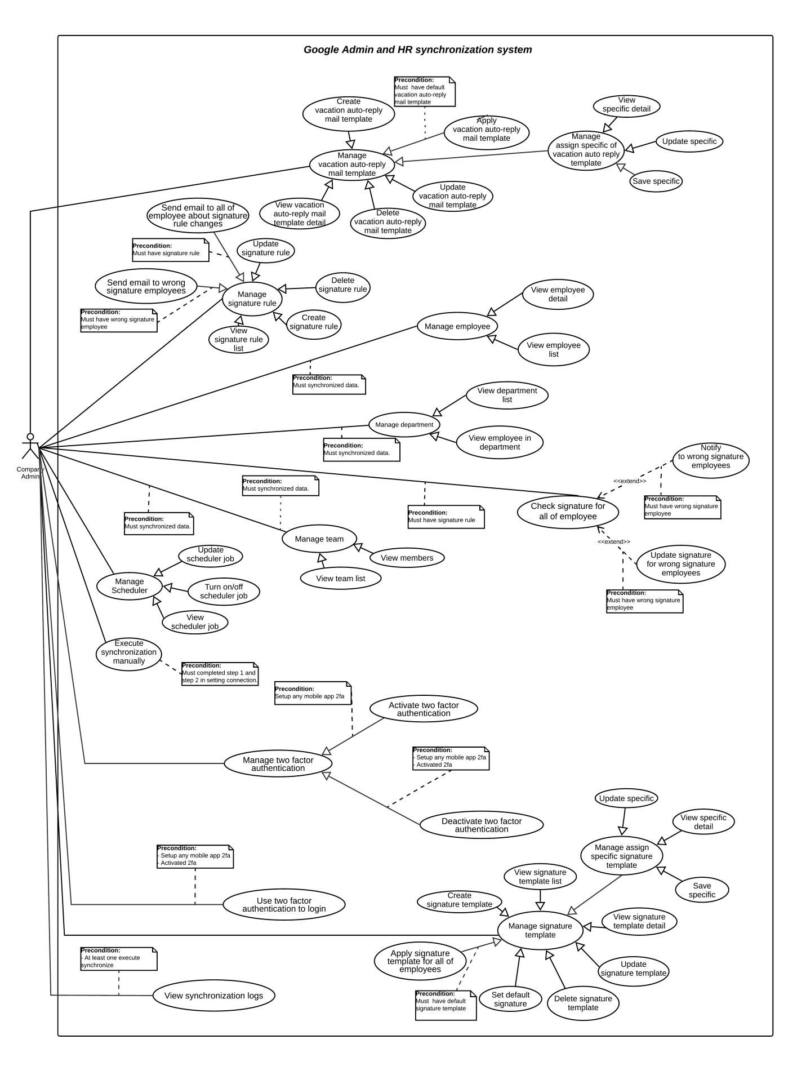

Table 13 - <Company admin> Overview Use Case

##### Update database connection or API endpoint



Figure 14 - Update database connection or API endpoint

|  |  |  |  |
| --- | --- | --- | --- |
| **USE CASE – GmHRS_C_01** | | | |
| **Use Case No.** | GmHRS_C_01 | **Use Case Version** | 2.0 |
| **Use Case Name** | Step 1: Update API endpoint or database connection | | |
| **Author** | ThanhPV | | |
| **Date** | 24/06/2020 | **Priority** | Normal |
| **Actor:**   * Company admin.   **Summary:**   * This use case allows Company update API endpoint or database connection.   **Goal:**   * Company admin update API endpoint or database connection.   **Trigger:**   * Company admin goes to setting page   **Precondition:**   * Unauthorized user is logged into the system with role “Company Admin”.   **Post condition:**   * Success: System update API endpoint or database connection success. * Fail: System show error message.   **Main Success Scenario:**   |  |  |  | | --- | --- | --- | | **Step** | **Actor Action** | **System Response** | | 1 | Company admin goes to setting page, in step 1 | System show:  -Connection Name: blank text input  -Hostname: blank text input  -port: blank text input  -Username: blank text input  -Password: blank text input  -Database type: select  -Next: button  -Test Connection: button  -Database connection: radio button  -API endpoint: radio button | | 2 | In database connection, company admin input information. [ Alternative] |  | | 3 | Company admin click “Test Connection” button | System show modal result | | 4 | Company admin click “Save” | System will save connection string and close modal | | 5 | Company admin click “Next” button | System show the next step |   **Alternative Scenario:**   |  |  |  | | --- | --- | --- | | **Step** | **Actor Action** | **System Response** | | 1 | Company admin goes to setting page, in step 1 and select API endpoint | System show:  -URL: blank text input  -Database connection: radio button  -API endpoint: radio button  -Next: button  -Test: button | | 2 | Company admin input information |  | | 3 | Company admin click “Test” button | System show modal result | | 4 | Company admin click “Save” button | System will save API endpoint and close modal | | 5 | Company admin click “Next” button | System show the next step |   **Exceptions:**   |  |  |  | | --- | --- | --- | | **No** | **Actor Action** | **System Response** | | 1 | Lost internet connection. | System fail to Test/Test Connection, Save step 1. |   **Relationships:** **N/A**  **Business Rules:**   * Company admin must input all of field to enable button “Test Connection”/”Test” * Database connection must pass all of field in modal result to save * API endpoint must pass all of field in modal result to save | | | |

##### Update G-Suite credential



Figure 15 - Update G-Suite credential

|  |  |  |  |
| --- | --- | --- | --- |
| **USE CASE – GmHRS_C_01** | | | |
| **Use Case No.** | GmHRS_C_01 | **Use Case Version** | 2.0 |
| **Use Case Name** | Step 2: Update S-Suite credentials | | |
| **Author** | ThanhPV | | |
| **Date** | 24/06/2020 | **Priority** | Normal |
| **Actor:**   * Company admin.   **Summary:**   * This use case allows Company update G-Suite credentials.   **Goal:**   * Company admin updateG-Suite credentials.   **Trigger:**   * Company admin click “Next” button in step 1   **Precondition:**   * Company admin update step 1 successfully   **Post condition:**   * Success: System update G-Suite credentials success. * Fail: System show error message.   **Main Success Scenario:**   |  |  |  | | --- | --- | --- | | **Step** | **Actor Action** | **System Response** | | 1 | Company admin goes to step 2 | System show:  -Admin company email: blank text input  -File JSON of key authenticated G-Suite: file input  -Next: button  -Test: button  -Back: button | | 2 | Company admin input information |  | | 3 | Company admin click “Test” button | System show modal result | | 4 | Company admin click “Save” | System will save G-Suite credential and close modal | | 5 | Company admin click “Next” button | System show the next step |   **Alternative Scenario: N/A**  **Exceptions:**   |  |  |  | | --- | --- | --- | | **No** | **Actor Action** | **System Response** | | 1 | Lost internet connection. | System fail to Test, Save step 2 |   **Relationships:** **N/A**  **Business Rules:**   * Company admin email must have role admin on G-Suite * File JSON of key authenticated G-Suite must be JSON file * Test G-Suite credential must valid 5 scope in modal result to save step 2 | | | |

##### Update schedule job



Figure 16 - Update schedule job

|  |  |  |  |
| --- | --- | --- | --- |
| **USE CASE – GmHRS_C_01** | | | |
| **Use Case No.** | GmHRS_C_01 | **Use Case Version** | 2.0 |
| **Use Case Name** | Step 3: Update schedule job | | |
| **Author** | ThanhPV | | |
| **Date** | 24/06/2020 | **Priority** | Normal |
| **Actor:**   * Company admin.   **Summary:**   * This use case allows Company update schedule job.   **Goal:**   * Company admin update schedule job.   **Trigger:**   * Company admin click “Next” button in step 2   **Precondition:**   * Company admin update step 1 successfully   **Post condition:**   * Success: System updates schedule job success. * Fail: System show error message.   **Main Success Scenario:**   |  |  |  | | --- | --- | --- | | **Step** | **Actor Action** | **System Response** | | 1 | Company admin goes to step 3 | System show:  - Choose schedule for synchronize: select  - Contain of selected: choose date/time  -Save: button  -Back: button  - On/Off: slide toggle | | 2 | Company admin input information |  | | 3 | Company admin click “Save” button | System save schedule and show message |   **Alternative Scenario: N/A**  **Exceptions:**   |  |  |  | | --- | --- | --- | | **No** | **Actor Action** | **System Response** | | 1 | Lost internet connection. | System fail to Save step 3 |   **Relationships:** **N/A**  **Business Rules:**   * If Company admin choose daily synchronize, Company admin must choose the time * If Company admin choose weekly synchronize, Company admin must choose day in week and time * If Company admin choose monthly synchronize, Company admin must choose day in month and time | | | |

##### Turn on/off schedule job



Figure 17 - Turn on/off schedule job

|  |  |  |  |
| --- | --- | --- | --- |
| **USE CASE – GmHRS_C_01** | | | |
| **Use Case No.** | GmHRS_C_01 | **Use Case Version** | 2.0 |
| **Use Case Name** | Turn on/off schedule job | | |
| **Author** | ThanhPV | | |
| **Date** | 24/06/2020 | **Priority** | Normal |
| **Actor:**   * Company admin.   **Summary:**   * This use case allows Company Turn on/off schedule job.   **Goal:**   * Company admin can Turn on/off schedule job.   **Trigger:**   * Company admin slide toggle “On/Off” in step 3   **Precondition:**   * Company admin update step 1 and step 2 successfully   **Post condition:**   * Success: System turn on/off schedule job success. * Fail: System show error message.   **Main Success Scenario:**   |  |  |  | | --- | --- | --- | | **Step** | **Actor Action** | **System Response** | | 1 | In step 3 on setting page Company admin slide toggle “On/Off” | System show confirm dialog:  -Change: button  -Cancel: button | | 2 | Company admin click “Cancel” button | Nothing change, close dialog | | 3 | Company admin click “Change” button | System change On/Off schedule time and show message |   **Alternative Scenario: N/A**  **Exceptions:**   |  |  |  | | --- | --- | --- | | **No** | **Actor Action** | **System Response** | | 1 | Lost internet connection. | System fail to turn on/off schedule job |   **Relationships:** **N/A**  **Business Rules:**   * Company admin must completed successfully in step 1 ,2 * Company admin must set time for schedule in step 3 successfully * Company admin must synchronize data manually in the first synchronize before turn on/off schedule job | | | |

##### View team list

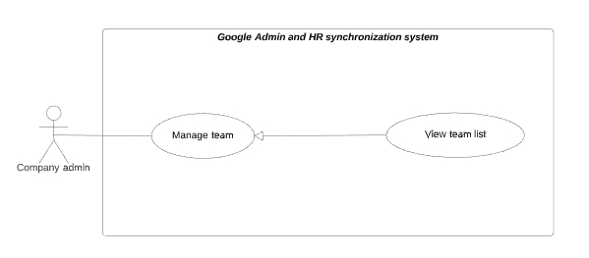

Figure 18 - <Company admin> View team list

|  |  |  |  |
| --- | --- | --- | --- |
| **USE CASE – GmHRS_C_01** | | | |
| **Use Case No.** | GmHRS_C_01 | **Use Case Version** | 2.0 |
| **Use Case Name** | View team list | | |
| **Author** | ThanhPV | | |
| **Date** | 24/06/2020 | **Priority** | Normal |
| **Actor:**   * Company admin.   **Summary:**   * This use case allows Company admin view team list.   **Goal:**   * Company admin view team list.   **Trigger:**   * Company admin goes to manage team page   **Precondition:**   * Unauthorized user is logged into the system with role “Company Admin”. * First synchronize successfully.   **Post condition:**   * Success: System show team list. * Fail: System show error message.   **Main Success Scenario:**   |  |  |  | | --- | --- | --- | | **Step** | **Actor Action** | **System Response** | | 1 | Company admin goes to manage team page | System shown team list. [Exception 1] |   **Alternative Scenario: N/A**  **Exceptions:**   |  |  |  | | --- | --- | --- | | **No** | **Actor Action** | **System Response** | | 1 | Lost internet connection. | System fail to load list team. |   **Relationships:** **N/A**  **Business Rules:**   * List of teams will show 5,10 or 15 records each page depend on selected of company admin * Company Admin can only view the team in their company | | | |

Table 14 - <Company admin> View team list use case specification

##### View team detail

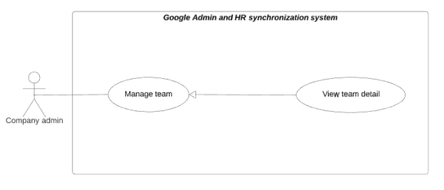

Figure 19 - <Company admin> View team detail

|  |  |  |  |
| --- | --- | --- | --- |
| **USE CASE – GmHRS_C_02** | | | |
| **Use Case No.** | GmHRS_C_02 | **Use Case Version** | 2.0 |
| **Use Case Name** | View team detail | | |
| **Author** | ThanhPV | | |
| **Date** | 24/06/2020 | **Priority** | Normal |
| **Actor:**   * Company admin.   **Summary:**   * This use case allows Company admin view list employee in specified team.   **Goal:**   * Company admin can view list employee in specified team.   **Trigger:**   * Company admin click “View” button   **Precondition:**   * Unauthorized user is logged into the system with role “Company Admin”.   **Post condition:**   * Success: System shows list employee of specified team. * Fail: System show error message.   **Main Success Scenario:**   |  |  |  | | --- | --- | --- | | **Step** | **Actor Action** | **System Response** | | 1 | Company admin click “View” button on row in table | System show list employee in modal  -Close: button | | 2 | Company admin click “Close” button | Nothing change, system close modal |   **Alternative Scenario: N/A**  **Exceptions:**   |  |  |  | | --- | --- | --- | | **No** | **Actor Action** | **System Response** | | 1 | Lost internet connection. | System fails to load list employee of specified team. |   **Relationships:** **N/A**  **Business Rules:**   * Company Admin can view specified team detail | | | |

Table 15 - <Company admin> View team detail use case specification

##### View department list

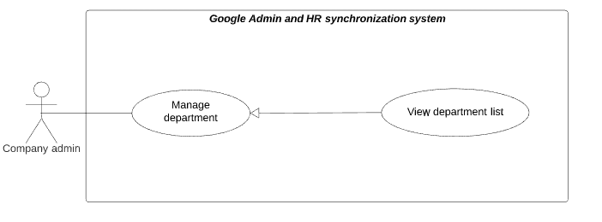

Figure 20 - <Company admin> View department list

|  |  |  |  |
| --- | --- | --- | --- |
| **USE CASE – GmHRS_C_03** | | | |
| **Use Case No.** | GmHRS_C_03 | **Use Case Version** | 2.0 |
| **Use Case Name** | View department list | | |
| **Author** | ThanhPV | | |
| **Date** | 24/06/2020 | **Priority** | Normal |
| **Actor:**   * Company admin.   **Summary:**   * This use case allows Company admin view department list.   **Goal:**   * Company admin view department list.   **Trigger:**   * Company admin goes to department page   **Precondition:**   * Unauthorized user is logged into the system with role “Company Admin”. * First synchronize successfully.   **Post condition:**   * Success: System show department list. * Fail: System show error message.   **Main Success Scenario:**   |  |  |  | | --- | --- | --- | | **Step** | **Actor Action** | **System Response** | | 1 | Company admin goes to manage department page | System shown department list. [Exception 1] |   **Alternative Scenario: N/A**  **Exceptions:**   |  |  |  | | --- | --- | --- | | **No** | **Actor Action** | **System Response** | | 1 | Lost internet connection. | System fails to load list account company. |   **Relationships:** **N/A**  **Business Rules:**   * List of teams will show 5,10 or 15 records each page depends on selected of system admin * Company Admin can only view the department in their company | | | |

Table 16 - <Company admin> View department list use case specification

##### View department detail

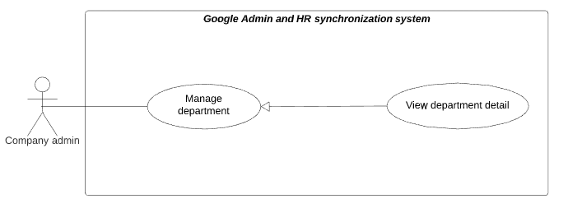

Figure 21 - <Company admin> View department detail

|  |  |  |  |
| --- | --- | --- | --- |
| **USE CASE – GmHRS_C_04** | | | |
| **Use Case No.** | GmHRS_C_04 | **Use Case Version** | 2.0 |
| **Use Case Name** | View department detail | | |
| **Author** | ThanhPV | | |
| **Date** | 24/06/2020 | **Priority** | Normal |
| **Actor:**   * Company admin.   **Summary:**   * This use case allows Company admin view list employee in specified department.   **Goal:**   * Company admin view list employee in specified department.   **Trigger:**   * Company admin click “View” button   **Precondition:**   * Unauthorized user is logged into the system with role “Company Admin”.   **Post condition:**   * Success: System shows list employee in specified team. * Fail: System show error message.   **Main Success Scenario:**   |  |  |  | | --- | --- | --- | | **Step** | **Actor Action** | **System Response** | | 1 | Company admin click Detail button on row in table | System show list employee in modal  -Close: button | | 2 | Company admin click “Close” button | Nothing change, system close modal |   **Alternative Scenario: N/A**  **Exceptions:**   |  |  |  | | --- | --- | --- | | **No** | **Actor Action** | **System Response** | | 1 | Lost internet connection. | System fails to load list employee of specified team. |   **Relationships:** **N/A**  **Business Rules:**   * Company admin can view department detail information | | | |

Table 17 - <Company admin> View department detail use case specification

##### View employee list

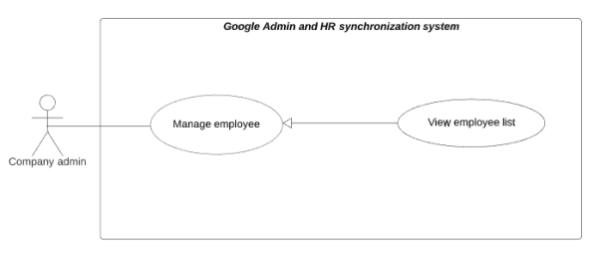

Figure 22 - <Company admin> View employee list

|  |  |  |  |
| --- | --- | --- | --- |
| **USE CASE – GmHRS_C_05** | | | |
| **Use Case No.** | GmHRS_C_05 | **Use Case Version** | 2.0 |
| **Use Case Name** | View employee list | | |
| **Author** | ThanhPV | | |
| **Date** | 24/06/2020 | **Priority** | Normal |
| **Actor:**   * Company admin.   **Summary:**   * This use case allows Company admin view employee list.   **Goal:**   * Company admin view employee list. * First synchronize successfully.   **Trigger:**   * Company admin goes to manage employee page   **Precondition:**   * Unauthorized user is logged into the system with role “Company Admin”.   **Post condition:**   * Success: System show employee list. * Fail: System show error message.   **Main Success Scenario:**   |  |  |  | | --- | --- | --- | | **Step** | **Actor Action** | **System Response** | | 1 | Company admin goes to manage employee page | System shown employee list. [Exception 1] |   **Alternative Scenario: N/A**  **Exceptions:**   |  |  |  | | --- | --- | --- | | **No** | **Actor Action** | **System Response** | | 1 | Lost internet connection. | System fails to load list employee. |   **Relationships:** **N/A**  **Business Rules:**   * List of employees will show 5,10 or 15 records each page depends on selected of company admin * Company Admin can only view the employee in their company | | | |

Table 18 - <Company admin> View employee list use case specification

##### View employee detail

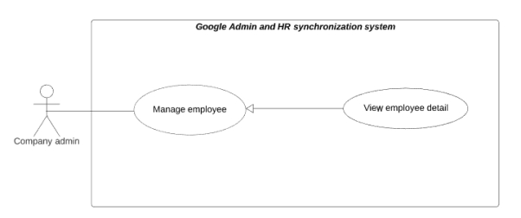

Figure 23 - <Company admin> View employee detail

|  |  |  |  |
| --- | --- | --- | --- |
| **USE CASE – GmHRS_C_06** | | | |
| **Use Case No.** | GmHRS_C_06 | **Use Case Version** | 2.0 |
| **Use Case Name** | View employee detail | | |
| **Author** | ThanhPV | | |
| **Date** | 24/06/2020 | **Priority** | Normal |
| **Actor:**   * Company admin.   **Summary:**   * This use case allows Company admin view employee detail.   **Goal:**   * Company admin view employee detail.   **Trigger:**   * Company admin click Detail button.   **Precondition:**   * Unauthorized user is logged into the system with role “Company Admin”.   **Post condition:**   * Success: System shows department detail information. * Fail: System show error message.   **Main Success Scenario:**   |  |  |  | | --- | --- | --- | | **Step** | **Actor Action** | **System Response** | | 1 | Company admin click “Detail” button | System shown popup. [Exception 1] |   **Alternative Scenario: N/A**  **Exceptions:**   |  |  |  | | --- | --- | --- | | **No** | **Actor Action** | **System Response** | | 1 | Lost internet connection. | System fails to load list account company. |   **Relationships:** **N/A**  **Business Rules:**   * Company Admin can view specified employee information detail | | | |

Table 19 - <Company admin> View employee detail use case specification

##### Create signature rule



Figure 24 - <Company admin> Create signature rule

|  |  |  |  |
| --- | --- | --- | --- |
| **USE CASE – GmHRS_C_07** | | | |
| **Use Case No.** | GmHRS_C_07 | **Use Case Version** | 2.0 |
| **Use Case Name** | Create signature rule | | |
| **Author** | ThanhPV | | |
| **Date** | 24/06/2020 | **Priority** | High |
| **Actor:**   * Company admin.   **Summary:**   * This use case allows Company admin create signature rule.   **Goal:**   * Company admin can create signature rule.   **Trigger:**   * Company admin click “New” button.   **Precondition:**   * Unauthorized user is logged into the system with role “Company Admin”.   **Post condition:**   * Success: Signature rule must be created. * Fail: System show error message.   **Main Success Scenario:**   |  |  |  | | --- | --- | --- | | **Step** | **Actor Action** | **System Response** | | 1 | Company admin click “Clear data” button | System clear all tentent in the signature template view. System show:  -Signature rule name: blank text input  - Minimum signature length: blank text input  - Maximum signature length: blank text input  -Table contain/not contain rule  -Add row: button | | 2 | Company admin click “Add row” button | System add a row in table:  -Column Rule: Select  -Column Content: blank text input  -Column Delete: Delete button | | 3 | Company admin input rule |  | | 4 | Company admin click “New” button to create signature rule | System show confirm dialog:  -Cancel: button  -Ok, do it: button | | 5 | Company admin click “Ok, do it” button | System will create signature rule and show message. [Exception 1,2,3,4,5] |   **Alternative Scenario: N/A**  **Exceptions:**   |  |  |  | | --- | --- | --- | | **No** | **Actor Action** | **System Response** | | 1 | Lost internet connection. | System fails to load items in “Contain”, “Not Contain”, “Value”. | | 2 | Company Admin enter blank or not enter signature rule name | System show error message: “Please input rule name and rule content!” | | 3 | Company Admin enter blank or not enter min and max signature length | System show error message: “Please check maximum and minimum length!” | | 4 | Company Admin not add rule in table rule | System show error message: “Please input rule data table!” | | 5 | Company Admin not enter or enter blank content of rule | System show error message: “Content of rule cannot blank! |   **Relationships:** **N/A**  **Business Rules:**   * If company admin select Contain this text in table rule, signature of employee must have the text of “content” in their signature * If company admin select Not contain this text in table rule, signature of employee must not have the text of “content” in their signature | | | |

Table 20 - <Company admin> Create signature rule use case specification

##### Update signature rule



Figure 25 - <Company admin> Update signature rule

|  |  |  |  |
| --- | --- | --- | --- |
| **USE CASE – GmHRS_C_09** | | | |
| **Use Case No.** | GmHRS_C_09 | **Use Case Version** | 2.0 |
| **Use Case Name** | Update signature rule | | |
| **Author** | ThanhPV | | |
| **Date** | 24/06/2020 | **Priority** | Normal |
| **Actor:**   * Company Admin.   **Summary:**   * This use case allows Company admin update specified signature rule.   **Goal:**   * System admin update specified signature rule.   **Trigger:**   * Company admin click “Update” button   **Precondition:**   * Signature rule was created   **Post condition:**   * Success: Signature rule must be updated. * Fail: System show error message.   **Main Success Scenario:**   |  |  |  | | --- | --- | --- | | **Step** | **Actor Action** | **System Response** | | 1 | Company admin click “Load” button  In signature rule list table | System close modal and show the information of signature rule detail:  -Signature rule name: text input  - Minimum signature length: text input  - Maximum signature length: text input  -Table contain/not contain rule  -Add row: button | | 2 | Company admin edit information |  | | 3 | Company admin click “Update” button | System show confirm dialog:  -Cancel: button  -Ok, do it: button | | 4 | Company admin click “Ok, do it” button to update signature rule | System update signature rule and show message [Exception 1,2,3,4,5] |   **Alternative Scenario: N/A**  **Exceptions:**   |  |  |  | | --- | --- | --- | | **No** | **Actor Action** | **System Response** | | 2 | Company Admin enter blank or not enter signature rule name | System show error message: “Please input rule name and rule content!” | | 3 | Company Admin enter blank or not enter min and max signature length | System show error message: “Please check maximum and minimum length!” | | 4 | Company Admin not add rule in table rule | System show error message: “Please input rule data table!” | | 5 | Company Admin not enter or enter blank content of rule | System show error message: “Content of rule cannot blank! | | 6 | Company Admin enter signature rule name already existed | System show error message: “Signature rule name already existed” |   **Relationships:** **N/A**  **Business Rules:**   * If company admin select Contain this text in table rule, signature of employee must have the text of “content” in their signature * If company admin select Not contain this text in table rule, signature of employee must not have the text of “content” in their signature | | | |

Table 21 - <Company admin> Update signature rule use case specification

##### Delete signature rule



Figure 26 - <Company admin> Delete signature rule

|  |  |  |  |
| --- | --- | --- | --- |
| **USE CASE – GmHRS_C_10** | | | |
| **Use Case No.** | GmHRS_C_10 | **Use Case Version** | 2.0 |
| **Use Case Name** | Delete signature rule | | |
| **Author** | ThanhPV | | |
| **Date** | 24/06/2020 | **Priority** | Normal |
| **Actor:**   * Company Admin.   **Summary:**   * This use case allows Company admin delete specified signature rule.   **Goal:**   * System admin delete specified signature rule.   **Trigger:**   * Company admin click “Delete” button   **Precondition:**   * Unauthorized user is logged into the system with role “Company Admin”.   **Post condition:**   * Success: System remove signature rule deleted in signature rule list. * Fail: System show error message.   **Main Success Scenario:**   |  |  |  | | --- | --- | --- | | **Step** | **Actor Action** | **System Response** | | 1 | Company admin click “Delete” button on specific row in signature rule list table | System show a popup:  -Cancel: button  -Ok, do it: button | | 2 | Company admin click “Ok, do it” button | System close dialog and delete signature rule. [Exception 1] |   **Alternative Scenario: N/A**  **Exceptions:**   |  |  |  | | --- | --- | --- | | **No** | **Actor Action** | **System Response** | | 1 | Lost internet connection. | System fails to delete signature rule |   **Relationships:** **N/A**  **Business Rules:**   * The data delete cannot convert | | | |

Table 22 - <Company admin> Delete signature rule use case specification

##### Send email to wrong signature employees

##### Send email to all of employee about signature rule changes

##### Checking signature for all employee

##### Notify to wrong signature employees

##### Update signature for wrong signature employees

##### View signature template list



Figure 27 - <Company admin> View signature template list

|  |  |  |  |
| --- | --- | --- | --- |
| **USE CASE – GmHRS_C_12** | | | |
| **Use Case No.** | GmHRS_C_12 | **Use Case Version** | 2.0 |
| **Use Case Name** | View signature template list | | |
| **Author** | ThanhPV | | |
| **Date** | 24/06/2020 | **Priority** | Normal |
| **Actor:**   * Company admin.   **Summary:**   * This use case allows Company admin view signature template list.   **Goal:**   * Company admin can view signature template list.   **Trigger:**   * Company admin click “Show all template” on menu bar in manage signature template page   **Precondition:**   * Unauthorized user is logged into the system with role “Company Admin”.   **Post condition:**   * Success: System show signature template list. * Fail: System show error message.   **Main Success Scenario:**   |  |  |  | | --- | --- | --- | | **Step** | **Actor Action** | **System Response** | | 1 | Company admin click “Show all template” on menu bar in manage signature template page | System will open modal and show list signature template. if there is no data available, system show modal with no data. If there is data, system will show modal with list signature template. |   **Alternative Scenario: N/A**  **Exceptions:**   |  |  |  | | --- | --- | --- | | **No** | **Actor Action** | **System Response** | | 1 | Lost internet connection. | System fails to load list signature template. |   **Relationships:** **N/A**  **Business Rules:**   * Company admin can view list of signature template. | | | |

Table 23 - <Company admin> View signature template list use case specification

##### Create signature template



Figure 28 - <Company admin> Create signature template

|  |  |  |  |
| --- | --- | --- | --- |
| **USE CASE – GmHRS_C_13** | | | |
| **Use Case No.** | GmHRS_C_13 | **Use Case Version** | 2.0 |
| **Use Case Name** | Create signature template | | |
| **Author** | ThanhPV | | |
| **Date** | 24/06/2020 | **Priority** | High |
| **Actor:**   * Company admin.   **Summary:**   * This use case allows Company admin create signature template.   **Goal:**   * Company admin create signature template.   **Trigger:**   * Company admin click ”New” button.   **Precondition:**   * Unauthorized user is logged into the system with role “Company Admin”.   **Post condition:**   * Success: Signature template must be created. * Fail: System show error message.   **Main Success Scenario:**   |  |  |  | | --- | --- | --- | | **Step** | **Actor Action** | **System Response** | | 1 | Company admin click “New” button | System clear all contain in create signature template view. System show:  -Signature name: blank text input  -Content: editor  -Load review: button  -Review content: Editor(Read only) | | 2 | Company admin input information |  | | 3 | Company admin click “Save” | System show confirm dialog:  -Cancel: button  -Ok, do it: button | | 4 | Company admin click “Ok, do it” button | System will save signature template and show message. [Exception 1,2,3] |   **Alternative Scenario: N/A**  **Exceptions:**   |  |  |  | | --- | --- | --- | | **No** | **Actor Action** | **System Response** | | 1 | Company admin does not enter, enter blank “Signature name” | System shows error message “Input signature name” | | 2 | Company admin does not enter or enter blank “Content” | System shows error message “Input signature template content!” | | 3 | Company admin input “Signature name” existed | System shows error message “Signature name already existed!” |   **Relationships:** **N/A**  **Business Rules:**   * Signature name must have at least 1 character. * Signature content must have at least 1 character and maximum 10000 characters. * If company admin have signature rule, all template created will follow the rule. The template that not valid rule cannot create. * Signature name not allow duplication. | | | |

Table 24 - <Company admin> Create signature template use case specification

##### View signature template detail



Figure 29 - <Company admin> View signature template detail

|  |  |  |  |
| --- | --- | --- | --- |
| **USE CASE – GmHRS_C_14** | | | |
| **Use Case No.** | GmHRS_C_14 | **Use Case Version** | 2.0 |
| **Use Case Name** | View signature template detail | | |
| **Author** | ThanhPV | | |
| **Date** | 24/06/2020 | **Priority** | High |
| **Actor:**   * Company admin.   **Summary:**   * This use case allows Company admin view signature template detail.   **Goal:**   * Company admin can view signature template detail.   **Trigger:**   * Company admin click “Load” button when view list template signature.   **Precondition:**   * Unauthorized user is logged into the system with role “Company Admin”. * Company admin view list signature before   **Post condition:**   * Success: System shows signature template detail information. * Fail: System show error message.   **Main Success Scenario:**   |  |  |  | | --- | --- | --- | | **Step** | **Actor Action** | **System Response** | | 1 | Company admin click “Load” button in modal signature template list | System close modal and load the detail of signature template. System show  -Signature name: text input  -Content: editor  -Load review: button  -Review content: Editor(Read only) |   **Alternative Scenario: N/A**  **Exceptions:**   |  |  |  | | --- | --- | --- | | **No** | **Actor Action** | **System Response** | | 1 | Lost internet connection. | System fails to load signature template detail. |   **Relationships:** **N/A**  **Business Rules:**   * Company admin can view detail specified signature template | | | |

Table 25 - <Company admin> View signature template detail use case specification

##### Update signature template



Figure 30 - <Company admin> Update signature template

|  |  |  |  |
| --- | --- | --- | --- |
| **USE CASE – GmHRS_C_15** | | | |
| **Use Case No.** | GmHRS_C_15 | **Use Case Version** | 2.0 |
| **Use Case Name** | Update signature template | | |
| **Author** | ThanhPV | | |
| **Date** | 24/06/2020 | **Priority** | High |
| **Actor:**   * Company admin.   **Summary:**   * This use case allows Company admin update signature template.   **Goal:**   * Company admin update signature template.   **Trigger:**   * Company admin click “Save” button when view signature template detail.   **Precondition:**   * Signature template was created   **Post condition:**   * Success: Signature template must be updated. * Fail: System show error message.   **Main Success Scenario:**   |  |  |  | | --- | --- | --- | | **Step** | **Actor Action** | **System Response** | | 1 | Company admin click “Load” button in modal signature template list | System close modal and load the detail of signature template. System show  -Signature name: text input  -Content: editor  -Load review: button  -Review content: Editor(Read only) | | 2 | Company admin input information to update |  | | 3 | Company admin click “Save” button | System will update signature template and show message |   **Alternative Scenario: N/A**  **Exceptions:**   |  |  |  | | --- | --- | --- | | **No** | **Actor Action** | **System Response** | | 1 | Company admin does not enter, enter blank “Signature name” | System shows error message “Input signature name” | | 2 | Company admin does not enter or enter blank “Content” | System shows error message “Input signature template content!” |   **Relationships:** **N/A**  **Business Rules:**   * Signature name must have at least 1 character. * Signature content must have at least 1 character and maximum 10000 characters. * If company admin have signature rule, all template updated will follow the rule. The template that not valid rule cannot update. * Signature name not allow duplication. | | | |

Table 26 - <Company admin> Update signature template use case specification

##### Delete signature template



Figure 31 - <Company admin> Delete signature template

|  |  |  |  |
| --- | --- | --- | --- |
| **USE CASE – GmHRS_C_16** | | | |
| **Use Case No.** | GmHRS_C_16 | **Use Case Version** | 2.0 |
| **Use Case Name** | Delete signature template | | |
| **Author** | ThanhPV | | |
| **Date** | 24/06/2020 | **Priority** | Normal |
| **Actor:**   * Company Admin.   **Summary:**   * This use case allows Company admin delete specified signature template.   **Goal:**   * System admin delete specified signature template.   **Trigger:**   * Company admin click “Delete” button in modal view list signature template   **Precondition:**   * Signature template was created.   **Post condition:**   * Success: System remove signature template deleted in signature template list. * Fail: System show error message.   **Main Success Scenario:**   |  |  |  | | --- | --- | --- | | **Step** | **Actor Action** | **System Response** | | 1 | Company admin click “Delete” button on specific row | System show a confirm dialog:  -Cancel: button  -OK, do it: button | | 2 | Company admin click “Cancel” button | Close dialog, nothing changes | | 3 | Company admin click “Ok, do it” button | Close dialog, System remove signature template deleted in signature template list. [Exception 1]. |   **Alternative Scenario: N/A**  **Exceptions:**   |  |  |  | | --- | --- | --- | | **No** | **Actor Action** | **System Response** | | 1 | Lost internet connection. | System fails to delete signature template |   **Relationships:** **N/A**  **Business Rules:**   * Company admin can delete specific signature template. * The template had been deleted cannot revert | | | |

Table 27 - <Company admin> Delete signature template use case specification

##### Set default signature



Figure 32 - Set default signature

|  |  |  |  |
| --- | --- | --- | --- |
| **USE CASE – GmHRS_C_16** | | | |
| **Use Case No.** | GmHRS_C_16 | **Use Case Version** | 2.0 |
| **Use Case Name** | Set default signature | | |
| **Author** | ThanhPV | | |
| **Date** | 24/06/2020 | **Priority** | Normal |
| **Actor:**   * Company Admin.   **Summary:**   * This use case allows Company admin set default signature.   **Goal:**   * Company admin can set default signature.   **Trigger:**   * Company admin click “Set default” button   **Precondition:**   * Load specific signature template.   **Post condition:**   * Success: System set default the signature template success. * Fail: System show error message.   **Main Success Scenario:**   |  |  |  | | --- | --- | --- | | **Step** | **Actor Action** | **System Response** | | 1 | Company admin load specific signature template |  | | 2 | Company admin click “Set default” button | System show confirm dialog:  -Cancel: button  -Ok, do it: button | | 3 | Company admin click “Ok, do it” button | Close dialog, System will set default the signature template and show message [Exception 1]. |   **Alternative Scenario: N/A**  **Exceptions:**   |  |  |  | | --- | --- | --- | | **No** | **Actor Action** | **System Response** | | 1 | Lost internet connection. | System fails to set default signature template |   **Relationships:** **N/A**  **Business Rules:**   * Company admin must load specific signature template before set default | | | |

Table 28 - Set default signature specification

##### Apply signature template for all employees



Figure 33 - Apply signature template for all employees

|  |  |  |  |
| --- | --- | --- | --- |
| **USE CASE – GmHRS_C_16** | | | |
| **Use Case No.** | GmHRS_C_16 | **Use Case Version** | 2.0 |
| **Use Case Name** | Apply signature template for all employees | | |
| **Author** | ThanhPV | | |
| **Date** | 24/06/2020 | **Priority** | Normal |
| **Actor:**   * Company Admin.   **Summary:**   * This use case allows Company admin apply signature template for all employees.   **Goal:**   * Company admin can apply signature template for all employees.   **Trigger:**   * Company admin click “Apply all employee” button   **Precondition:**   * Set default signature template.   **Post condition:**   * Success: System set default signature template for all employee. * Fail: System show error message.   **Main Success Scenario:**   |  |  |  | | --- | --- | --- | | **Step** | **Actor Action** | **System Response** | | 1 | Company admin click “Apply all employee” button | System show confirm dialog:  -Cancel: button  -Ok, do it: button | | 3 | Company admin click “Ok, do it” button | Close dialog, System will set default the signature template and show message [Exception 1]. |   **Alternative Scenario: N/A**  **Exceptions:**   |  |  |  | | --- | --- | --- | | **No** | **Actor Action** | **System Response** | | 1 | Lost internet connection. | System fails to set default signature template | | 2 | Invalid signature rule | System shows error message “signature template not follow the rule, please check notification” |   **Relationships:** **N/A**  **Business Rules:**   * Company admin must set default signature template before * Company admin can apply when default signature valid default signature rule | | | |

##### Save specific assign signature template

##### Create vacation auto-reply mail template



Figure 34- <Company admin> Create vacation auto-reply mail template

|  |  |  |  |
| --- | --- | --- | --- |
| **USE CASE – GmHRS_C_17** | | | |
| **Use Case No.** | GmHRS_C_17 | **Use Case Version** | 2.0 |
| **Use Case Name** | Create vacation auto-reply mail template | | |
| **Author** | ThanhPV | | |
| **Date** | 24/06/2020 | **Priority** | High |
| **Actor:**   * Company admin.   **Summary:**   * This use case allows Company admin create vacation auto-reply mail template.   **Goal:**   * Company admin create vacation auto-reply mail template.   **Trigger:**   * Company admin click “Create Template” button.   **Precondition:**   * Unauthorized user is logged into the system with role “Company Admin”.   **Post condition:**   * Success: Vacation auto-reply mail template must be created. * Fail: System show error message.   **Main Success Scenario:**   |  |  |  | | --- | --- | --- | | **Step** | **Actor Action** | **System Response** | | 1 | Company admin click “Create Template” button | System redirect to create template view:  -Template Name: blank text input  -Subject: blank text input.  -Content: Editor  -Close: button  -Create template: button | | 2 | Company admin click “Close” button | Nothing changes, system redirect to manage vacation auto-reply mail template view | | 3 | Company input information |  | | 4 | Company admin click “Create Template” button to create vacation auto-reply mail template | System redirect to manage vacation auto-reply mail template view and shows table of vacation auto-reply mail template that has created vacation auto-reply mail template row. [Exception 1, 2, 3]. |   **Alternative Scenario: N/A**  **Exceptions:**   |  |  |  | | --- | --- | --- | | **No** | **Actor Action** | **System Response** | | 1 | Company admin does not enter or enter blank “Template Name”. | System shows error message “Template name is required”. | | 2 | Company admin does not enter or enter blank “Subject”. | System shows error message “Subject is required”. | | 2 | Company admin enters a “Template Name” used by another. | System shows error message” Template Name already exist ! Please input another again !”. |   **Relationships:** **N/A**  **Business Rules:**   * A Template name not allow duplicate. * Template name must have at least 1 character * Subject must have at least 1 character | | | |

Table 29 - <Company admin> Create auto-reply mail template use case specification

##### View vacation auto-reply mail template detail



Figure 35 - <Company admin> View auto-reply mail template detail

|  |  |  |  |
| --- | --- | --- | --- |
| **USE CASE – GmHRS_C_17** | | | |
| **Use Case No.** | GmHRS_C_17 | **Use Case Version** | 2.0 |
| **Use Case Name** | View vacation auto-reply mail template detail | | |
| **Author** | ThanhPV | | |
| **Date** | 24/06/2020 | **Priority** | High |
| **Actor:**   * Company admin.   **Summary:**   * This use case allows Company admin view vacation auto-reply mail template detail.   **Goal:**   * Company admin can view vacation auto-reply mail template detail.   **Trigger:**   * Company admin click “View” button.   **Precondition:**   * Vacation auto-reply mail template has been created.   **Post condition:**   * Success: System shows vacation auto-reply mail template detail information. * Fail: System show error message.   **Main Success Scenario:**   |  |  |  | | --- | --- | --- | | **Step** | **Actor Action** | **System Response** | | 1 | Company admin click “View” button | System redirect to vacation auto-reply mail template detail page and show:  -Template Name: text  -Subject: text.  -Content: Editor  -Save: button  -Close: button | | 2 | Company admin click “Close” button | Nothing change, system redirect to manage vacation auto-reply mail template page | | 3 | Company admin click “Save” button | System will update vacation auto-reply mail template and show message.[Exception 1,2,3,4] |   **Alternative Scenario: N/A**  **Exceptions:**   |  |  |  | | --- | --- | --- | | **No** | **Actor Action** | **System Response** | | 1 | Lost internet connection. | System fail to load auto-reply mail template detail | | 2 | Edit “Template Name” less than 1 character | System shows error message “Template name is required” | | 3 | Edit “Subject” less than 1 character | System shows error message “Subject is required” | | 4 | Edit “Template Name” already exist | System shows error message “Template Name already exist ! Please input another again !” |   **Relationships:** **N/A**  **Business Rules:**   * Company admin can edit information here * When edit information , template name must not less than 1 character * When edit information , subject must not less than 1 character * When edit template name, not allow duplicate with another template name | | | |

Table 30 - <Company admin> View auto-reply mail template detail use case specification

##### Update vacation auto-reply mail template



Figure 36 - <Company admin> Update vacation auto-reply mail template

|  |  |  |  |
| --- | --- | --- | --- |
| **USE CASE – GmHRS_C_18** | | | |
| **Use Case No.** | GmHRS_C_18 | **Use Case Version** | 2.0 |
| **Use Case Name** | Update vacation auto-reply mail template | | |
| **Author** | ThanhPV | | |
| **Date** | 24/06/2020 | **Priority** | High |
| **Actor:**   * Company admin.   **Summary:**   * This use case allows Company admin update vacation auto-reply mail template.   **Goal:**   * Company admin update vacation auto-reply mail template.   **Trigger:**   * Company admin click “Update” button.   **Precondition:**   * Click button “View” in manage vacation auto-reply mail page.   **Post condition:**   * Success: Auto-reply mail template must be updated. * Fail: System show error message.   **Main Success Scenario:**   |  |  |  | | --- | --- | --- | | **Step** | **Actor Action** | **System Response** | | 1 | Company admin click “View” button in manage vacation auto-reply mail template page | System redirect to vacation auto-reply mail template detail page and show:  -Template Name: text  -Subject: text.  -Content: Editor  -Save: button  -Close: button | | 2 | Company admin click “Close” button | Nothing change, system redirect to manage vacation auto-reply mail template page | | 3 | Company admin edit information |  | | 4 | Company admin click “Save” button to create auto-reply mail template | System will update vacation auto-reply mail template and show message. [Exception 1, 2, 3]. |   **Alternative Scenario: N/A**  **Exceptions:**   |  |  |  | | --- | --- | --- | | **No** | **Actor Action** | **System Response** | | 1 | Lost internet connection. | System fail to load auto-reply mail template detail | | 2 | Edit “Template Name” less than 1 character | System shows error message “Template name is required” | | 3 | Edit “Subject” less than 1 character | System shows error message “Subject is required” | | 4 | Edit “Template Name” already exist | System shows error message “Template Name already exist ! Please input another again !” |   **Relationships:** **N/A**  **Business Rules:**   * Template name must not less than 1 character * Subject must not less than 1 character * Not allow duplicate with another template name | | | |

Table 31 - <Company admin> Update vacation auto-reply mail template use case specification

##### Delete vacation auto-reply mail template



Figure 37 - <Company admin> Delete vacation auto-reply mail template

|  |  |  |  |
| --- | --- | --- | --- |
| **USE CASE – GmHRS_C_16** | | | |
| **Use Case No.** | GmHRS_C_16 | **Use Case Version** | 2.0 |
| **Use Case Name** | Delete vacation auto-reply mail template | | |
| **Author** | ThanhPV | | |
| **Date** | 24/06/2020 | **Priority** | Normal |
| **Actor:**   * Company Admin.   **Summary:**   * This use case allows Company admin delete specified vacation auto-reply mail template.   **Goal:**   * System admin delete specified vacation auto-reply mail template.   **Trigger:**   * Company admin click “Delete” button   **Precondition:**   * Vacation auto-reply mail template was created.   **Post condition:**   * Success: System remove vacation auto-reply mail template in vacation auto-reply mail template list. * Fail: System show error message.   **Main Success Scenario:**   |  |  |  | | --- | --- | --- | | **Step** | **Actor Action** | **System Response** | | 1 | Company admin click “Delete” button on specific row | System show a dialog confirm:  -Delete: button  -Cancel: button | | 2 | Company admin click “Cancel” button | Close dialog, nothing changes | | 3 | Company admin click “Delete” button | Close dialog, System remove vacation auto-reply mail template deleted in vacation auto-reply mail template list. [Exception 1]. |   **Alternative Scenario: N/A**  **Exceptions:**   |  |  |  | | --- | --- | --- | | **No** | **Actor Action** | **System Response** | | 1 | Lost internet connection. | System fails to delete auto-reply mail | | 2 | Company admin delete template is assigning | System show dialog with message “This template is assign specific. Please delete specific assign before” |   **Relationships:** **N/A**  **Business Rules:**   * Company admin can delete specific signature auto-reply mail template. * When delete template finish, the data cannot be revert * When the template is assigning specific, the template cannot be delete | | | |

Table 32 - <Company admin> Delete vacation auto-reply mail template use case specification

##### Apply vacation auto-reply mail template



Figure 38 - Apply vacation auto-reply mail template

|  |  |  |  |
| --- | --- | --- | --- |
| **USE CASE – GmHRS_C_17** | | | |
| **Use Case No.** | GmHRS_C_17 | **Use Case Version** | 2.0 |
| **Use Case Name** | Apply vacation signature template | | |
| **Author** | ThanhPV | | |
| **Date** | 24/06/2020 | **Priority** | Normal |
| **Actor:**   * Company Admin.   **Summary:**   * This use case allows Company admin apply vacation auto-reply mail template.   **Goal:**   * System admin can apply vacation auto-reply mail template.   **Trigger:**   * Company admin click “Apply” button   **Precondition:**   * Must have default vacation auto-reply mail template.   **Post condition:**   * Success: System apply vacation auto-reply mail template success. * Fail: System show error message.   **Main Success Scenario:**   |  |  |  | | --- | --- | --- | | **Step** | **Actor Action** | **System Response** | | 1 | Company admin click “Apply” button on specific row | System show a dialog confirm:  -Apply: button  -Cancel: button | | 2 | Company admin click “Cancel” button | Close dialog, nothing changes | | 3 | Company admin click “Delete” button | Close dialog, System remove vacation auto-reply mail template deleted in vacation auto-reply mail template list. [Exception 1,2]. |   **Alternative Scenario: N/A**  **Exceptions:**   |  |  |  | | --- | --- | --- | | **No** | **Actor Action** | **System Response** | | 1 | Lost internet connection. | System fails to delete auto-reply mail | | 2 | Company admin delete template is assigning | System show dialog with message “This template is assign specific. Please delete specific assign before” |   **Relationships:** **N/A**  **Business Rules:**   * Company admin can delete specific signature auto-reply mail template. * When delete template finish, the data cannot be revert * When the template is assigning specific, the template cannot be delete * When apply vacation auto-reply mail template, apply specific will be priority | | | |

Table 33 - Apply vacation auto-reply mail template specification

##### Update specific of vacation auto-reply mail template

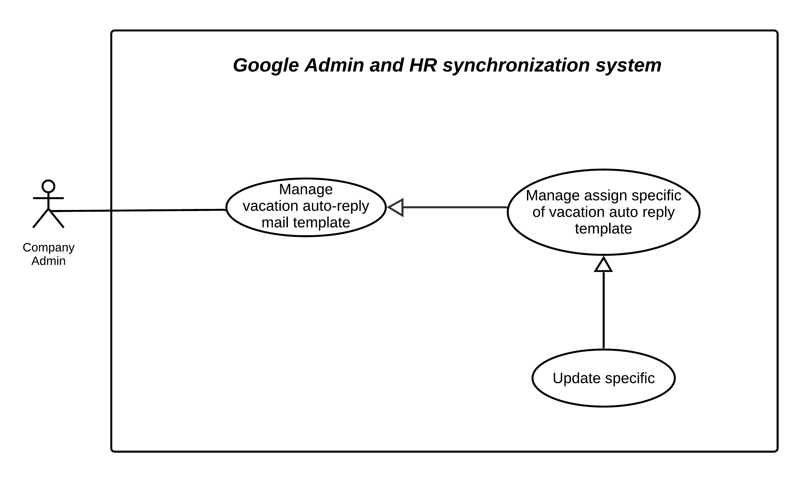

Figure 39 - Update specific of vacation auto-reply mail template

|  |  |  |  |
| --- | --- | --- | --- |
| **USE CASE – GmHRS_C_18** | | | |
| **Use Case No.** | GmHRS_C_18 | **Use Case Version** | 2.0 |
| **Use Case Name** | Update specific of vacation auto-reply mail template | | |
| **Author** | ThanhPV | | |
| **Date** | 24/06/2020 | **Priority** | Normal |
| **Actor:**   * Company Admin.   **Summary:**   * This use case allows Company admin Update specific of vacation auto-reply mail template.   **Goal:**   * System admin can update specific of vacation auto-reply mail template.   **Trigger:**   * Company admin click “Save” button   **Precondition:**   * Specific of vacation auto-reply mail template was created   **Post condition:**   * Success: System update specific of vacation auto-reply mail template success. * Fail: System show error message.   **Main Success Scenario:**   |  |  |  | | --- | --- | --- | | **Step** | **Actor Action** | **System Response** | | 1 | Company admin click “Add row” button | System add a row in table and show:  -Specific by: select  -Value: multiple select  -Template: select  -View: button  -Delete: button | | 2 | Company admin choose information |  | | 3 | Company admin click “View” button | System show modal contain list employee of value that company admin selected | | 4 | Company admin click “Save” button | System will update specific apply and show message. [Exception 1] |   **Alternative Scenario: N/A**  **Exceptions:**   |  |  |  | | --- | --- | --- | | **No** | **Actor Action** | **System Response** | | 1 | Lost internet connection. | System fails to update |   **Relationships:** **N/A**  **Business Rules:**   * If company admin specific apply for employee with more than 1 template, system will consider the priority based on the table to apply * If the employee is not apply specific, the default template will be applied to that employee * Data deleted and saved will not be reverted | | | |

Table 34 - Update specific of vacation auto-reply mail template specification

##### View specific of vacation auto-reply mail detail



Figure 40 - View specific of vacation auto-reply mail template

|  |  |  |  |
| --- | --- | --- | --- |
| **USE CASE – GmHRS_C_18** | | | |
| **Use Case No.** | GmHRS_C_18 | **Use Case Version** | 2.0 |
| **Use Case Name** | Update specific of vacation auto-reply mail template | | |
| **Author** | ThanhPV | | |
| **Date** | 24/06/2020 | **Priority** | Normal |
| **Actor:**   * Company Admin.   **Summary:**   * This use case allows Company admin view specific of vacation auto-reply mail template detail.   **Goal:**   * System admin can view specific of vacation auto-reply mail template detail.   **Trigger:**   * Company admin click “View” button   **Precondition:**   * Company admin has data in table assign specific * Company admin must select column value in table   **Post condition:**   * Success: System show list employee in specific row. * Fail: System show error message.   **Main Success Scenario:**   |  |  |  | | --- | --- | --- | | **Step** | **Actor Action** | **System Response** | | 1 | Company admin click “View” button | System open modal and show list employee:  -Close: button | | 2 | Company admin click “Close” button | Nothing change, system close modal detail. [Exception 1] |   **Alternative Scenario: N/A**  **Exceptions:**   |  |  |  | | --- | --- | --- | | **No** | **Actor Action** | **System Response** | | 1 | Lost internet connection. | System fails to load list employee |   **Relationships:** **N/A**  **Business Rules:**   * Company admin can view detail specific row in table | | | |

Table 35 - View specific of vacation auto-reply mail template specification

##### View schedule job



Figure 41 - <Company admin> View schedule job

|  |  |  |  |
| --- | --- | --- | --- |
| **USE CASE – GmHRS_C_21** | | | |
| **Use Case No.** | GmHRS_C_21 | **Use Case Version** | 2.0 |
| **Use Case Name** | View schedule job | | |
| **Author** | ThanhPV | | |
| **Date** | 24/06/2020 | **Priority** | High |
| **Actor:**   * Company admin.   **Summary:**   * This use case allows Company admin view schedule job.   **Goal:**   * Company admin view schedule job.   **Trigger:**   * Company admin goes to manage schedule page.   **Precondition:**   * Schedule job must be created.   **Post condition:**   * Success: System shows auto-reply mail template information. * Fail: System show error message.   **Main Success Scenario:**   |  |  |  | | --- | --- | --- | | **Step** | **Actor Action** | **System Response** | | 1 | Company admin goes to manage schedule | System show:  -Daily: selected.  -Weekly: selected  -Monthly: selected  -Update: button  -Delete: button |   **Alternative Scenario: N/A**  **Exceptions:**   |  |  |  | | --- | --- | --- | | **No** | **Actor Action** | **System Response** | | 1 | Lost internet connection. | System fail to load schedule job |   **Relationships:** **N/A**  **Business Rules:**   * Company admin can view schedule job | | | |

Table 36 - <Company admin> View schedule job use case specification

##### Create schedule job



Figure 42 - <Company admin> Create schedule job

|  |  |  |  |
| --- | --- | --- | --- |
| **USE CASE – GmHRS_C_22** | | | |
| **Use Case No.** | GmHRS_C_22 | **Use Case Version** | 2.0 |
| **Use Case Name** | Create schedule job | | |
| **Author** | ThanhPV | | |
| **Date** | 24/06/2020 | **Priority** | High |
| **Actor:**   * Company admin.   **Summary:**   * This use case allows Company admin create schedule job.   **Goal:**   * Company admin create schedule job.   **Trigger:**   * In setting, company admin clicks “Schedule Synchronize”.   **Precondition:**   * Validate” database connection” or” API Endpoint” successfully. * Validate “Config G-suite Authentication” successfully   **Post condition:**   * Success: Schedule job must be created. * Fail: System show error message.   **Main Success Scenario:**   |  |  |  | | --- | --- | --- | | **Step** | **Actor Action** | **System Response** | | 1 | Company admin click “Schedule synchronize” tag | System show: step 1  -Choose day: selected. | | 2 | Company admin select items in “Choose day” |  | | 3 | Company admin click “Next” button | System show | | 4 | Company click “Back” button | System back to step 1 | | 5 | Company admin click “Submit” | System show: step 3  -Setting up schedule synchronize successfully. [Exception 1] |   **Alternative Scenario: N/A**  **Exceptions:**   |  |  |  | | --- | --- | --- | | **No** | **Actor Action** | **System Response** | | 1 | Lost internet connection. | System fail to submit schedule job |   **Relationships:** **N/A**  **Business Rules:**   * Company admin can select one or more days in week. * Company admin only choose a specific time to apply for days in week. | | | |

Table 37 - <Company admin> Create schedule job use case specification

##### Update schedule job



Figure 43 - <Company admin>Update schedule job

|  |  |  |  |
| --- | --- | --- | --- |
| **USE CASE – GmHRS_C_23** | | | |
| **Use Case No.** | GmHRS_C_23 | **Use Case Version** | 2.0 |
| **Use Case Name** | Update schedule job | | |
| **Author** | ThanhPV | | |
| **Date** | 24/06/2020 | **Priority** | High |
| **Actor:**   * Company admin.   **Summary:**   * This use case allows Company admin update schedule job.   **Goal:**   * Company admin update schedule job.   **Trigger:**   * Company admin goes to manage schedule page.   **Precondition:**   * Schedule job must be created.   **Post condition:**   * Success: Schedule job must be updated. * Fail: System show error message.   **Main Success Scenario:**   |  |  |  | | --- | --- | --- | | **Step** | **Actor Action** | **System Response** | | 1 | Company Admin goes to manage schedule | System shows:  -Daily: selected.  -Weekly: selected  -Monthly: selected  -Update: button  -Delete: button | | 2 | Company Admin update information |  | | 3 | Company Admin click “Update” button | System show popup:  -OK: button  -Close: button | | 4 | Company Admin click “Close” button | Close popup, nothing changes | | 5 | Company Admin click “OK” button | System closes popup and update information |   **Alternative Scenario: N/A**  **Exceptions:**   |  |  |  | | --- | --- | --- | | **No** | **Actor Action** | **System Response** | | 1 | Lost internet connection. | System fail to load schedule job |   **Relationships:** **N/A**  **Business Rules:**   * Company admin can update schedule job * Company admin can select one or more days in week. * Company admin only choose a specific time to apply for days in week. | | | |

Table 38 - <Company admin> Update schedule job use case specification

##### Execute synchronization manually



Figure 44 - <Company admin> Execute synchronization manually

|  |  |  |  |
| --- | --- | --- | --- |
| **USE CASE – GmHRS_C_24** | | | |
| **Use Case No.** | GmHRS_C_24 | **Use Case Version** | 2.0 |
| **Use Case Name** | Execute synchronization manually | | |
| **Author** | SonNC, ThongND | | |
| **Date** | 24/06/2020 | **Priority** | High |
| **Actor:**   * Company admin.   **Summary:**   * This use case allows Company admin Execute synchronization manually.   **Goal:**   * Company admin Execute synchronization manually.   **Trigger:**   * Company admin click button “Synchronize” in modal preview.   **Precondition:**   * Validate “database connection” or “API Endpoint” successfully. * Validate “Config G-suite Authentication” successfully.   **Post condition:**   * Success Execute synchronization manually successfully. * Fail: System show error message.   **Main Success Scenario:**   |  |  |  | | --- | --- | --- | | **Step** | **Actor Action** | **System Response** | | 1 | Company admin click icon synchronize at top right page. | System show modal show time at last synchronize and button “Synchronize” | | 2 | Company Admin click button “Synchronize” | System show modal for preview after comparing data, includes button “Synchronize now” and button “Close” | | 3 | Company Admin selects item that want to synchronize (selected all is default). Then clicks “Synchronize now” | Modal for preview close when synchronize completed. | | 4 | Company click button “Close” | Modal for preview data close |   **Alternative Scenario: N/A**  **Exceptions:**   |  |  |  | | --- | --- | --- | | **No** | **Actor Action** | **System Response** | | 1 | Lost internet connection. | System fail to Execute Synchronization manually and show message “Connection time out” | | 2 | G Suite API or HRMS API have error occurring | System fail to Execute Synchronization manually and show message “Synchronize failed”. |   **Relationships:** **N/A**  **Business Rules:**   * Company admin can Execute synchronization manually * In the first synchronize, company admin must synchronize manually * At first synchronize, after Admin Company click “Execute Synchronization”, system will show the data after comparing between HRMS and G-suite to Admin Company confirm. * At second synchronize, after Admin Company click “Execute Synchronization”, system will show the data after comparing between HRMS and GmHRS to Admin Company confirm. * After Admin Company confirm the the data after comparing, synchronize manually officially implemented * After synchronize successfully. Information of team, department and employee can view in the system | | | |

Table 39 - <Company admin> Execute synchronization manually use case specification

##### Activate two factor authentications

##### Deactivate two factor authentications

##### Use two factor authentication to login

#### <System handler> Overview Use Case

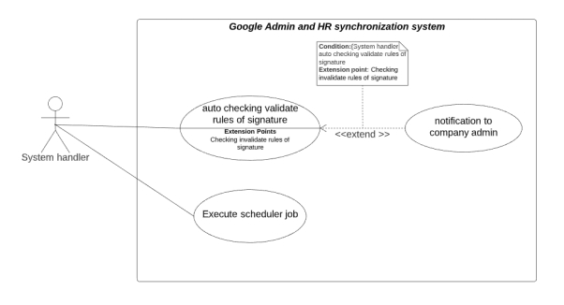

Figure 45 - <System handler> Overview Use Case

##### Auto checking validate rules of signature

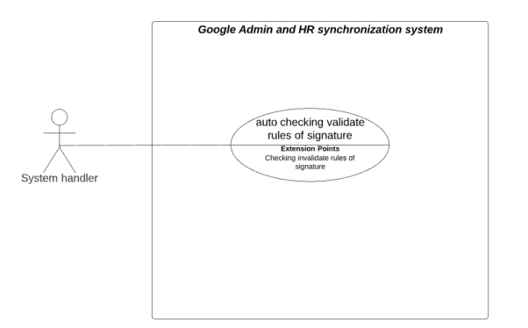

Figure 46 - <System handler> Auto checking validate rules of signature

|  |  |  |  |
| --- | --- | --- | --- |
| **USE CASE – GmHRS_H_1** | | | |
| **Use Case No.** | GmHRS_H_1 | **Use Case Version** | 2.0 |
| **Use Case Name** | Auto checking validate rules of signature | | |
| **Author** | ThanhPV | | |
| **Date** | 24/06/2020 | **Priority** | High |
| **Actor:**   * System handler.   **Summary:**   * This use case allows System handler Auto checking validate rules of signature.   **Goal:**   * System handler can Auto checking validate rules of signature.   **Trigger:**   * Employee change their signature template.   **Precondition:**   * Employee change their signature template.   **Post condition:**   * Success: System handler can auto checking validate signature through the rule * Fail: System show error message.   **Main Success Scenario:**   |  |  |  | | --- | --- | --- | | **Step** | **Actor Action** | **System Response** | | 1 | Change signature template from Gmail setting | System receive trigger from G-suite API |   **Alternative Scenario: N/A**  **Exceptions:**   |  |  |  | | --- | --- | --- | | **No** | **Actor Action** | **System Response** | | 1 | Lost connection | Auto checking validate signature fail |   **Relationships:** **N/A**  **Business Rules:**   * When signature template was modified by employee. System will receive trigger from g-suite to get information was updated * If information was updated validate with signature rule. Updates are accepted * If information was updated invalidate with signature rule. System will send notification to company admin | | | |

Table 40 - <System handler> Auto checking validate rules of signature use case specification

##### Notification to company admin

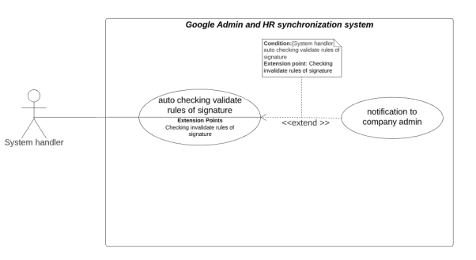

Figure 47 - <System handler> Notification to company admin

|  |  |  |  |
| --- | --- | --- | --- |
| **USE CASE – GmHRS_H_2** | | | |
| **Use Case No.** | GmHRS_H_2 | **Use Case Version** | 2.0 |
| **Use Case Name** | Notification to company admin | | |
| **Author** | ThanhPV | | |
| **Date** | 24/06/2020 | **Priority** | High |
| **Actor:**   * System handler   **Summary:**   * This use case allows System handler notification to company admin   **Goal:**   * Company admin receive notification.   **Trigger:**   * Invalidate update signature temple from employee.   **Precondition:**   * System checking update signature template invalidate.   **Post condition:**   * Success: Company admin receive notification * Fail: System show error message.   **Main Success Scenario:**   |  |  |  | | --- | --- | --- | | **Step** | **Actor Action** | **System Response** | | 1 | System receive invalid information updated |  | | 2 | System send notification to company admin |  |   **Alternative Scenario: N/A**  **Exceptions:**   |  |  |  | | --- | --- | --- | | **No** | **Actor Action** | **System Response** | | 1 | Lost connected | Fail to send notification to company admin |   **Relationships:** **N/A**  **Business Rules: N/A** | | | |

Table 41 - <System handler> Notification to company admin use case specification

##### Execute schedule job

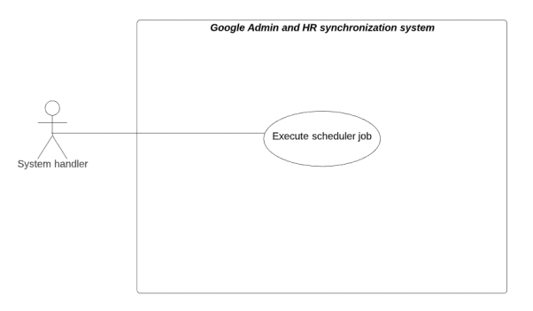

Figure 48 - <System handler> Execute schedule job

|  |  |  |  |
| --- | --- | --- | --- |
| **USE CASE – GmHRS_H_3** | | | |
| **Use Case No.** | GmHRS_H_3 | **Use Case Version** | 2.0 |
| **Use Case Name** | Execute synchronization job | | |
| **Author** | ThanhPV | | |
| **Date** | 24/06/2020 | **Priority** | High |
| **Actor:**   * System handler.   **Summary:**   * This use case allows System handler can execute schedule job.   **Goal:**   * System can execute schedule job.   **Trigger:**   * On time action execute job.   **Precondition:**   * Validate “connection string” or “API Endpoint”. * Validate “Config G-suite Authentication”. * Setting “Schedule synchronization” successfully.   **Post condition:**   * Success: System must be synchronized successfully. * Fail: System show error message.   **Main Success Scenario:**   |  |  |  | | --- | --- | --- | | **Step** | **Actor Action** | **System Response** | | 1 | System handler send request to G-suite API | System receive status | | 2 | System send status |  |   **Alternative Scenario: N/A**  **Exceptions:**   |  |  |  | | --- | --- | --- | | **No** | **Actor Action** | **System Response** | | 1 | Lost connection | Execute synchronize fail |   **Relationships:** **N/A**  **Business Rules: N/A** | | | |

Table 42 - <System handler> Execute schedule job use case specification

#### <Authorized User> Overview Use Case



Figure 49 - <Authorized User> Overview Use Case

##### Sig out



Figure 50 - Sig out

|  |  |  |  |
| --- | --- | --- | --- |
| **USE CASE – GmHRS_C_25** | | | |
| **Use Case No.** | GmHRS_C_25 | **Use Case Version** | 2.0 |
| **Use Case Name** | Log out | | |
| **Author** | ThanhPV | | |
| **Date** | 24/06/2020 | **Priority** | High |
| **Actor:**   * Company admin.   **Summary:**   * This use case allows Authorized User sig out.   **Goal:**   * Authorized User stops accessing the system.   **Trigger:**   * Authorized User click “Log out” button.   **Precondition:**   * Unauthorized User logged into the system with role “Company Admin”.   **Post condition:**   * Success: Account is sig out successfully * Fail: System show error message.   **Main Success Scenario:**   |  |  |  | | --- | --- | --- | | **Step** | **Actor Action** | **System Response** | | 1 | Company admin click “Sig out” button | The action would terminate the user session and delete user token.  The authenticated user navigated to the homepage. [Exception 1] |   **Alternative Scenario: N/A**  **Exceptions: N/A**  **Relationships:** **N/A**  **Business Rules:**   * User must be authenticated user. * After logout successfully, all role become “Unauthorized User” and redirect to login page | | | |

## **Software System Attribute**

### **Usability**

* + 1. ***Graphic User Interface***
  + GUI for web application is designed based on material UI.
  + Web application content will be written by the English.
  + Some actions are represented by icons instead of texts.
  + Some simple forms are represented by dialogs instead of new pages.
    1. ***Usability***
  + 80% of users can use it after 2 hours of training.

### Reliability

* The information storing on the database is permanent.
* The data should be backed up periodically.
* The account password should be hashed before saving.

### Availability

* The system 99% up time.

### Security

* Input data is validated before handling to data.
* Each signed-in user will create a session, which limits certain time in the system.
* Each user has a permission to access to the system by their role.
* Support two factor authentication.

### Maintainability

* The system is divided into separate modules for easy maintain.

### Portability

* Web application can be run on Chrome browser version 83 or later.

### Performance

* Requests from users are responded in less than 10 seconds at 5 Mbps bandwidth speed.



## Conceptual Diagram

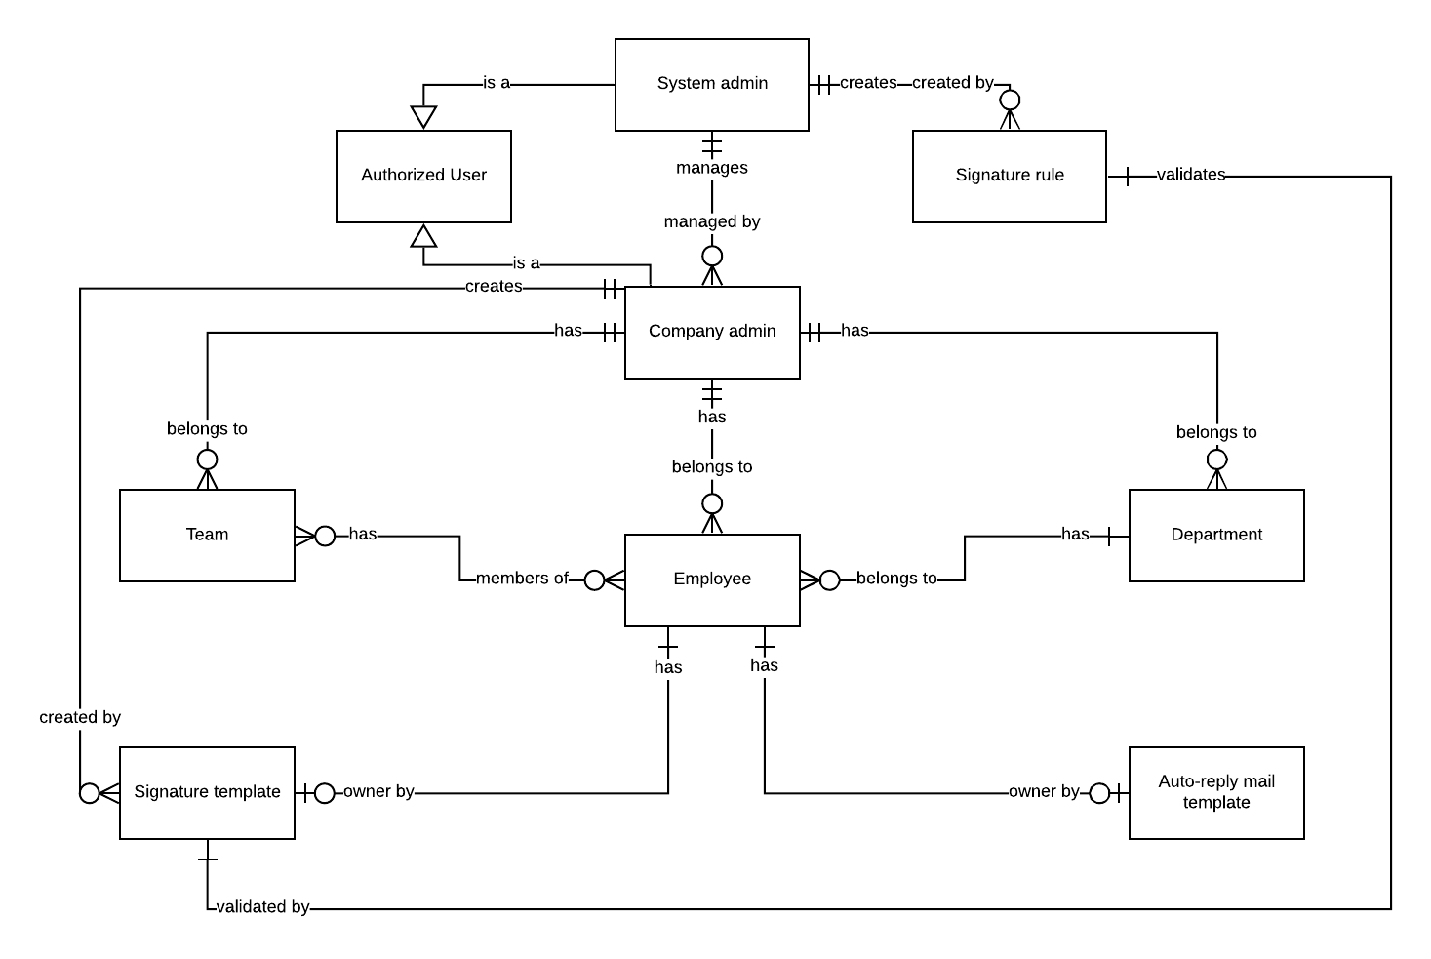

Figure 51 - Conceptual Diagram



# D. Software Design Description

## Design Overview

* This document describes the technical and user interface design of GmHRS System. It includes the architectural design, the detailed design of common functions and business functions and the design of database model.
* The architectural design describes the overall architecture of the system and the architecture of each main component and subsystem.
* The detailed design describes static and dynamic structure for each component and functions. It includes class diagrams, class explanations and sequence diagrams for each use cases.
* The database design describes the relationships between entities and details of each entity
* Document overview:
* Section 1: gives an overall description of the system architecture design
* Section 2: gives component diagrams that describe the connection and integration of the system.
* Section 3: gives the detail design description which includes class diagram, class explanation, and sequence diagram to details the application functions.
* Section 4: describe screens design.
* Section 5: describe a fully attributed ERD.
* Section 6: describe algorithms.

## System Architectural Design



Figure 52 - System Architectural Design

### Web Application Architectural Description

In the client side, we choose Angular because:

* Improve the productivity of the programmers
* Clear development structure
* Angular is easy to maintain isolated components

In the server side, we choose NodeJS because

* Receive and process multiple connections with a single thread. This helps the system consume the least amount of RAM and run fastest when not having to create new threads for each query
* Non-blocking, I/O helps make the most of server resources without creating latency

## Component Diagram

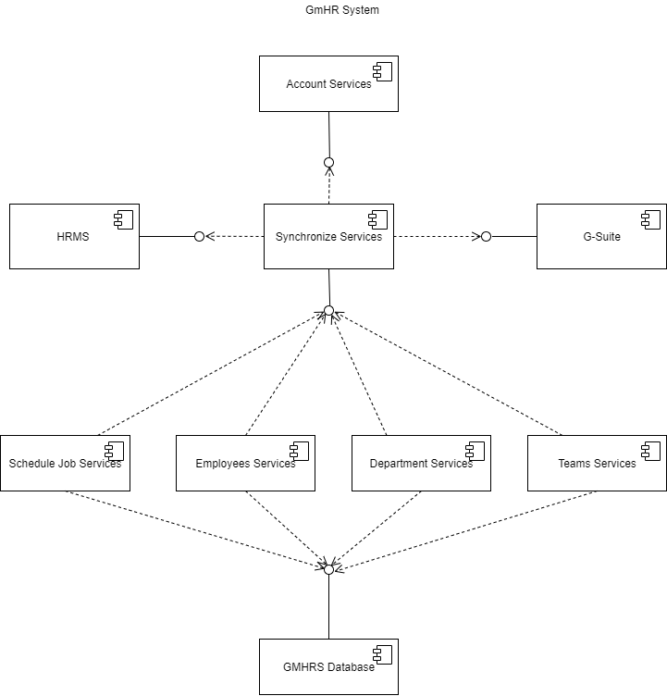

Figure 53 - Component Diagram

|  |  |
| --- | --- |
| COMPONENT DICTIONARY: DESCRIBES COMPONENTS | |
| Account Services | Provide API for manage account company manager. |
| Synchronize Services | Provide API for synchronize data between Company and G-Suite. |
| HRMS API Component | Connect to database of company and create API endpoint for synchronize process |
| G-Suite | Provide function for get data from G-Suite by using G-Suite API. |
| Schedule Job Service | Provide API for manage schedule job like on/off and change time synchronize. |
| Employees Services | Provide API for manage employees by work directly with GmHRS Database. |
| Teams Services | Provide API for manage teams by work directly with GmHRS Database. |
| Departments Services | Provide API for manage department by work directly with GmHRS Database. |

Table 43 - Component Diagram dictionary

## Detailed Description

### Class diagram

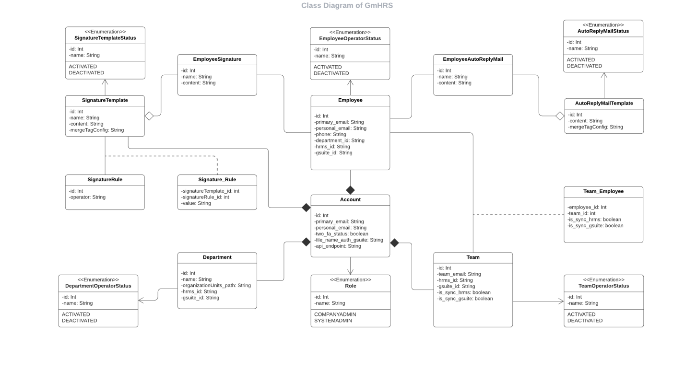

Figure 54: Class Diagram

### Class Dictionary

|  |  |  |
| --- | --- | --- |
| Class dictionary: describe Class | | |
| Class Name | Mapping column with Conceptual diagram | Description |
| Account | Account | Contain the Account Information |
| Employee | Employee | Contain the Employee Information |
| EmployeeOperatorStatus | N/A | Contain the status of Employee |
| Team | Team | Contain the Team Information |
| TeamOperatorStatus | N/A | Contain the status of Team |
| Department | Department | Contain the Department Information |
| DepartmentOperatorStatus | N/A | Contain the status of Department |
| Role | Role | Contain the Role Information |
| EmployeeSignature | N/A | Contain the Signature of Employee |
| SignatureTemplate | N/A | Contain the Signature Template Information |
| SignatureRule | Signature Rule | Contain the Rule of Signature Information |
| Signature_Rule | N/A | Contain the SignatureTemplate and SignatureRule Information |
| SignatureTemplateStatus | N/A | Contain the status of SignatureTemplate |
| EmployeeAutoReplyMail | N/A | Contain the Auto Reply Mail of Employee |
| AutoReplyMailTemplate | Auto Reply Mail Template | Contain the Auto Replay Mail Template Information |
| AutoReplyMailStatus | N/A | Contain the status of AutoReplyMail |
| Team_Employee | N/A | Contain Team and Employee Information |

Table 44 - Class Dictionary

### Class Diagram Explanation

#### Account

|  |  |  |  |
| --- | --- | --- | --- |
| Attribute | Type | Visibility | Description |
| id | int | Private | Unique identifier of an Account |
| primary_email | String | Private | The Primary Email of Account |
| personal_email | String | Private | The Personal email of Account |
| two_fa_status | String | Private | 2 Factor Authentication of Account |
| file_name_auth_gsuite | String | Private | The Name JOSN file of Account |
| api_endpoint | String | Private | The API Endpoint of Account |

Table 45- Account Attribute

#### Employee

|  |  |  |  |
| --- | --- | --- | --- |
| Attribute | Type | Visibility | Description |
| id | int | Private | Unique identifier of an Employee |
| primary_email | String | Private | The Primary Email of Employee |
| personal_email | String | Private | The Personal Email of Employee |
| phone | String | Private | The Phone of Employee |
| department_id | String | Private | The Department of Employee |
| hrms_id | String | Private | Employee id of company from HRMS |
| gsuite_id | string | Private | The G-Suite id of Employee |

Table 46 - Employee Attribute

#### EmployeeOperatorStatus

|  |  |  |  |
| --- | --- | --- | --- |
| Attribute | Type | Visibility | Description |
| id | int | Private | Unique identifier of an Employee Status |
| name | String | Private | The Name of Employee Status |

Table 47 - EmployeeOperatorStatus Attribute

#### Team

|  |  |  |  |
| --- | --- | --- | --- |
| Attribute | Type | Visibility | Description |
| id | int | Private | Unique identifier of a Team |
| team_mail | String | Private | The Email of Team |
| hrms_id | String | Private | Team id of company from HRMS |
| gsuite_id | String | Private | G-Suite id of Team |
| is_sync_hrms | boolean | Private | Synchronized Team from HRMS |
| is_sync_gsuite | boolean | Private | Synchronized Team from G-Suite |

Table 48 - Team Attribute

#### TeamOperatorStatus

|  |  |  |  |
| --- | --- | --- | --- |
| Attribute | Type | Visibility | Description |
| id | int | Private | Unique identifier of an Employee Status |
| name | String | Private | The Name of Team Status |

Table 49 - TeamOperatorStatus Attribute

#### Department

|  |  |  |  |
| --- | --- | --- | --- |
| Attribute | Type | Visibility | Description |
| id | int | Private | Unique identifier of a Department |
| name | String | Private | The Name of Department |
| organizationUnits_path | String | Private | The Name of Subsidiaries |
| hrms_id | String | Private | Synchronized Team from HRMS |
| gsuite_id | String | Private | Synchronized Team from G-Suite |

Table 50 - Department Attribute

#### DepartmentOperatorStatus

|  |  |  |  |
| --- | --- | --- | --- |
| Attribute | Type | Visibility | Description |
| id | int | Private | Unique identifier of a Department Status |
| name | String | Private | The Name of Department Status |

Table 51 - DepartmentOperatorStatus Attribute

#### Role

|  |  |  |  |
| --- | --- | --- | --- |
| Attribute | Type | Visibility | Description |
| id | int | Private | Unique identifier of a Role |
| name | String | Private | The Name of Department Status |

Table 52 - Role Attribute

#### EmployeeSignature

|  |  |  |  |
| --- | --- | --- | --- |
| Attribute | Type | Visibility | Description |
| id | int | Private | Unique identifier of a Role |
| name | String | Private | The Name of Department Status |
| content | String | Private | The Content of Employee Signature |

Table 53 - EmployeeSignature Attribute

#### SignatureTemplate

|  |  |  |  |
| --- | --- | --- | --- |
| Attribute | Type | Visibility | Description |
| id | int | Private | Unique identifier of a Role |
| name | String | Private | The Name of Department Status |
| content | String | Private | The Content of Signature Template |
| mergeTagConfig | String | Private | The String that contain Name, Email of Employee |

Table 54 – SignatureTemplate Attribute

#### SignatureRule

|  |  |  |  |
| --- | --- | --- | --- |
| Attribute | Type | Visibility | Description |
| id | int | Private | Unique identifier of a Signature Rule |
| operator | int | Private | The value of Signature Rule |

Table 55 – SignatureRule Attribute

#### Signature_Rule

|  |  |  |  |
| --- | --- | --- | --- |
| Attribute | Type | Visibility | Description |
| signatureTemplate_id | int | Private | Unique identifier of a Signature Template |
| signatureRule_id | int | Private | Unique identifier of a Signature Rule |
| content | String | Private | The Content of SignatureRule |

Table 56 - Signature_Rule Attribute

#### SignatureTemplateStatus

|  |  |  |  |
| --- | --- | --- | --- |
| Attribute | Type | Visibility | Description |
| id | int | Private | Unique identifier of a Signature Template Status |
| name | String | Private | The Name of Signature Template Status |

Table 57 - SignatureTemplateStatus Attribute

#### EmployeeAutoReplyMail

|  |  |  |  |
| --- | --- | --- | --- |
| Attribute | Type | Visibility | Description |
| id | int | Private | Unique identifier of a Signature Template Status |
| name | String | Private | The Name of Signature Template Status |
| content | String | Private | The Content of Employee signature |

Table 58 - EmployeeAutoReplyMail Attribute

|  |  |  |  |
| --- | --- | --- | --- |
| **Method** | **Return Type** | **Visibility** | **Description** |
| Getter | Attribute type | Public | Get attribute value. |
| Setter | Void | Public | Set value of attribute. |

Table 59 - EmployeeAutoReplyMail Method

#### AutoReplyMailTemplate

|  |  |  |  |
| --- | --- | --- | --- |
| Attribute | Type | Visibility | Description |
| id | int | Private | Unique identifier of a Auto Reply Mail Template |
| content | String | Private | The Content of Auto Reply Mail Template |
| mergeTagConfig | String | Private | The String that contain Name, Email of Employee |

Table 60 – AutoReplyMailTemplate Attribute

#### AutoReplyMailStatus

|  |  |  |  |
| --- | --- | --- | --- |
| Attribute | Type | Visibility | Description |
| id | int | Private | Unique identifier of an Auto Reply Mail Template |
| name | String | Private | The Name of Auto Reply Mail Template |

Table 61 – AutoReplyMailStatus Attribute

#### Team_Employee

|  |  |  |  |
| --- | --- | --- | --- |
| Attribute | Type | Visibility | Description |
| employee_id | int | Private | Unique identifier of an Employee |
| team_id | String | Private | Unique identifier of a Team |
| is_sync_hrms | boolean | Private | Synchronized Employee from HRMS |
| is_sync_gsuite | boolean | Private | Synchronized Employee from G-Suite |

Table 62 - Team_Employee Attribute

### Interaction Diagram

#### View employee list



Figure 55 - < Sequence Diagram> - View employee list

#### View department list



Figure 56 - < Sequence Diagram>View department list

#### View team list



Figure 57 - < Sequence Diagram>View team list

#### View account company list



Figure 58 - < Sequence Diagram>View list account company

#### Create account company



Figure 59 - < Sequence Diagram>Create account company

#### Create signature rule



Figure 60 - < Sequence Diagram> Create signature rule

#### View schedule job



Figure 61 - < Sequence Diagram>View schedule job

#### Save schedule job

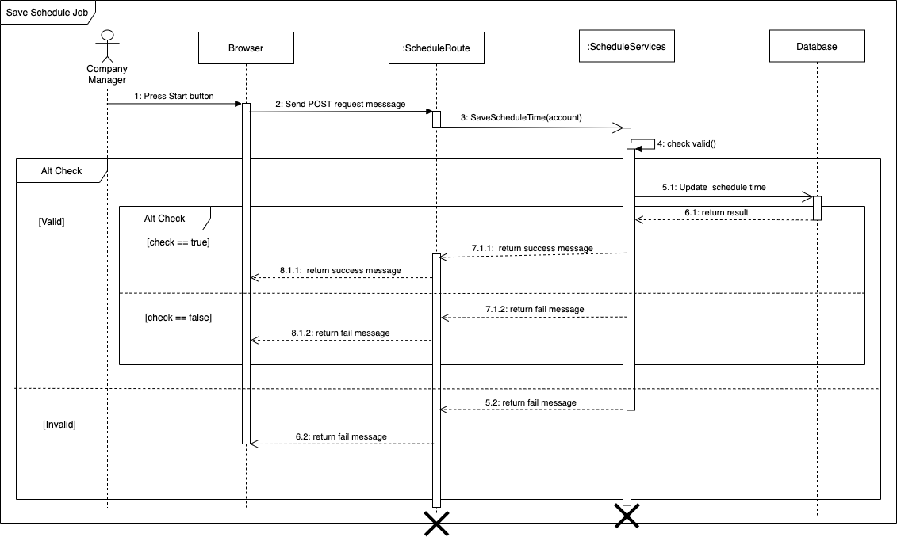

Figure 62 - < Sequence Diagram> Save schedule job

#### Start schedule job

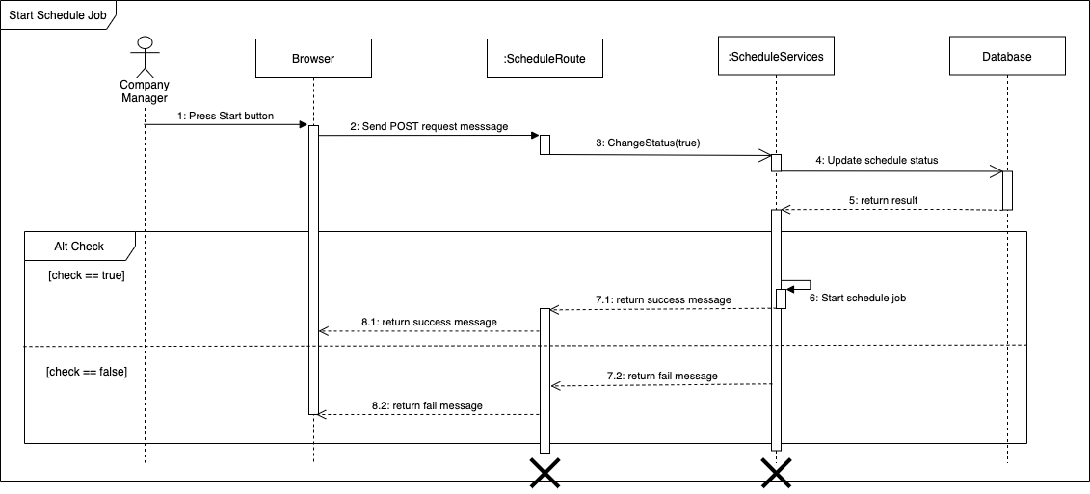

Figure 63 - < Sequence Diagram> Start schedule job

#### Execute synchronization manually



Figure 64 - <Sequence Diagram>Execute synchronization manually

#### Delete signature rule

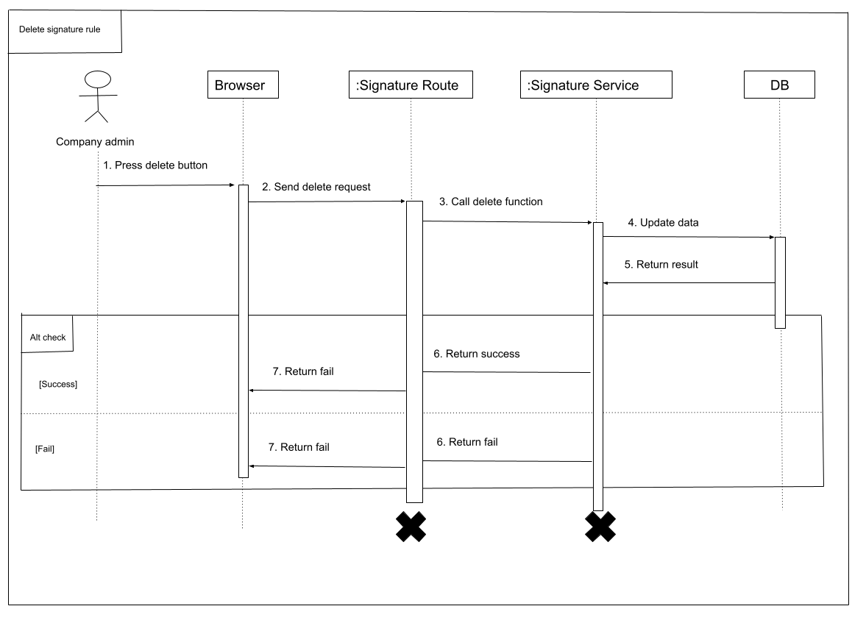

Figure 65 - <Sequence Diagram>Delete signature rule

#### Delete signature

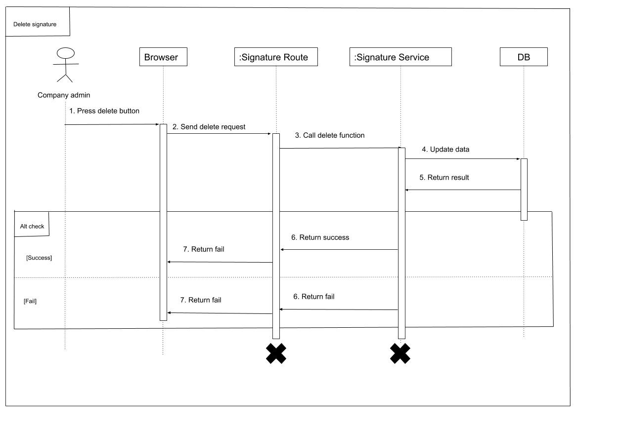

Figure 66 - <Sequence Diagram>Delete signature

#### Get wrong signature employee

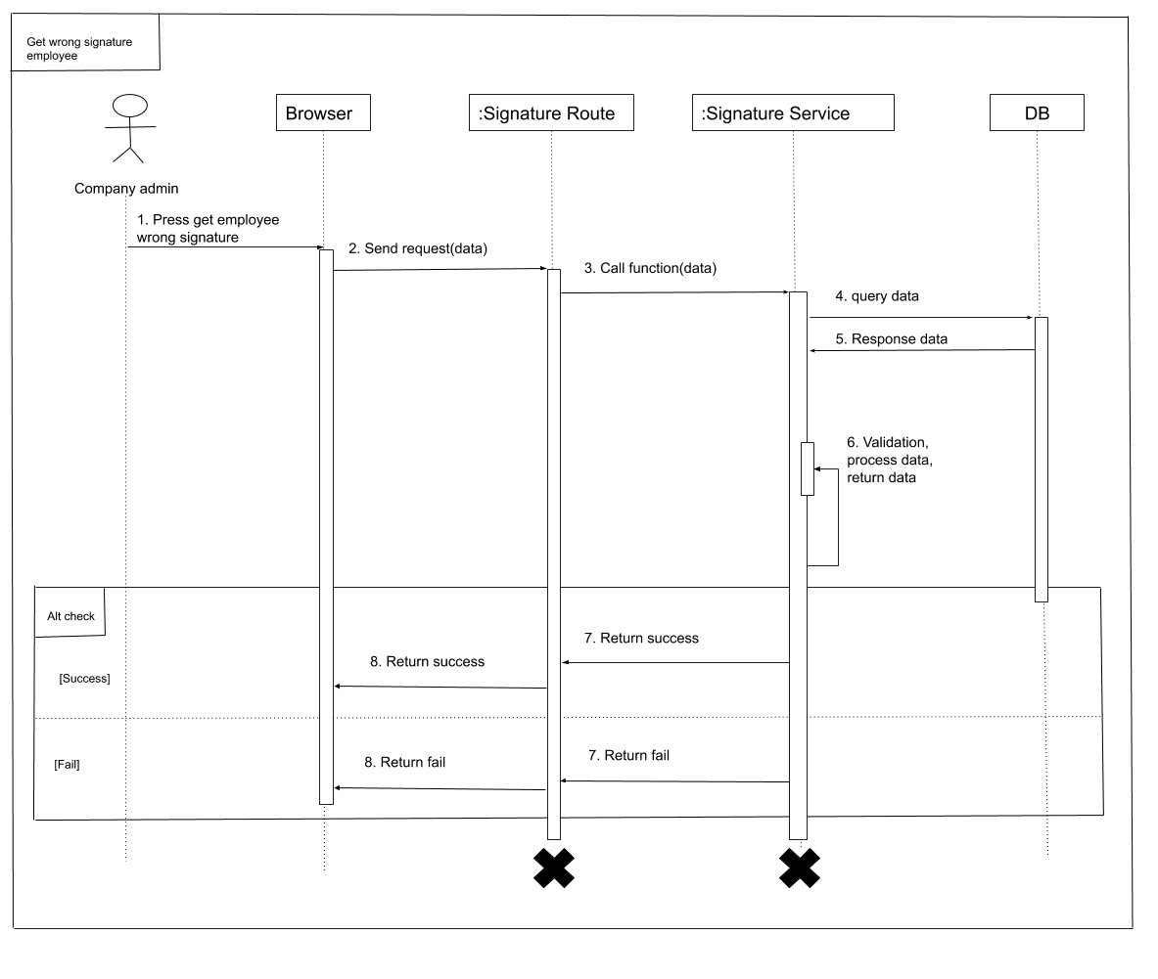

Figure 67 - <Sequence Diagram> Get wrong signature employee

#### Save signature rule

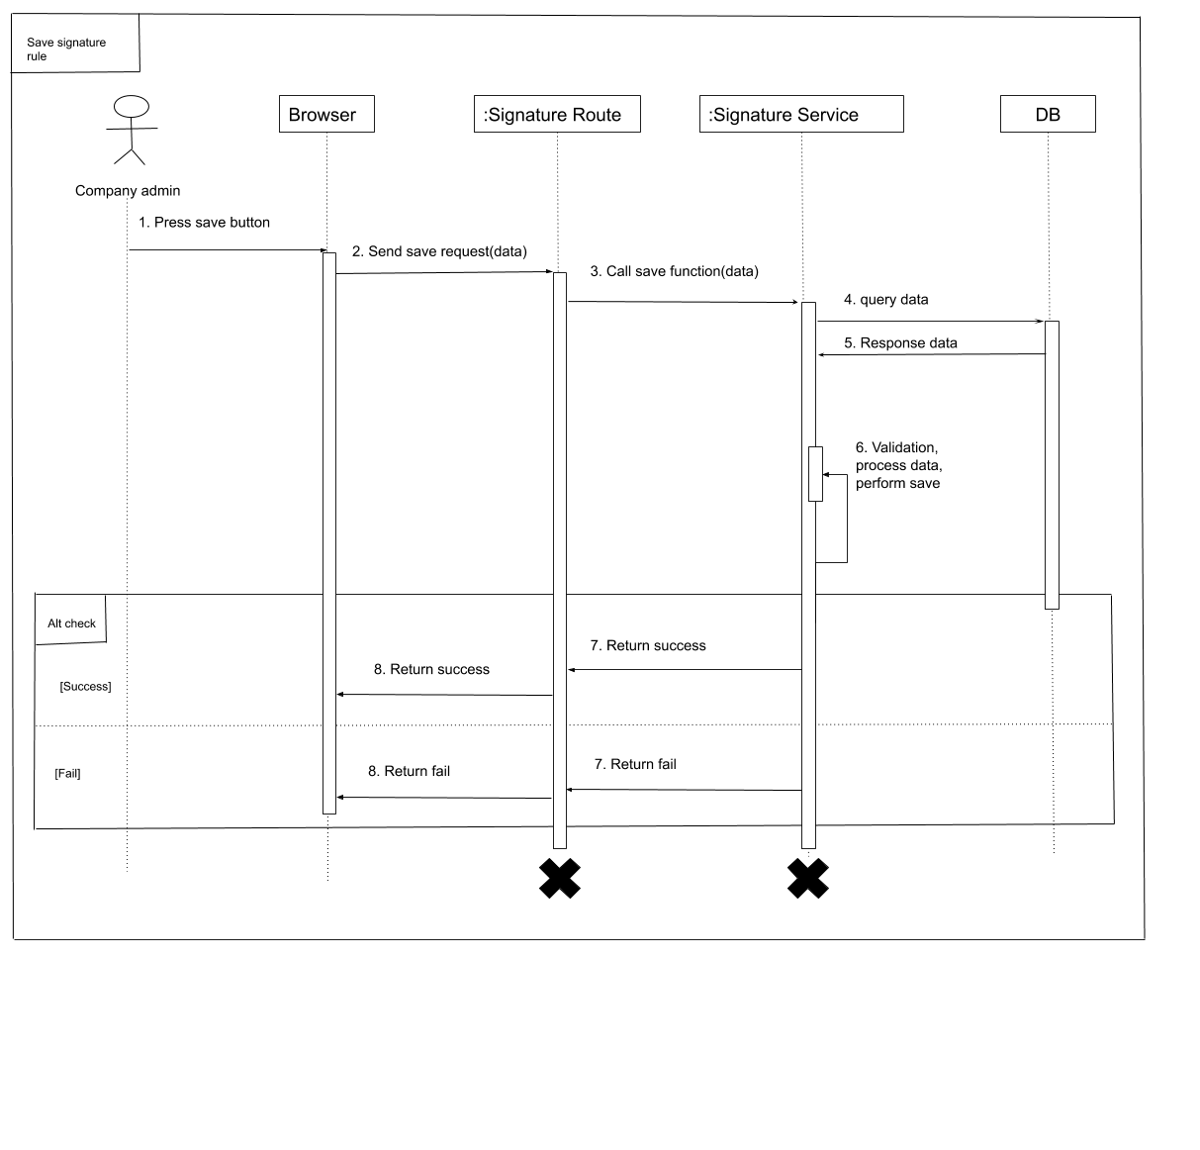

Figure 68 - <Sequence Diagram> Save signature rule

#### Save signature

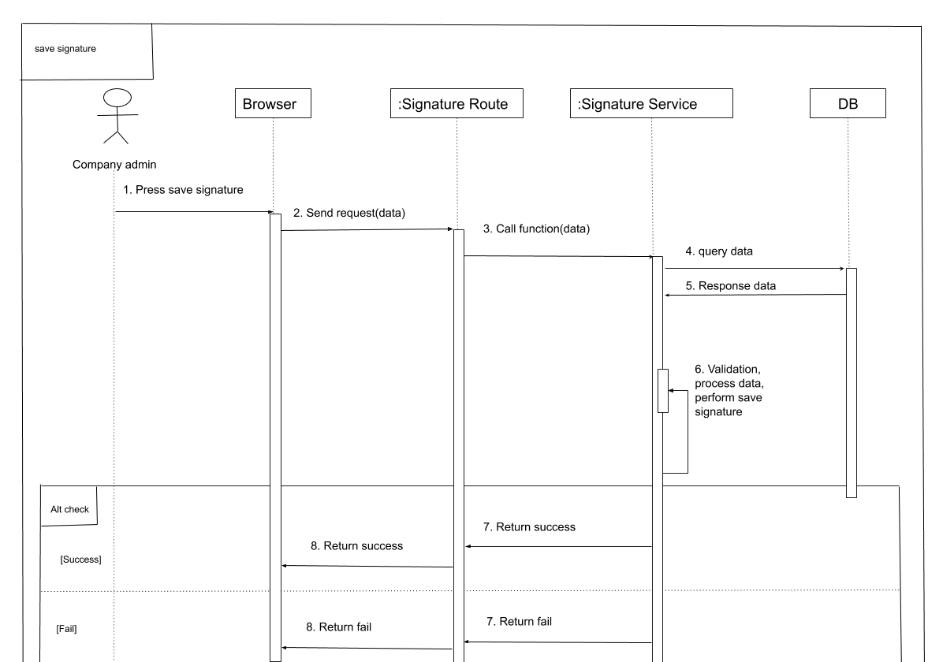

Figure 69 - <Sequence Diagram> Save signature

#### Send notify about rule to employee

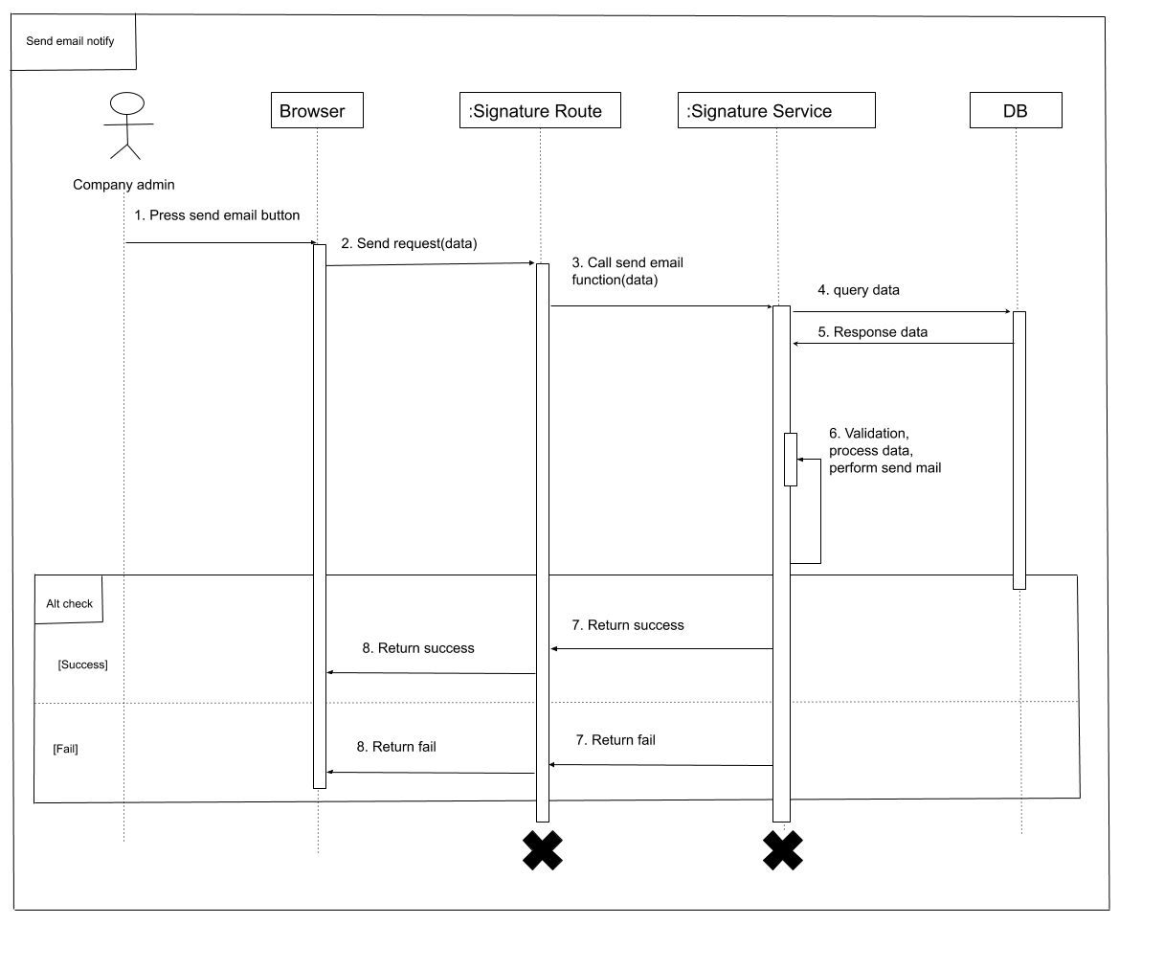

Figure 70- <Sequence Diagram> Send notify about rule to employee

#### Send mail to wrong signature employee

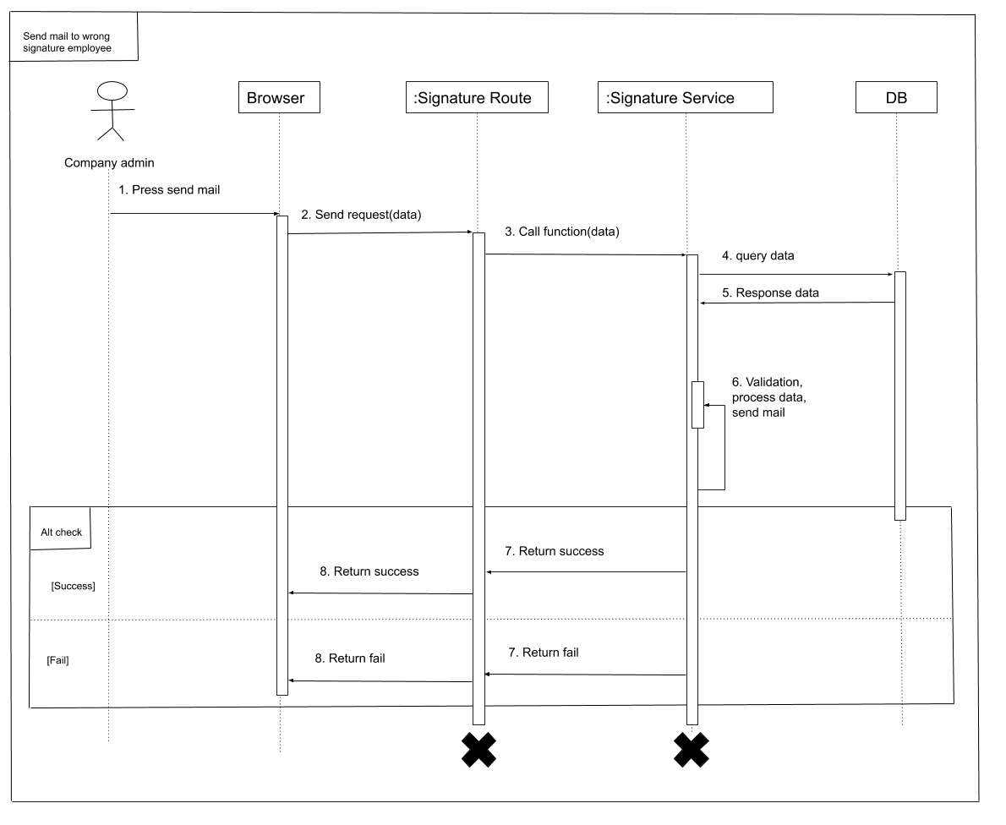

Figure 71 - <Sequence Diagram> Send mail to wrong signature employee

#### Specific apply signature

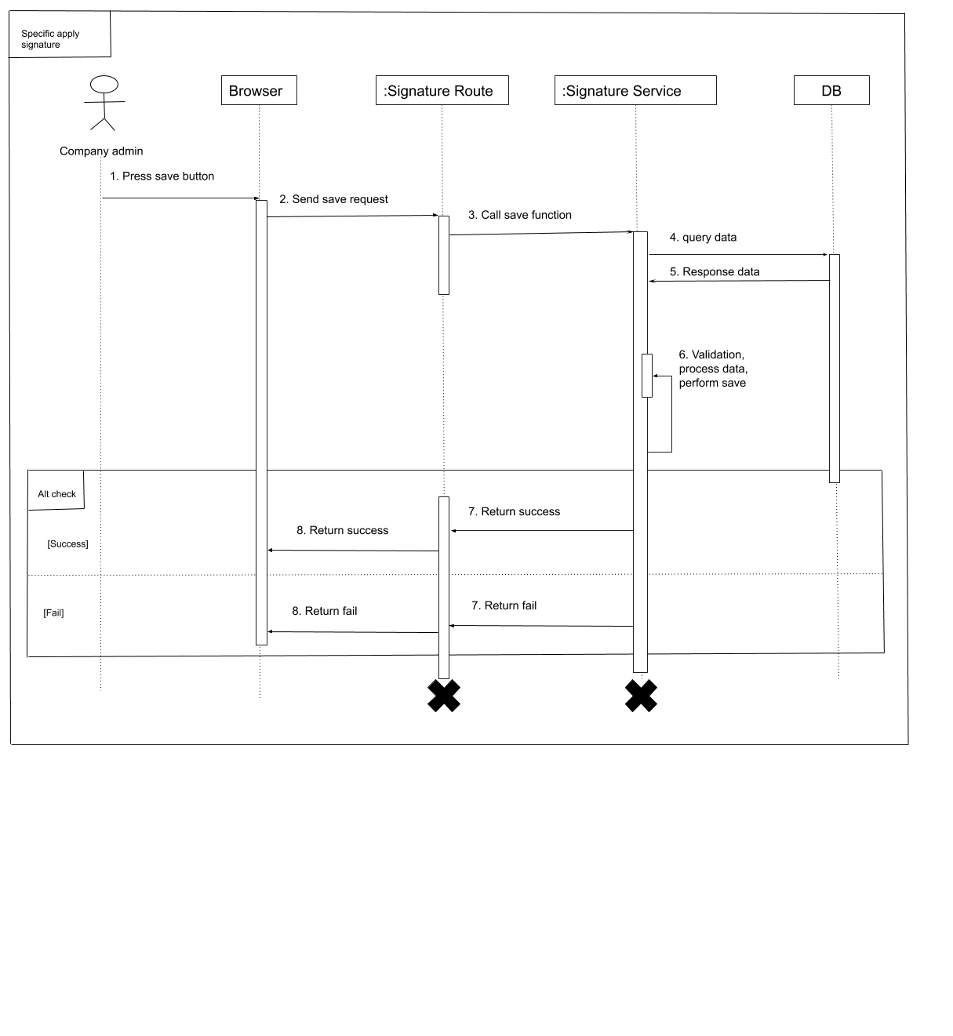

Figure 72 - <Sequence Diagram> Specific apply signature

#### Update signature for employee

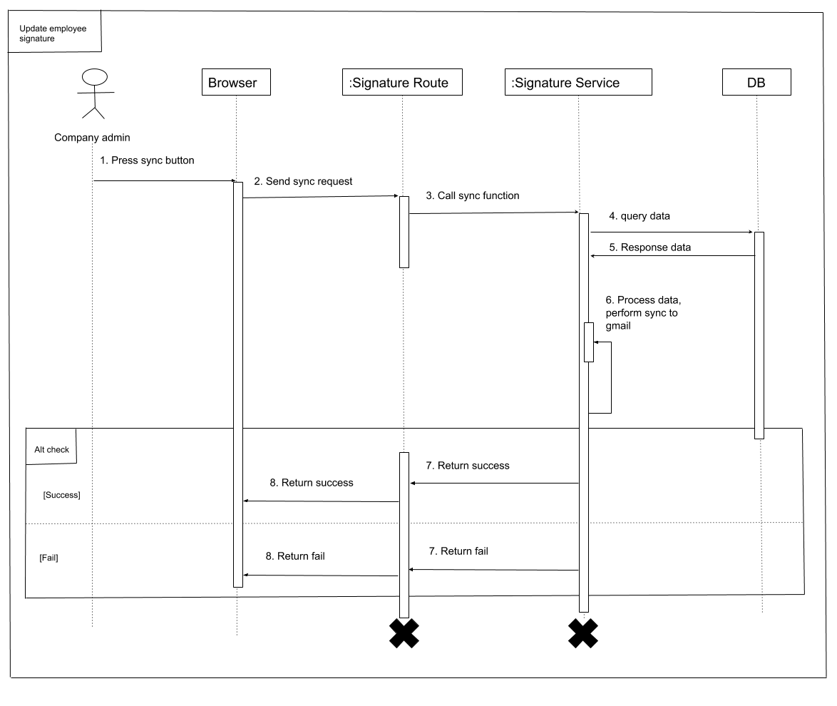

Figure 73 - <Sequence Diagram> Update signature for employee

#### Update signature for only wrong signature employee

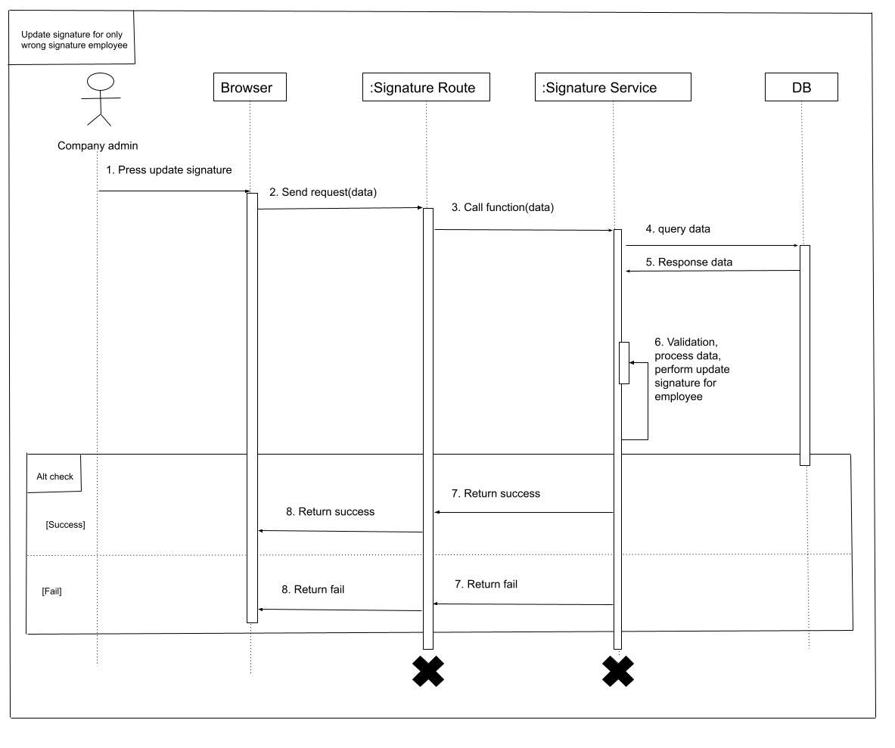

Figure 74 - <Sequence Diagram>Update signature for only wrong signature employee

#### Approve access by phone



Figure 75 - <Activity Diagram> Approve access by phone

#### Load Home Screen



Figure 76 - <Activity Diagram> Load home screen

#### Scan QR



Figure 77 - <Activity Diagram> Scan QR

## Interface

### Unauthorized user

#### Login



Figure 78 - <Guest> Login interface

Fields

|  |  |  |  |  |  |  |
| --- | --- | --- | --- | --- | --- | --- |
| **No** | **Field Name** | **Description** | **Read only** | **Mandatory** | **Control Type** | **Data Type** |
| 1 | Username | Username to login | No | Yes | Field input | String |
| 2 | Password | Password to login | No | Yes | Field input | String |

Table 63 - <Fields> Login

Buttons/Hyperlinks

|  |  |  |  |  |
| --- | --- | --- | --- | --- |
| **No** | **Function** | **Description** | **Validation** | **Outcome** |
| 3 | Login | Login into the system | Required | Transfer to home page |
| 5 | Register Account | Register to the system | N/A | Transfer to register view |
| 4 | Forgot Password | User forgot password | N/A | Transfer to forgot password view |

Table 64 - <Buttons/Hyperlinks> Login

#### Register



Figure 79 - <Guest> Register interface

Fields

|  |  |  |  |  |  |  |
| --- | --- | --- | --- | --- | --- | --- |
| **No** | **Field Name** | **Description** | **Read only** | **Mandatory** | **Control Type** | **Data Type** |
| 1 | Username | Username to register | No | Yes | Field input | String |
| 2 | Your email | email | No | Yes | Field input | String |
| 3 | Password | Password of user | No | Yes | Field input | String |
| 4 | Confirm Password | Matching with password | No | Yes | Field input | String |
| 5 | Phone | Phone number | No | Yes | Field input | String |
| 6 | Address | Address | No | No | Field input | String |

Table 65 - <Fields> Register

Buttons/Hyperlinks

|  |  |  |  |  |
| --- | --- | --- | --- | --- |
| **No** | **Function** | **Description** | **Validation** | **Outcome** |
| 7 | Register | Login into the system | Required | Transfer to login page |
| 8 | Back to sig in | Back to login page | N/A | Transfer to login page |

Table 66 - <Buttons/Hyperlinks> Register

#### Reset Password



Figure 80 - <Unauthorized user> Reset password

|  |  |  |  |  |  |  |
| --- | --- | --- | --- | --- | --- | --- |
| **No** | **Field Name** | **Description** | **Read only** | **Mandatory** | **Control Type** | **Data Type** |
| 1 | Username | Username to register | No | Yes | Field input | String |
| 2 | Phone | Phone number of user | No | Yes | Field input | String |
| 3 | Email | Email of user | No | Yes | Field input | String |

Table 67 - <Fields> Reset password

Fields

Buttons/Hyperlinks

|  |  |  |  |  |
| --- | --- | --- | --- | --- |
| **No** | **Function** | **Description** | **Validation** | **Outcome** |
| 4 | Reset password | Reset password | Required | Transfer to input new password |
| 5 | Back to sig in | Back to login page | N/A | Transfer to login page |

Table 68 - <Buttons/Hyperlinks> Reset password

### Company Admin

#### Company Admin Page



Figure 81 - <Company Admin> Company Admin Page interface

Buttons/Hyperlinks

|  |  |  |  |  |
| --- | --- | --- | --- | --- |
| **No** | **Function** | **Description** | **Validation** | **Outcome** |
| 1 | Go to dashboard page | Go to dashboard page | N/A | Transfer to dashboard page |
| 2 | Go to guide page | Go to guide page | N/A | Transfer to guides page |
| 3 | Go to employee page | Go to employee page | N/A | Transfer to employee page |
| 4 | Go to team page | Go to team page | N/A | Transfer to team page |
| 5 | Go to department page | Go to department page | N/A | Transfer to department page |
| 6 | Go to 2 factor authentication pages | Go to 2 factor authentication pages | N/A | Transfer to 2 factor authentication pages |
| 7 | Signature template | Go to manage signature of employees | N/A | Transfer to signature template page |
| 8 | Auto reply mail | Go to auto reply mail | N/A | Transfer to auto reply mail page |

Table 69 - <Button/Hyperlinks> Company Admin Page

#### View Employee list



Figure 82 - <Company Admin> View Employee list interface

Fields

|  |  |  |  |  |  |  |
| --- | --- | --- | --- | --- | --- | --- |
| **No** | **Field Name** | **Description** | **Read only** | **Mandatory** | **Control Type** | **Data Type** |
| 1 | Filter | Search employee by primary_email, personal_email or name of employee | No | No | Field input | String |

Table 70 - <Fields> View Employee list

#### View Employee detail

#### View Department list



Table 71 - <Company Admin> View Department list interface

Fields

|  |  |  |  |  |  |  |
| --- | --- | --- | --- | --- | --- | --- |
| **No** | **Field Name** | **Description** | **Read only** | **Mandatory** | **Control Type** | **Data Type** |
| 1 | View employees of department | View all employees of a department | No | No | Field inpur | String |
| 2 | Filter | Search department by name of department | No | No | Field input | String |

#### View Department detail

#### View Team list



Figure 83 - <Admin Company> View Team list interface

Fields

|  |  |  |  |  |  |  |
| --- | --- | --- | --- | --- | --- | --- |
| **No** | **Field Name** | **Description** | **Read only** | **Mandatory** | **Control Type** | **Data Type** |
| 1 | View employee of team | View all employees of a team | No | No | Field inpur | String |
| 2 | Filter | Search team by email or name of team | No | No | Field input | String |

#### View Team detail

#### Synchronize manually



Figure 84 - <Company Admin> Synchronize manually interface

Buttons/Hyperlinks

|  |  |  |  |  |
| --- | --- | --- | --- | --- |
| **No** | **Function** | **Description** | **Validation** | **Outcome** |
| 1 | Show synchronize | Show synchronize button | Yes | Show button |
| 2 | Synchronize | Synchronize manually or first synchronize | Yes | System show confirm page between HRMS and G-Suite |

Table 72 - <Company Admin> Synchronize manually interface

#### Setting connection



Figure 85 - <Company Admin> Setting connection interface

Fields

|  |  |  |  |  |  |  |
| --- | --- | --- | --- | --- | --- | --- |
| **No** | **Field Name** | **Description** | **Read only** | **Mandatory** | **Control Type** | **Data Type** |
| 1 | Connection name | Name of connection | No | Yes | Field input | String |
| 2 | Host name | Name or IP address of connection | No | Yes | Field input | String |
| 3 | Port | TCP/IP port | No | Yes | Field input | String |
| 4 | Username | User name of connection | No | Yes | Field input | String |
| 5 | Password | Password of username | No | Yes | Field input | String |
| 6 | Database type | Type of database | No | Yes | Select | String |

Table 73 - <Fields> Setting connection

Buttons/Hyperlinks

|  |  |  |  |  |
| --- | --- | --- | --- | --- |
| **No** | **Function** | **Description** | **Validation** | **Outcome** |
| 7 | Save | Save connection | Yes | System show save connection status |
| 8 | Test connection | Checking validate of connection | Yes | System show test connection status |

Table 74 - <Buttons/Hyperlinks> Setting connection

#### Setting API endpoint



Figure 86 - <Company Admin> Setting API endpoint interface

|  |  |  |  |  |  |  |
| --- | --- | --- | --- | --- | --- | --- |
| **No** | **Field Name** | **Description** | **Read only** | **Mandatory** | **Control Type** | **Data Type** |
| 1 | API endpoint | Fill API endpoint | No | Yes | Field input | String |

Fields

Table 75 - <Fields> Setting API endpoint

Buttons/Hyperlinks

|  |  |  |  |  |
| --- | --- | --- | --- | --- |
| **No** | **Function** | **Description** | **Validation** | **Outcome** |
| 2 | Next | Next step | Yes | Transfer to setting key gsuite step |
| 3 | Test | Test API endpoint | Yes | System validate API endpoint |

Table 76 - <Buttons/Hyperlinks> Setting API endpoint

#### Con-fig G-Suite Authentication



Figure 87 - <Company Admin> Con-fig G-Suite Authentication interface

Fields

|  |  |  |  |  |  |  |
| --- | --- | --- | --- | --- | --- | --- |
| **No** | **Field Name** | **Description** | **Read only** | **Mandatory** | **Control Type** | **Data Type** |
| 1 | Company email | Email company with role admin on g-suite | No | Yes | Field input | String |

Table 77 - <Fields> Con-fig G-Suite Authentication

Buttons/Hyperlinks

|  |  |  |  |  |
| --- | --- | --- | --- | --- |
| **No** | **Function** | **Description** | **Validation** | **Outcome** |
| 2 | Input file | File key to access G-suite of company | Yes | Show name of file JSON |
| 3 | Go back | Go to last step | No | Transfer to last step |
| 4 | Next | Next step | Yes | Go to setting schedule step |
| 5 | Test | Test g-suite key | Yes | Show test status |

Table 78 - <Buttons/Hyperlinks> Con-fig G-Suite Authentication

#### Setting schedule Synchronize



Figure 88 - <Company Admin> Setting schedule synchronize interface

Fields

|  |  |  |  |  |  |  |  |  |  |
| --- | --- | --- | --- | --- | --- | --- | --- | --- | --- |
| **No** | **Field Name** | | **Description** | | **Read only** | | **Mandatory** | **Control Type** | **Data Type** |
| 1 | Choose type schedule | Choose type of schedule | | No | | Yes | | Select | String | |
| 2 | Choose day schedule | Choose day for schedule | | No | | Yes | | Select | String | |
| 3 | Choose time schedule | Choose time of day for schedule | | No | | Yes | | Auto field input | String | |

Table 79 - <Fields> Setting schedule synchronize

Buttons/Hyperlinks

|  |  |  |  |  |
| --- | --- | --- | --- | --- |
| **No** | **Function** | **Description** | **Validation** | **Outcome** |
| 4 | Back | Back to upload gsuite key | No | Transfer to upload gsuite key |
| 5 | Save | Submit schedule synchronize | Yes | System show schedule synchronize status |
| 6 | On/Off auto synchronize | On/Off auto synchronize | Yes | Show On/Off auto synchronize status |

Table 80 - <Buttons/Hyperlinks> Setting schedule synchronize

#### 2 Factor Authentication



Figure 89 - <Company Admin> 2 Factor Authentication interface

Fields

|  |  |  |  |  |  |  |
| --- | --- | --- | --- | --- | --- | --- |
| **No** | **Field Name** | **Description** | **Read only** | **Mandatory** | **Control Type** | **Data Type** |
| 2 | QR code | QR code for mobile to get secret key from server | Yes | Yes | Image | Image |
| 3 | OTP number | 6 number of OTP on mobile | No | Yes | Input field | number |

Table 81 - <Fields> 2 Factor authentication

Buttons/Hyperlinks

|  |  |  |  |  |
| --- | --- | --- | --- | --- |
| **No** | **Function** | **Description** | **Validation** | **Outcome** |
| 1 | Link get mobile app | Link for get mobile app of GmHRS | No | Transfer to get mobile app page |
| 4 | Active 2 factor authentication | Active 2 factor authentication | Yes | Show2 factor authentication status |

Table 82 - <Buttons/Hyperlinks> 2 Factor authentication

#### Dash board



Figure 90 - <Company Admin> Dashboard interface

Buttons/Hyperlinks

|  |  |  |  |  |
| --- | --- | --- | --- | --- |
| **No** | **Function** | **Description** | **Validation** | **Outcome** |
| 1 | Notify to wrong signature employees | Send mail notify wrong signature to employees | Yes | Send mail notify to wrong signature employees |
| 2 | Show log synchronize | Show log about synchronize | Yes | Show log synchronize |

Table 83 - <Buttons/Hyperlinks> Dash board

#### Setting



Figure 91 - <Company Admin> Setting interface

Buttons/Hyperlinks

|  |  |  |  |  |
| --- | --- | --- | --- | --- |
| **No** | **Function** | **Description** | **Validation** | **Outcome** |
| 1 | Open setting panel | Open setting panel | No | Show setting panel |
| 2 | Setting connection | Setting connection | No | Transfer to setting connection page |
| 3 | Profile | Profile of user | No | Transfer to profile page |
| 4 | Sign out | Sign out | No | Log out account |

Table 84 - <Buttons/Hyperlinks> Setting

#### Deactivate two factor authentication



Figure 92 - <Company Admin> Deactivate two factor authentication

Fields

|  |  |  |  |  |  |  |
| --- | --- | --- | --- | --- | --- | --- |
| **No** | **Field Name** | **Description** | **Read only** | **Mandatory** | **Control Type** | **Data Type** |
| 1 | Input OTP | Input OTP to deactivate 2FA | No | Yes | Input field | String |

Table 85 - <Fields> Deactivate 2 Factor authentication

Buttons/Hyperlinks

|  |  |  |  |  |
| --- | --- | --- | --- | --- |
| **No** | **Function** | **Description** | **Validation** | **Outcome** |
| 2 | Deactivate 2FA | Deactivate 2FA | Yes | Deactivate 2FA |

Table 86 - <Buttons/Hyperlinks> Deactivate 2 Factor authentication

#### Signature



Figure 93 - <Company Admin> Signature interface

Fields

|  |  |  |  |  |  |  |
| --- | --- | --- | --- | --- | --- | --- |
| **No** | **Field Name** | **Description** | **Read only** | **Mandatory** | **Control Type** | **Data Type** |
| 8 | Signature name | Signature name | No | Yes | Input field | String |
| 9 | Signature template content | Signature content use to update for employees | No | Yes | Text editor | String |
| 11 | Review content | Review content for signature template | Yes | No | Text editor | String |

Figure 94 - <Fields> Signature

Buttons/Hyperlinks

|  |  |  |  |  |
| --- | --- | --- | --- | --- |
| **No** | **Function** | **Description** | **Validation** | **Outcome** |
| 1 | Signature | Go to signature tab | No | Transfer to signature tab |
| 2 | Signature rule | Go to signature rule tab | No | Transfer to signature rule tab |
| 3 | Specific assign | Show specific assign modal | Yes | Show specific assign |
| 4 | Show all signature template | Show all signature template | Yes | Show all signature template |
| 5 | Add dynamic content | Add dynamic content to signature template content | No | Add dynamic content to signature template content |
| 6 | Add image | Add image to signature template content | No | Add image to content |
| 7 | Notification | Show notification about signature when save or app for employees | Yes | Show notification about signature when save or app for employees |
| 10 | Load review | Load review to user allow they know how this signature look in Gmail | No | Load review to user allow they know how this signature look in Gmail |
| 12 | New | New signature template | Yes | Show message notify |
| 13 | Update | Update this signature template | Yes | Show message notify |
| 14 | Clear data | Clear data in input field in signature template | No | Data of input field will be clear |
| 15 | Set default | Set default signature template | Yes | Show message notify |

Table 87 - <Buttons/Hyperlinks> Signature

#### Specific assign signature



Figure 95 - <Company Admin> specific assign signature interface

Fields

|  |  |  |  |  |  |  |
| --- | --- | --- | --- | --- | --- | --- |
| **No** | **Field Name** | **Description** | **Read only** | **Mandatory** | **Control Type** | **Data Type** |
| 1 | Specific by | Choose specific apply by position, team, department | No | Yes | Select | String |
| 2 | Choose value | Choose team, position, department for apply specific | No | Yes | Select | String |
| 3 | Signature name | Choose signature to apply for above value | No | Yes | Select | String |

Table 88 - <Fields> Specific apply

Buttons/Hyperlinks

|  |  |  |  |  |
| --- | --- | --- | --- | --- |
| **No** | **Function** | **Description** | **Validation** | **Outcome** |
| 4 | View employees | View who will be applied for this signature | No | Show list user |
| 5 | Delete | Delete this specific rule | No | Delete this rule |
| 6 | Add rule | Add more rule row | No | Add 1 row more |
| 7 | Save | Save this specific assign rule | Yes | Save this specific assign rule |
| 8 | Close | Close this modal without save | No | Close this modal |

Table 89 - < Buttons/Hyperlinks> Specific apply

#### Show all signature



Figure 96 - <Company Admin> show all signature interface

Buttons/Hyperlinks

|  |  |  |  |  |
| --- | --- | --- | --- | --- |
| **No** | **Function** | **Description** | **Validation** | **Outcome** |
| 1 | Load | Load this signature template content | No | Load this signature template content |
| 2 | Delete | Delete this signature template | No | Delete this signature template |

Table 90 - < Buttons/Hyperlinks> Show all signature

#### Signature rule



Figure 97 - <Company Admin> Signature rule interface

Fields

|  |  |  |  |  |  |  |
| --- | --- | --- | --- | --- | --- | --- |
| **No** | **Field Name** | **Description** | **Read only** | **Mandatory** | **Control Type** | **Data Type** |
| 5 | Signature rule name | Signature rule name | No | Yes | Input field | String |
| 6 | Minimum length | Minimum length of signature | No | Yes | Input field | String |
| 7 | Maximum length | Maximum length of signature | No | Yes | Input field | String |
| 8 | Must content or not | Signature of employee must contain this text or must not contain this text | No | Yes | Select | String |
| 9 | Content | This text will be contained or must not be contained in signature of employee belong to No. 8 above | No | Yes | Input field | String |

Table 91 - < Fields> Signature rule

Buttons/Hyperlinks

|  |  |  |  |  |
| --- | --- | --- | --- | --- |
| **No** | **Function** | **Description** | **Validation** | **Outcome** |
| 1 | Show all signature template rule | Show all signature template rule | Yes | Show all signature template rule |
| 2 | Add dynamic content | Add dynamic content to siganture template rule content | No | Add dynamic content to siganture template rule content |
| 3 | Send email notify | Send email notify to wrong signature employees | No | Success message |
| 4 | Check wrong signature employees | Check who wrong signature in company | No | Show list wrong signature employee group by email |
| 10 | Delete | Delete this row | No | Delete this row |
| 11 | Add row | Add 1 row rule more | No | Add 1 row more |
| 12 | Save | Save this signature rule | Yes | Show message notify |
| 13 | Update | Update this signature rule | Yes | Show message notify |
| 14 | Clear data | Clear data of this signature rule to easy to create new one | No | Clear data |
| 15 | Set default | Set this signature to default | Yes | Show message notify |

Table 92 - <Buttons/Hyperlinks> Signature rule

#### Show all signature rule



Figure 98 - <Company Admin> Show all signature rule interface

Buttons/Hyperlinks

|  |  |  |  |  |
| --- | --- | --- | --- | --- |
| **No** | **Function** | **Description** | **Validation** | **Outcome** |
| 1 | Load | Load this signature template rule content | No | Load this signature template rule content |
| 2 | Delete | Delete this signature template rule | No | Delete this signature template rule |

Table 93 - < Buttons/Hyperlinks> Show all signature rule

#### Check wrong signature employees



Figure 99 - <Company Admin> Check wrong signature employee interface

Buttons/Hyperlinks

|  |  |  |  |  |
| --- | --- | --- | --- | --- |
| **No** | **Function** | **Description** | **Validation** | **Outcome** |
| 1 | Show what rule employees wrong | Show what rule employees wrong | No | Show list rule employees wrong |
| 2 | Update signature for only worng | Update signature for only wrong | No | Show message notify |
| 3 | Send email notify | Send email notify to wrong signature employees | No | Success message |
| 4 | Close | Close this modal | No | Close this modal |

Table 94 - <Buttons/Hyperlinks> Check wrong signature employees

#### Vacation auto-reply mail



Figure 100 - <Company Admin> Vacation auto reply mail interface

Buttons/Hyperlinks

|  |  |  |  |  |
| --- | --- | --- | --- | --- |
| **No** | **Function** | **Description** | **Validation** | **Outcome** |
| 1 | Auto reply mail tab | Go to auto reply mail tab | No | Show list auto reply mail tempalte |
| 2 | Assign specific auto reply mail | Go to assign specific auto reply mail | No | Transfer to assign specific auto reply mail |
| 3 | Apply | Apply auto reply mail for employees | Yes | Show message notify |
| 4 | Create auto reply mail template | Go to create auto reply mail template | No | Transfer to create auto reply mail template |
| 5 | View | View content of auto reply mail template | No | Transfer to auto view content of auto reply mail template |
| 6 | Set default | Set this auto reply template to default | No | Show message notify |
| 7 | Delete | Delete this auto reply mail template | Yes | Show message notify |

Table 95 - <Buttons/Hyperlinks> Vacation auto reply mail

#### Specific vacation auto reply mail



Figure 101 - Company Admin> Specific vacation auto reply mail interface

Fields

|  |  |  |  |  |  |  |
| --- | --- | --- | --- | --- | --- | --- |
| **No** | **Field Name** | **Description** | **Read only** | **Mandatory** | **Control Type** | **Data Type** |
| 1 | Choose specific by | Choose specific by | No | Yes | Select | String |
| 2 | Value | Choose value of specific by | No | Yes | Select | String |
| 3 | Auto reply template name | Choose auto reply template name | No | Yes | Select | String |

Table 96 - <Fields> Specific vacation auto reply mail

Buttons/Hyperlinks

|  |  |  |  |  |
| --- | --- | --- | --- | --- |
| **No** | **Function** | **Description** | **Validation** | **Outcome** |
| 4 | View employees | View who will be applied for this template | No | Show list employee |
| 5 | Delete | Delete this row template | No | Delete this row |
| 6 | Apply | Apply auto reply mail for employees | Yes | Show message notify |
| 7 | Save | Save this specific assign | No | Show message notify |

Table 97 - < Buttons/Hyperlinks> Specific vacation auto reply mail

#### Create vacation auto-reply mail template



Figure 98 - <Company Admin> Create auto reply mail interface

Fields

|  |  |  |  |  |  |  |
| --- | --- | --- | --- | --- | --- | --- |
| **No** | **Field Name** | **Description** | **Read only** | **Mandatory** | **Control Type** | **Data Type** |
| 1 | Template name | Auto reply mail template name | No | Yes | Input field | String |
| 2 | Subject | Auto reply mail subject | No | Yes | Input field | String |
| 3 | Auto reply template content | Auto reply template content | No | Yes | Text editor | String |

Table 115 - <Fields> Create auto reply mail

Buttons/Hyperlinks

|  |  |  |  |  |
| --- | --- | --- | --- | --- |
| **No** | **Function** | **Description** | **Validation** | **Outcome** |
| 4 | Create | Create new auto reply mail template | Yes | Show message notify |
| 5 | Close | Close and go to auto reply mail list | No | Transfer to auto reply mail list |

Table 116 - <Fields> Create auto reply mail

#### View detail vacation auto-reply mail template



Figure 93 - <Company Admin> Create auto reply mail interface

Fields

|  |  |  |  |  |  |  |
| --- | --- | --- | --- | --- | --- | --- |
| **No** | **Field Name** | **Description** | **Read only** | **Mandatory** | **Control Type** | **Data Type** |
| 1 | Template name | Auto reply mail template name | No | Yes | Input field | String |
| 2 | Subject | Auto reply mail subject | No | Yes | Input field | String |
| 3 | Auto reply template content | Auto reply template content | No | Yes | Text editor | String |

Table 117 - <Fields> View detail auto reply mail

Buttons/Hyperlinks

|  |  |  |  |  |
| --- | --- | --- | --- | --- |
| **No** | **Function** | **Description** | **Validation** | **Outcome** |
| 4 | Create | Create new auto reply mail template | Yes | Show message notify |
| 5 | Close | Close and go to auto reply mail list | No | Transfer to auto reply mail list |

Table 118 - <Fields> View detail auto reply mail

### System Admin

#### System Admin Navigation



Figure 93 - <System Admin> System Admin Navigation interface

Buttons/Hyperlinks

|  |  |  |  |  |
| --- | --- | --- | --- | --- |
| **No** | **Function** | **Description** | **Validation** | **Outcome** |
| 1 | Go to account company page | Go to account company page | N/A | Transfer to account company page |
| 2 | Go to 2 factor authentication page | Go to 2 factor authentication page | N/A | Transfer to 2 factor authentication page |

Table 119 - <Buttons/Hyperlinks> System Admin Navigation

#### View list account company



Figure 94 - <System Admin> View account company list interface

Fields

|  |  |  |  |  |  |  |
| --- | --- | --- | --- | --- | --- | --- |
| **No** | **Field Name** | **Description** | **Read only** | **Mandatory** | **Control Type** | **Data Type** |
| 4 | Search | Filter email, username | No | No | Field input | String |

Table 120 - <Fields> View list account company

Buttons/Hyperlinks

|  |  |  |  |  |
| --- | --- | --- | --- | --- |
| **No** | **Function** | **Description** | **Validation** | **Outcome** |
| 1 | Add account company | Create an account company | No | Open add account company dialog |
| 2 | View account company detail | View account company detail | No | Open account company detail dialog |
| 3 | Update account company | Update specified account company | No | Open update account company dialog |

Table 121 - <Buttons/Hyperlinks> View list account company

#### Create account company



Figure 95 - <System Admin> Create account company interface

Fields

|  |  |  |  |  |  |  |
| --- | --- | --- | --- | --- | --- | --- |
| **No** | **Field Name** | **Description** | **Read only** | **Mandatory** | **Control Type** | **Data Type** |
| 1 | Email | Email of account company | No | Yes | Field input | String |
| 2 | Username | Username to create account company | No | Yes | Field input | String |
| 3 | Password | Password of account company | No | Yes | Field input | String |
| 4 | Phone | Phone of user | No | Yes | Field input | String |

Table 122 - <Fields> Create account company

Buttons/Hyperlinks

|  |  |  |  |  |
| --- | --- | --- | --- | --- |
| **No** | **Function** | **Description** | **Validation** | **Outcome** |
| 5 | Close | Close | No | Close dialog |
| 6 | Add account company | Add account company to account company list | Yes | Show success notify |

Table 123 - <Buttons/Hyperlinks> Create account company

#### Update account company



Figure 96 - <System Admin> Update account company interface

Fields

|  |  |  |  |  |  |  |
| --- | --- | --- | --- | --- | --- | --- |
| **No** | **Field Name** | **Description** | **Read only** | **Mandatory** | **Control Type** | **Data Type** |
| 1 | Email | Email of account company | Yes | Yes | Text field | String |
| 2 | Username | Username to create account company | Yes | Yes | Text field | String |
| 3 | Address | Address of account company | No | Yes | Field input | String |
| 4 | Phone | Phone of account company | Yes | Yes | Field input | String |
| 5 | Created date | Account create date | Yes | No | Field input | String |
| 6 | Modified date | Account info modified date | Yes | No | Field input | String |
| 7 | API enpoint | API end point of company HRMS | No | No | Field input | String |
| 8 | Database connection | Data base connection string of company | Yes | Yes | Field input | String |

Table 124 - <Fields> Update account company

Buttons/Hyperlinks

|  |  |  |  |  |
| --- | --- | --- | --- | --- |
| **No** | **Function** | **Description** | **Validation** | **Outcome** |
| 9 | Close | Close modal | No | Close modal |
| 10 | Update account company | Update account company | Yes | Show message notify |

Table 125 - <Buttons/Hyperlinks> Update account company

#### Two factor Authentication



Figure 97 - <System Admin> Activate 2 Factor Authentication interface

Fields

|  |  |  |  |  |  |  |
| --- | --- | --- | --- | --- | --- | --- |
| **No** | **Field Name** | **Description** | **Read only** | **Mandatory** | **Control Type** | **Data Type** |
| 2 | QR code | QR code for mobile to get secret key from server | Yes | Yes | Image | Image |
| 3 | OTP number | 6 number of OTP on mobile | No | Yes | Input field | number |

Table 126 - <Fields> 2 Factor authentication

Buttons/Hyperlinks

|  |  |  |  |  |
| --- | --- | --- | --- | --- |
| **No** | **Function** | **Description** | **Validation** | **Outcome** |
| 1 | Link get mobile app | Link for get mobile app of GmHRS | No | Transfer to get mobile app page |
| 4 | Active 2 factor authentication | Active 2 factor authentication | Yes | Show2 factor authentication status |

Table 127 - <Buttons/Hyperlinks> 2 Factor authentication

## Database Design

### Entity relationship diagram (ERD)

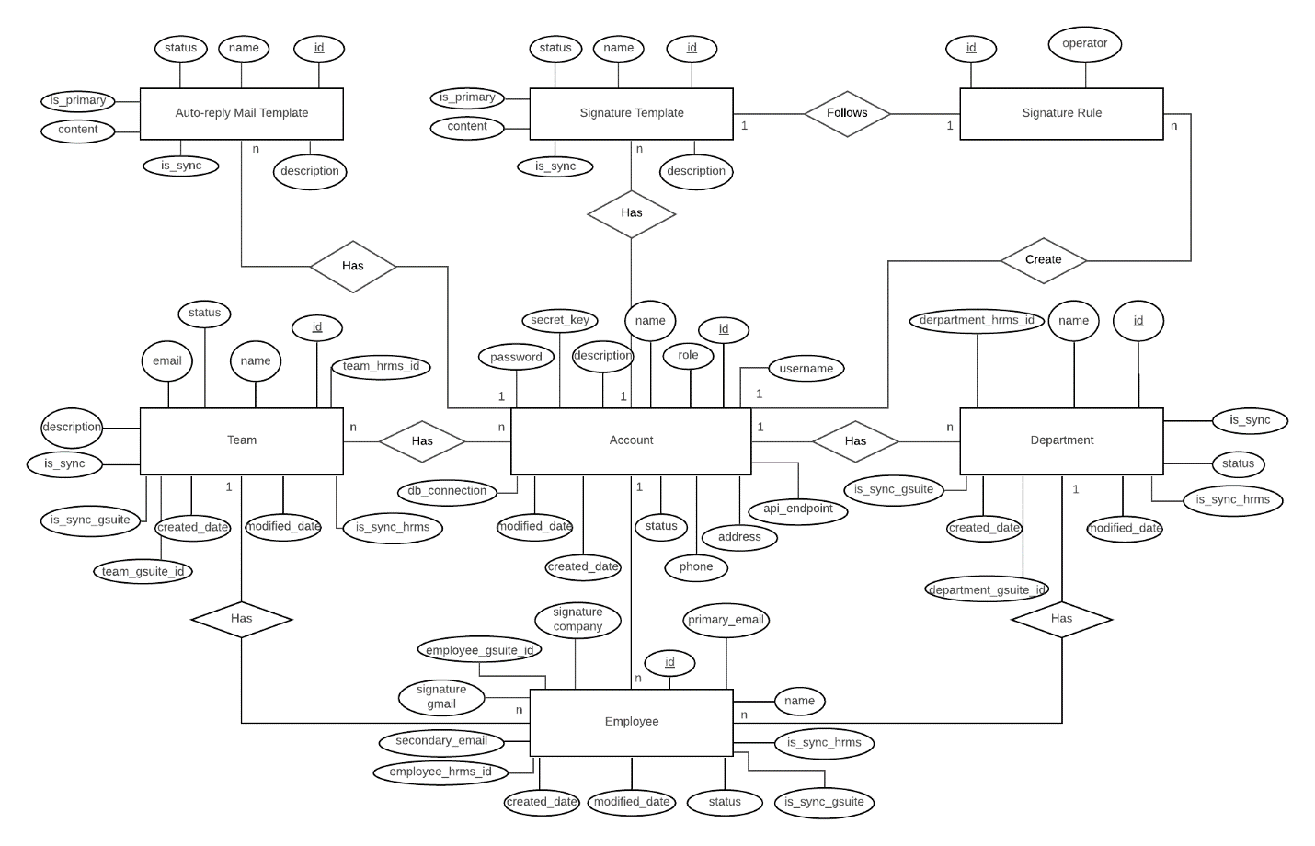

Figure 107 - Entity relationship diagram (ERD)

### Data dictionary

|  |  |  |
| --- | --- | --- |
| Entity dictionary: describe Entity | | |
| Entity Name | Mapping column with Conceptual diagram | Description |
| Account | Account | Contain the Account information. |
| Employee | Employee | Contain the Employee information |
| Department | Department | Contain the Department information |
| Team | Team | Contain the Team information |
| Signature Rule | Signature Rule | Contain the Rule of signature template |
| Signature Template | Signature Template | Contain the Signature Template information |
| Auto-reply Mail Template | Auto-reply Mail Template | Contain the Auto-reply Mail Template information |

Table 106 - Entity relationship diagram dictionary

## Algorithms

### Time base OTP

#### Definition

This algorithm is used to create one time password based on real time and secret key. To increase the security for user accounts

#### Define problem

We need an algorithm that can create OTP on clients and servers without an internet connection. This algorithm must ensure that each time OTP is created, it must ensure the number of digits generated is 6

#### Solution

Time based One time password (TOTP) guarantees to solve the problems mentioned above. This algorithm helps generate 6-digit otp, exactly on each creation with a combination of real-time and secret keys.

**Dictionary:**

* Base32: Include A-Z and 2-7: ABCDEFGHIJKLMNOPQRSTUVWXYZ234567

**To create OTP:**

**Conditional**: A secret key in base32 must shared between server and client.

**Step 1**: Secret_Hex: Convert secret key from base32 to Hexadecimal.

**Step 2**: Current_Time: Get current time in second divides the integer by 30.

**Step 3**: Time_in_hex: time convert to Hexadecimal.

**Step 4**: Hmac_SHA1: use Hmac SHA1 algorithm to hash Secret_key and Time_in_hex.

**Step 5**: Offset: get the last char of Hmac_SHA1 convert to Decimal.

**Step 6**: Big_Int: Convert 7FFFFFFF from hexadecimal to decimal.

**Step 7**: Otp_temp: Perform calculations on bits Offset in step 5 ‘AND’ Big_Int in step 6.

**Step 8**: Get last 6 digits from Otp_temp of step 7. If it less than 6 digits then add ‘0’ to font until it reaches 6 numbers.

#### Complexity

The complexity of this algorithm is: O(n)2

#### Example

**Example 1:**

Secret Key: R2ZTEFMCAUSFTAZDRFF6KEU3P62EZB52UXZ7MCBSYLMULWAXXJYA

Time: Fri Jul 03 2020 01:41:36 convert to second is 1593715296411 seconds.

OTP: 692 075.

**Example 2:**

Secret Key: R2ZTEFMCAUSFTAZDRFF6KEU3P62EZB52UXZ7MCBSYLMULWAXXJYA

Time: Fri Jul 03 2020 01:44:06 convert to second is 1593715446136 seconds.

OTP: 819 292.

**Example 3:**

Secret Key: R2ZTEFMCAUSFTAZDRFF6KEU3P62EZB52UXZ7MCBSYLMULWAXXJYA

Time: Fri Jul 03 2020 01:46:10 convert to second is 1593715570670 seconds.

OTP: 843 492.)

### Comparing with merge sort

#### Definition

This algorithm is used to compare employee, team and department lists between HRMS and G-suite systems of company.

List must be comparing:

* + Employee
  + Team
  + Department

For set up data on GmHRS for synchronizing on G-Suite, the system must be defining three lists of employee, team and department:

* + Creating new list
    - The system is filter out lists belongs to HRMS but not existed on G-Suite
  + Updating list
    - The system is filter out list existed both HRMS system and G-Suite system.
  + Out of HRMS system list
    - The system is filter out list is not belonging to HRMS system but existed on G-Suite.



Figure 108 Comparing employees of G Suite and HRMS



Figure 109 <Flowchart> Comparing with idea from merge sort

#### Complexity

The complexity of this algorithm is: O (n + m) + O(nlnn) + O(mlnm).

# E. System Implementation and Test

## Introduction

### Overview

This section describes the approach and methodologies for the testing phase of GmHRS. It provides in the detail necessary information about the implementation and testing procedure of the system included test plans, test cases, test result, test environments and pass/fail criteria as a checklist to cover possible cases.



### Test approach

* **Goal**: Test all features in GmHRS based on the core flow.
* **Method**: black-box testing
* **Technique**: check list

## Test plan

The purpose of testing is to ensure GmHRS reaches technical requirements and business rules. This section describes the core flow for each actor in GmHRS and test cases for each feature inflows. The test cases also are updated as required for each release.

### Features to be tested

* Authorized User:
  + Sign In
* Company admin:
  + Setting (3 steps: connection, g-suite credential, schedule jobs)
  + Executing synchronize Gmail business (Gmail of business of employee, team, department)
  + Signature (Manage signature, synchronize signature, specific applies, assigning signature)
  + Signature rule (Manage rule, Send Email notification, check invalid signature)
  + Vacation auto reply mail template (Manage template, assigning template by specific, synchronize)
* System handler
  + Auto synchronize(auto synchronize follow setting time schedule)

### Features not to be tested

* System admin manage account

## Database Relationship Diagram

### Physical diagram



|  |  |
| --- | --- |
| DATA DICTIONARY: DESCRIBE CONTENT OF ALL TABLES | |
| Table name | Description |
| account | Contains the account information |
| employee | Contains the employee information |
| department | Contains the department information |
| team | Contains the team information |
| team_employee | Contains the employee in team information |
| accountoperatorstatus | Contains the account status information |
| depart,emtoperatorstatus | Contains the department status information |
| teamoperatorstatus | Contains the team status information |
| position_in_company | Contains the position in company information |
| email_templates | Contains the auto reply mail template information |
| specific_mail | Contains the information assign specific auto reply mail template |
| specific_mail_employee | Contains the employee assigned auto reply mail template information |
| specific_mail_department | Contains the employee in the department assigned auto reply mail template information |
| specific_mail_position | Contains the employee have the position assigned auto reply mail template information |
| specific_mail_team | Contains the employee in the team assigned auto reply mail template information |
| role | Contains the role in system information |
| signaturetemplate | Contains the signature template information |
| signaturerule | Contains the signature template rule information |
| signaturerule_content | Contains the signature rule content information |
| specific_signature | Contains the information assign specific signature template |
| specific_signature_department | Contains the employee in the department assigned signature template |
| specific_signature_employee | Contains the employee assigned signature template |
| specific_signature_team | Contains the employee in the team assigned signature template |
| specific_signature_position | Contains the employee have the position assigned signature template |
| support_specific_by | Contains the support specific by what |
| dynamic_rule | Contains the dynamic rule information |
| sync_log | Contains the synchronize log information |
| sync_log_detail | Contains the synchronize log detail information |



### Database diagram explanation

#### account

|  |  |  |
| --- | --- | --- |
| **Attribute** | **Type** | **Description** |
| id | Int | Unique identifier of an account |
| username | Varchar (30) | The user name of account |
| email | Varchar (45) | The email of account |
| password | Varchar (45) | The hashed password of the account |
| created_date | Datetime | The time account was created |
| modified_data | Timestamp | The time account was modified |
| role_id | Int | The role of account in system |
| status_id | Int | The status active or deactivate of account |
| api_endpoint | Varchar (200) | The API endpoint of account when setting |
| connection_database | Varchar (200) | The connection string of account when setting |
| two_fa_status | Int | The status of two factor |
| address | Varchar (200) | The address of account |
| phone | Varchar (12) | The phone of account |
| file_name_auth_gsuite_company | Varchar (45) | The name of file g-suite authentication |
| company_id | Int | The id company of account |
| is_first_sync | Tinyint | Checking the first synchronize |
| schedule_time | Varchar (50) | The schedule time of account |
| company_email | Varchar (45) | G-suite email with role admin |
| is_schedule | TINYINT | Checking schedule synchronize |
| last_sync_date | Datetime | The time last synchronize of account |
| secret_key | Varchar (300) | The secret key to use 2 factors of account |
| customer_id | Varchar (45) | Customer id on g-suite of account |

Table 107 - account attribute

#### employee

|  |  |  |
| --- | --- | --- |
| **Atrribute** | **Type** | **Description** |
| id | Int | Unique identifier of an employee |
| first_name | Varchar (45) | The first name of employee |
| last_name | Varchar (45) | The last name of employee |
| personal_email | Varchar (45) | The personal email of employee |
| primary_email | Varchar (45) | The email use to synchronize on G Suite |
| address | Varchar (200) | The address of employee |
| phone | Varchar (12) | The phone of employee |
| department_id | Int | The department id of employee |
| status_id | Int | The status activates of employee |
| created_date | Datetime | The time employee was created |
| modified_date | timestamp | The time employee was modified |
| hrms_id | Varchar (45) | The id of employee on HRMS |
| gsuite_id | Varchar (45) | The id of employee on G Suite |
| account_id | int | The id account of employee to determine belong to which company |
| vacation_start_date | Date | The vacation time of employee start |
| vacation_end_date | Date | The vacation time of employee end |
| positon_id | int | The position of employee in company |

Table 108 - employee attribute

#### department

|  |  |  |
| --- | --- | --- |
| Attribute | Type | Description |
| id | Int | Unique identifier of an employee |
| name | Varchar (45) | The name of department |
| description | Varchar (300) | The description of department |
| status_id | Int | The status active of department |
| created_date | Datetime | The time department was created |
| modified_date | Timestamp | The time department was modified |
| hrms_id | Varchar (45) | The id of employee on HRMS |
| gsuite_id | Varchar (45) | The id of employee on g-suite |
| account_id | Int | The id account of department to determine belong to which company |
| orgunits_path | Varchar (100) | The Name of Subsidiaries |
| email | Varchar (45) | The email of department |

Table 109 - department attribute

#### team

|  |  |  |
| --- | --- | --- |
| Attribute | Type | Description |
| id | Int | Unique identifier of a team |
| name | Varchar (100) | The name of team |
| email | Varchar (45) | The email of team |
| description | Varchar (300) | The description of team |
| modified_date | Timestamp | The time team was modified |
| created_date | Datetime | The time team was created |
| status_id | Int | Checking status active of team |
| hrms_id | Varchar (45) | The id of employee on HRMS |
| gsuite_id | Varchar (45) | The id of employee on G Suite |
| account_id | Int | The id account of team to determine belong to which company |

Table 110 - Team Attribute

#### team_employee

|  |  |  |
| --- | --- | --- |
| Attribute | Type | Description |
| Employee_id | Int | Mapping with employee table to determine the employee as a member in the team |
| Team_id | int | Mapping with team table to determine the team |
| Created_date | timestamp | The time that the employee joins the team |

Table 111 - team_employee Attribute

#### accountoperatorstatus

|  |  |  |
| --- | --- | --- |
| Attribute | Type | Description |
| id | Int | Unique identifier of an account status |
| name | Varchar (45) | The name of status |

Table 112 - Accountoperatorstatus attribute

#### employeeoperatorstatus

|  |  |  |
| --- | --- | --- |
| Attribute | Type | Description |
| id | Int | Unique identifier of an employee status |
| name | Varchar (45) | The name of status |

Table 113 - Employeeoperatorstatus Attribute

#### departmentoperatorstatus

|  |  |  |
| --- | --- | --- |
| Attribute | Type | Description |
| id | Int | Unique identifier of a department status |
| name | Varchar (45) | The name of status |

Table 114 - Departmentoperatorstatus Attribute

#### teamoperatorstatus

|  |  |  |
| --- | --- | --- |
| Attribute | Type | Description |
| id | Int | Unique identifier of a team status |
| name | Varchar (45) | The name of status |

Table 115 - Teamoperatorstatus Attribute

#### positon_in_company

|  |  |  |
| --- | --- | --- |
| Attribute | Type | Description |
| id | Int | Unique identifier of a position |
| name | Varchar (45) | The name of position |
| account_id | Int | The id account of position to determine belong to which company |
| hrms_id | Varchar (45) | The id of employee on HRMS |

Table 116 - Position_in_company Attribute

#### email_templates

|  |  |  |
| --- | --- | --- |
| Attribute | Type | Description |
| templateId | Int | Unique identifier of an email template |
| templateName | Varchar (45) | The name of template to distinguish it from another template |
| accountId | int | The id account of email template to determine belong to which company |
| subject | Varchar (250) | The subject of email template |
| template | Longtext | Save config email template |
| html | Longtext | Save html of email template |
| create_at | Datetime | The time email template was created |

Table 117 - Email_templates Attribute

#### specific_mail

|  |  |  |
| --- | --- | --- |
| Attribute | Type | Description |
| id | Int | Unique identifier of a specific mail |
| account_id | Int | The id account of specific mail to determine belong to which company |
| priority | Int | The priority of specific mail |
| email_template_id | Int | Determine which email template |
| specificby | Char (1) | Contain character to determine specific by which |

Table 118 - specific_mail Attriute

#### specific_mail_employee

|  |  |  |
| --- | --- | --- |
| Attribute | Type | Description |
| employee_id | Int | Mapping with employee table to determine the employee is assigned specific email template |
| specific_mailtemplate_id | Int | Mapping with the specific_mail table to determine which template the employee is assigned to |

Table 119 - Specific_mail_employee Attribute

#### specific_mail_department

|  |  |  |
| --- | --- | --- |
| Attribute | Type | Description |
| department_id | Int | Mapping with department table to determine the department is assigned specific email template |
| specific_mailtemplate_id | Int | Mapping with the specific_mail table to determine which template the department is assigned to |

Table 120 - specific_mail_department Atrribute

#### specific_mail_position

|  |  |  |
| --- | --- | --- |
| Attribute | Type | Description |
| position_id | Int | Mapping with position table to determine the position is assigned specific email template |
| specific_mailtemplate_id | Int | Mapping with the specific_mail table to determine which template the position is assigned to |

Table 121 - Specific_mail_positon Attribute

#### specific_mail_team

|  |  |  |
| --- | --- | --- |
| Attribute | Type | Description |
| team_id | Int | Mapping with team table to determine the team is assigned specific email template |
| specific_mailtemplate_id | Int | Mapping with the specific_mail table to determine which template the team is assigned to |

Table 122 - Specific_mail_team Attribute

#### role

|  |  |  |
| --- | --- | --- |
| Attribute | Type | Description |
| Id | Int | Unique identifier of a role |
| name | Varchar (45) | The name of role |

Table 123 - Role Attribute

#### signaturetemplate

|  |  |  |
| --- | --- | --- |
| Attribute | Type | Description |
| id | Int | Unique identifier of a signature template |
| name | Varchar (100) | The name of signature template |
| content | Text | Saving content of signature template |
| account_id | Int | The id account of signature template to determine belong to which company |
| is_primary | Int | Checking signature template default |

Table 124 - signaturetemplate Attribute

#### signaturerule

|  |  |  |
| --- | --- | --- |
| Attribute | Type | Description |
| id | Int | Unique identifier of a role |
| name | Varchar (100) | The name of signature rule |
| account_id | Int | The id account of signature rule to determine belong to which company |
| is_primary | Int | Checking signature template default |
| Max | Int | Max length of signature content |
| Min | int | Min length of signature content |

Table 125 - signaturerule Attribute

#### signaturerule_content

|  |  |  |
| --- | --- | --- |
| Attribute | Type | Description |
| id | Int | Unique identifier of a role |
| name | Varchar (100) | The name of signature rule |
| account_id | Int | The id account of signature rule to determine belong to which company |
| is_primary | Int | Checking signature template default |
| Max | Int | Max length of signature content |
| Min | int | Min length of signature content |

Table 126 - signaturerule_content Attribute

#### Specific_signature

|  |  |  |
| --- | --- | --- |
| Attribute | Type | Description |
| id | Int | Unique identifier of a specific signature |
| account_id | Int | The id account of specific signature to determine belong to which company |
| Signature_id | Int | Determine which signature template |
| specificBy | Varchar (50) | Contain characters to determine specific by which |
| priority | int | The priority of specific signature |

Table 127 - specific_signature Attribute

#### specific_signature_datepartment

|  |  |  |
| --- | --- | --- |
| Attribute | Type | Description |
| Specific_id | Int | Mapping with the specific_signature table to determine which template the department is assigned to |
| Department_id | int | Mapping with department table to determine the department is assigned specific signature template |

Table 128 - specific_signature_department Attribute

#### specific_signature_employee

|  |  |  |
| --- | --- | --- |
| Attribute | Type | Description |
| Specific_id | Int | Mapping with the specific_signature table to determine which template the employee is assigned to |
| employee_id | int | Mapping with employee table to determine the employee is assigned specific signature template |

Table 129 - specific_signature_employee Attribute

#### specific_signature_team

|  |  |  |
| --- | --- | --- |
| Attribute | Type | Description |
| specific_id | Int | Mapping with the specific_signature table to determine which template the team is assigned to |
| team_id | int | Mapping with team table to determine the team is assigned specific signature template |

Table 130- specific_signature_team Attrubute

#### specific_signature_position

|  |  |  |
| --- | --- | --- |
| Attribute | Type | Description |
| specific_id | Int | Mapping with the specific_signature table to determine which template the positon is assigned to |
| positon_id | int | Mapping with position table to determine the positon is assigned specific signature template |

Table 131 - specific_signature_position Attribute

#### Support_specific_by

|  |  |  |
| --- | --- | --- |
| Attribute | Type | Description |
| id | Int | Unique identifier of a specific signature |
| name | Varchar (100) | The name of support specific |
| description | Varchar (100) | The description of support specific |
| feature | Varchar (100) | The feature will be support specific |

Table 132 - support_specific_by Attribute

#### Dynamic_rule

|  |  |  |
| --- | --- | --- |
| Attribute | Type | Description |
| id | Int | Unique identifier of a dynamic rule |
| name | Varchar (100) | The name dynamic rule |
| content | Varchar (100) | The content of dynamic rule |

Table 133 - Dynamic_rule Attribute

#### Sync_log

|  |  |  |
| --- | --- | --- |
| Attribute | Type | Description |
| id | Int | Unique identifier of a sync log |
| name | Varchar (45) | The name of sync log |
| account_id | int | The id account of sync log to determine belong to which company |
| status | TINYINT | The status of sync log |
| modified_date | Timestamp | The time sync log was modified |

Table 134 - Sync_log Attribute

#### Sync_log_detail

|  |  |  |
| --- | --- | --- |
| Attribute | Type | Description |
| id | Int | Unique identifier of a sync log detail |
| Employee_id | Int | Mapping to employee table to get information if employee resource changed |
| Team_id | Int | Mapping to team table to get information if team resource changed |
| Department_id | Int | Mapping to department table to get information if department resource changed |
| Sync_log_id | int | Mapping to sync_log table to get information |
| type | Char (1) | Determine Create, Delete or Update |

Table 135 - Sync_log_detail Attribute

## System Testing Test Case



### Core Flow

#### <Company Admin> Signature template



Figure 110 - <Signature template>

#### <Company admin, System admin> Two factor authentication

,

Figure 111: <Company admin> Two factor authentication

#### <Company admin> Setting



Figure 112 <Company admin> Setting

#### <Company admin> Execute synchronize Gmail business



Figure 113 <Company admin> Execute synchronize Gmail business

#### <Company admin> Manage vacation auto reply mail template



Figure 114 <Company admin> Manage vacation auto reply mail template

#### <Company admin> Assign vacation auto reply mail template



Figure 115 <Company admin> Assign vacation auto reply mail template

### Test Case

#### <Company admin> Signature template

|  |  |  |  |  |  |
| --- | --- | --- | --- | --- | --- |
| **ID** | **Test Case Description** | **Test case procedure** | **Expected output** | **Result** | **Test Date** |
| **Create signature template** | | | | | |
| ST_1 | User inputs empty signature name | 1. User use create signature template | System shows an error message: “Input signature name!”. | Pass | 16/08/2020 |
| SU_2 | User inputs empty signature template content | 1. User use create signature template | System shows error message: “Input signature template content!”. | Pass | 16/08/2020 |
| SI_1 | User inputs signature template name and signature template content | Signature template name: “template 1”.  Content: “Signature for my company”. | System shows error message: “Create signature template 1 successfully!”. | Pass | 16/08/2020 |
| **View all signature template** | | | | | |

|  |  |  |  |  |  |  |
| --- | --- | --- | --- | --- | --- | --- |
| SI_2 | View all signature | Don’t have any signature template | Table with empty data | Pass | 16/08/2020 | |
| SI_3 | View all signature | Have signature templates | Table display with data of signature template | Pass | 16/08/2020 | |
| **Assign specific signature template** | | | | | | |
| SI_4 | User assign specific signature template | Don’t have any signature template | System display message: “You don’t have any signature template PASS” | Pass | | 16/08/2020 |
| SI_5 | User assign specific signature template | Have signature templates | Display table to assign specific signature template | Pass | | 16/08/2020 |
| SI_6 | User add specific assign and save | Don’t add info in row | System display message: “Please select value to save!” | Pass | | 16/08/2020 |
| SI_7 | User add specific assign and save | Select information:  Position: Admin, CEO | System display message: “Save specific template successfully!” | Pass | | 16/08/2020 |
| Synchronization signature of employees | | | | | | |
| SI_8 | User press Synchronize now | Don’t have signature template | System display message: “You do not have signature template or signature template default” | Pass | | 16/08/2020 |
| SI_9 | User press Synchronize now | Have signature template | System display message: “Update all employee signature successfully!” | Pass | | 16/08/2020 |
| Set default signature template | | | | | | |
| SI_10 | User set default signature template | User set signature template | System display message: “Set signature template default successfully!” | Pass | | 16/08/2020 |
| Create signature rule | | | | | | |
| SI_11 | User create signature rule | User input info and press save | System display message: “Save signature rule successfully!” | Pass | | 16/08/2020 |
| SI_12 | User view all signature template rule | User press view all signature template rule | System show all signature template rule available | Pass | | 16/08/2020 |
| SI_13 | User press send mail notify about signature rule to employees | Have signature template rule default in system | System show message: “Send mail notify to all employee successfully!” | Pass | | 16/08/2020 |
| SI_14 | User press check employee wrong signature | Have signature template rule default | System show employee with wrong. | Pass | | 16/08/2020 |
| SI_15 | User press send mail to wrong employee signature | Have wrong signature employee | System show message: “Send mail successfully!” | Pass | | 16/08/2020 |
|  |  |  |  |  | |  |

Table 136: <Company admin>

#### <Company admin> Two Factor authentication

|  |  |  |  |  |  |
| --- | --- | --- | --- | --- | --- |
| **ID** | **Test Case Description** | **Test case procedure** | **Expected output** | **Result** | **Test Date** |
| **Two factor authentication** | | | | | |
| ST_1 | User scan QR in mobile | First time user app | System shows success message: “You have got secret key from server!”. | Pass | 16/08/2020 |
| SU_2 | User input OTP to action 2fa feature | Have not active 2fa yet | System shows success message: “Active 2fa successfully!”. | Pass | 16/08/2020 |
| SI_1 | User input OTP to de active 2fa feature | 2fa activated | System shows error message: “DE active 2fa successfully!”. | Pass | 16/08/2020 |

4.2.2

#### <Company Admin> Setting test

|  |  |  |  |  |  |  |
| --- | --- | --- | --- | --- | --- | --- |
| ID | Test Case Description | Test case procedure | Expected output | Inter Dependence Test Case | Result | Test Date |
| Data connection | | | | | | |
| S1 | Company Admin setting database connection | 1. Company admin click setting on setting menu.  2. Company admin input information: “Connection name”: HRMS, “Hostname”:  103.143.209.237 “Port”:3306 “Username”: root“ Password”:Zz@123456 “Dialect”: My SQL.  3. Company admin click “Test connection” button.  4. Company admin click “Save” button in modal | System shows success messages. | N/A | Pass | 16/08/2020 |
| S2 | Company Admin setting database connection with “My SQL” and wrong “Connection name” | 1. Company admin click setting on setting menu.  2. Company admin input information: “Connection name”: HRMS , “Hostname”:  103.143.209.237 “Port”:3306 “Username”: root“ Password”:Zz@123456 “Dialect”: My SQL.  3. Company admin click “Test connection” button. | System show modal result with status “fail”, message: “Wrong connection name, please input again” | N/A | Pass | 16/08/2020 |
| S3 | Company Admin setting database connection with “My SQL” and wrong “Hostname” | 1. Company admin click setting on setting menu.  2. Company admin input information: “Connection name”: HRMS, “Hostname”:  103.143.209.2371 “Port”:3306 “Username”: root “Password”:Zz@123456 “Dialect”: My SQL.  3. Company admin click “Test connection” button. | System show modal result with status “fail” , message: “Wrong host, please input again!, please input again” | N/A | Pass | 16/08/2020 |
| S4 | Company Admin setting database connection with “My SQL” and wrong “Username” or “Password” | 1. Company admin click setting on setting menu.  2. Company admin input information: “Connection name”: HRMS, “Hostname”:  103.143.209.2371 “Port”:3306 “Username”: root “Password”:Zz@123456 “Dialect”: My SQL.  3. Company admin click “Test connection” button. | System show modal result with status “fail”, message: “Wrong user name or password, please input again!” | N/A | Pass | 16/08/2020 |
| S4 | Company Admin setting database connection with “My SQL” and wrong “Port” | 1. Company admin click setting on setting menu.  2. Company admin input information: “Connection name”: hrms1, “Hostname”:  103.143.209.2371 “Port”:3306 “Username”: root “Password”:Zz@123456 “Dialect”: My SQL.  3. Company admin click “Test connection” button. | System show modal result with status “fail”, message: “Wrong port, please input again!” | N/A | Pass | 16/08/2020 |
| S5 | Company Admin setting database connection with dialog MySQL and wrong port | 1.Company admin click “setting” on setting menu.  2. Company admin input MySQL dialects and wrong port information.  3. Company admin click “Test connection” button. | System fail | N/A | Pass | 16/08/2020 |
| API Endpoint | | | | | | |
| S6 | Company admin setting API endpoint | 1. Company admin click setting on setting menu.  2. Company admin select “API endpoint” in step 1  3. Company admin input information: “URL”: https://hrms123.herokuapp.com/api/data-hrms  4. Company admin click “Test” button.  5. Company admin click “Save” button in modal | System shows success messages. | N/A | Pass | 16/08/2020 |
| S7 | Company admin setting API endpoint | 1. Company admin click setting on setting menu.  2. Company admin select “API endpoint” in step 1  3. Company admin input information: “URL”: https://hrms123.herokuapp.com/api/   4. Company admin click “Test” button. | System shows modal result with status “fail” | N/A | Pass | 16/08/2020 |
| G-Suite credential | | | | | | |
| S8 | Company admin setting g-suite credential | 1. Company admin setting connection string or API end point success.  2. Company admin click “next” button.  3. Company admin input information:  “Admin company email”: [z@capstonesummer2020-fu.page](mailto:z@capstonesummer2020-fu.page) “file JSON of key g-suite authentication”: JSON file  4. Company admin click “Test” button  5. System show result test. Company admin click “Save” button | System shows success messages. | N/A | Pass | 16/08/2020 |
| S9 | Company admin setting schedule | 1. Company admin setting g-suite credential success.  2. Company admin click “Next” button.  3. Company admin input right information.  4. Company admin click “Save” button | System shows success messages. | N/A | Pass | 16/08/2020 |

#### <Company Admin> Create auto-reply template test

|  |  |  |  |  |  |
| --- | --- | --- | --- | --- | --- |
| ID | Test Case Description | Test case procedure | Expected output | Result | Test Date |
| **Create template** | | | | | |
| CT1 | User input with empty input | 1: User click button “Create template”. System navigate to create page    2: Click “Save” | System shows validate message:  - “Please input name” at field Name  - “Please input first subject” at field Subject | Pass | 16-08-2020 |
| CT2 | Input with valid input | 1: Input:  -Name: Vung tau vacation  -Subject: Company in Vung Tau trip  -Design template  2: Click “Save” | Notification success will be shown with message: “Creating template is successfully” | Pass | 16-08-2020 |

#### <Company Admin> Assign template to employee

|  |  |  |  |  |  |
| --- | --- | --- | --- | --- | --- |
| ID | Test Case Description | Test case procedure | Expected output | Result | Test Date |
| **Assign template to employee** | | | | | |
| AE1 | Assign template with no configuration rule | 1: User click button “Assign”.    2: Click “Save” | 1: Notification success will be shown with message:” All employee is assigned template”.  2: All employee was assigning a default template | Pass | 16-08-2020 |
| AE2 | Assign template with no configuration rule and company has no default template | 1: User click button “Assign”.    2: Click “Save” | 1: Notification error will be shown with message:” Please choose default template before assign”. | Pass | 16-08-2020 |
| AE3 | Assign template has configuration rule | 1: User click button “Assign”.    2: Click “Save” | Employee who satisfy with rule has highest priority will be assign email template | Pass | 16-08-2020 |

#### <Company Admin> Save assign template

|  |  |  |  |  |  |
| --- | --- | --- | --- | --- | --- |
| ID | Test Case Description | Test case procedure | Expected output | Result | Test Date |
| **Save rule to assign** | | | | | |
| SA1 | Save rule configuration with element has no template choose | 1: User click button “Add row”.    2: Input:  -Type: department.  -Value: Angular1,  -Template: null    3: Click “Save” | 1: Notification error will be shown with message:” Please choose template”. | Pass | 16-08-2020 |
| SA2 | Save rule configuration with element has empty row | 1: User double click button “Add row”.    2:  At row 2 input:  -Type: department.  -Value: Angular1,  -Template: vacation    3: Click “Save” | 1: Notification success will be shown with message:” Rule configuration is saved successfully”. | Pass | 16-08-2020 |
| SA3 | Change rule configuration | 1:  At 1 row change input to:  -Type: department.  -Value: Angular1,  -Template: vacation    2: Click “Save” | 1: Notification success will be shown with message:” Rule configuration is saved successfully” and page is reset.    2: Element value has changed. | Pass | 16-08-2020 |

# F. Software User Manual

## Installation Guide

### Setting up environment at server side

#### Hardware requirements

|  |  |  |
| --- | --- | --- |
| **Server** | **Minimum Requirements** | **Recommended** |
| **Internet Connection** | Cable, Wi-Fi (4 Mbps) | Cable, Wi-Fi (8 Mbps) |
| **Operating System** | Windows 10 | Windows 10 |
| **Computer Processor** | Intel® CORE i5 Quad core 2.1 GHz | Intel® CORE i7 Quad core 2.4 GHz |
| **Computer Memory** | 4GB RAM | 8GB or more |
| **Internet Connection** | Cable, Wi-Fi (4 Mbps) | Cable, Wi-Fi (8 Mbps) |

*Table 79: Hardware requirements for Server*

#### Software requirements

|  |  |  |
| --- | --- | --- |
| **Name** | **Name/Version** | **Description** |
| **Environment** | NodeJS 10.6.3 | Specification for developing EMM Shopify Extension |
| **IDE** | Visual Studio Code 1.40.1 | Programming tools |
| **DBMS** | MySQL Server 80 | Used to create & manage the database for system |
| **Source control** | SourceTree 3.3.4 | Used for source control |
| **Web browser** | Chrome 78.0.3904.108 | Testing browser |

*Table 80: Software requirements for Server*



### Deployment

#### Prepare development package

**Step 1**: Download and setup NodeJS v10.6.3

Link download: <https://nodejs.org/en/download/>

**Step 2**: Download and setup Visual Studio Code 1.40.1

Link download: <https://code.visualstudio.com/download>

**Step 3**: Download and setup Nodemon

Run command: npm install -g nodemon

**Step 4**: Download, setup and configure MySQL

Link download: <https://dev.mysql.com/downloads/installer/>

**Step 5**: Open server project and run command: nodemon start

#### Deployment of web service / web application

#### Deploy MySQL and web service

***Register account on vHost.vn*** <https://vhost.vn/>



*Figure 79 - Registered accounts with VPS service by Facebook or Twitter account*



Figure 116 - Manage services page on vHost.vn



Figure 117 - Manage VPS service at manage product page



Figure 118 - Use Remote desktop application to remote to VPS server with IP and password had provided..



Figure 119 This is desktop VPS

**Step 1**: Download and setup NodeJS v10.6.3

**Link download**: <https://nodejs.org/en/download/>

**Step 2**: Download and setup Nodemon

**Run command**: npm install -g nodemon

**Step 3**: Download, setup and configure MySQL

**Link download**: <https://dev.mysql.com/downloads/installer/>

**Step 4**: Open server project and run command: nodemon start

**Step 5**: **Run command**: sudo ufw allow 3000 (public port of application)

Done, connect to <http://103.143.209.237:3000> check for work.

## User guide

### Signature template

#### Create signature



Figure 120 - Design signature template

|  |  |
| --- | --- |
| **Step** | **Description** |
| Pre-condition | * User must sign in as a GmHRS * User must be in signature template page |
| 1 | Click button “New” |
| 2 | Input signature name |
| 3 | Input content |
| 4 | You can in put dynamic content |
| 5 | You can insert image |
| 6 | Click “Loading view” to review the template |
| 7 | Click “Save” button to save the template |

Table 137 - Create signature template description

#### 2.2.2. View all signature



Figure 121 - View list template signature



Figure 122 - View list template signature

|  |  |
| --- | --- |
| **Step** | **Description** |
| Pre-condition | * User must sign in as a GmHRS * User must be in signature template page |
| 1 | Click “View all template” on menu bar |
| 2 | You can view detail signature template |
| 3 | You can delete signature template |

Table 138 - View signature template list description

#### 2.2.3. Specific apply signature



Figure 123 Manage specific for apply template.



Figure 124 Manage specific for apply template.

|  |  |
| --- | --- |
| **Step** | **Description** |
| Pre-condition | * User must sign in as a GmHRS * User must be in signature template page * User must be have at least 1 signature template |
| 1 | Click “Specific apply” on menu bar |
| 2 | Click “Add row” |
| 3 | Choose “Specific by” (ex: team, department) |
| 4 | Choose “Value” of “Specific by” |
| 5 | Choose “Signature Name” |
| 6 | You can view list employee will been applied |
| 7 | You can delete the specific apply |
| 8 | Click “Save” to save the specific apply |

Table 139 - Manage specific apply template description

#### 2.2.4 Synchronization signature template



Figure 125 - Synchronize on Gmail specific signature template just add for employee matched.

#### 2.2.5 Create rule of signature template



Figure 126 - Creating rules of signature template

#### 2.2.5 View all rule



Figure 127 - View list of rules for signature



Figure 128 - View/Delete rules of signature template.

#### 2.2.6 Sending mail notify



Figure 129 - Notify to employees who have signature form did not follow rules of company signature.

#### 2.2.7 Check wrong signature



Figure 130 - View all employee who did not follow rule of company signature.



Figure 131 - View detail signature of employees did not follow company rules.

### 2.2 Two factor

#### 2.2.1 Active



Figure 132 - Set up application mobile and enable two-factor

#### 2.2.2 De active



Figure 133 - Disable two-factor

#### 2.2.3 Mobile



Figure 134 - Scan QR for dowload application two-factor on mobile



Figure 135 - Scan the secret key for authenticatate with web server



Figure 136 - Display OTP and time for expired code



### Synchronize manually



Figure 137 - Click synchronize for first sync with G-suite by GmHRS



Figure 138 - System show list review data for execute synchronize

|  |  |
| --- | --- |
| **Step** | **Description** |
| Pre-condition | * User must sign in as a GmHRS * User must click synchronize button in header |
| 1 | Click button “Synchronize” to open modal view data sync |
| 2 | Choose “Synchronize” for synchronize all data |

Table 140 - System show list review data for execute synchronize description

### Setting

#### Setting data connection



Figure 139 - Setting

|  |  |
| --- | --- |
| **Step** | **Description** |
| Pre-condition | * User must sign in as a GmHRS |
| 1 | Navigate to setting connection page. |

Table 141 - Setting description



Figure 140 - Enter all of fields required for database connection



Figure 141 Data response matched all of fields GmHRS required.

|  |  |
| --- | --- |
| **Step** | **Description** |
| Pre-condition | * User must sign in as a GmHRS * User must in setting page |
| 1 | Click button “Setting” to view data sync |
| 2 | Input Connection name |
| 3 | Input Host name |
| 4 | Input Port |
| 5 | Input username |
| 6 | Input password |
| 7 | Input database type |
| 8 | Test connection to configuration database |
| 8.1 | Save setting connection to GmHRS database |
| 9 | Navigate to next step |

Table 141 - Setting data connection description

#### Setting G-Suite credential



Figure 142 – Setting G-Suite credential



Figure 143 - Show list scope that is accessed on G-Suite.

|  |  |
| --- | --- |
| **Step** | **Description** |
| Pre-condition | * User must sign in as a GmHRS * User must in setting page and complete setting step 1 |
| 1 | Input admin company email |
| 2 | Add file .json to connect to g-suite |
| 3 | Test file .json and email |
| 3.1 | Save file and admin email |
| 5 | Navigate to next step |

Table 142 - Setting G-Suite credential description

#### Setting schedule



Figure 144 - Set schedule for synchronize

|  |  |
| --- | --- |
| **Step** | **Description** |
| Pre-condition | * User must sign in as a GmHRS * User must in setting page and complete setting step 2 |
| 1 | Choose type of time schedule |
| 2 | Add day to schedule |
| 3 | Add time to schedule |
| 4 | Save configuration to database |
| 5 | Turn on/off auto synchronize |

Table 143 - Set schedule for synchronize description



### Auto reply mail

#### Create auto reply template



Figure 145 - Design template for vacation auto-reply mail

|  |  |
| --- | --- |
| **Step** | **Description** |
| Pre-condition | * User must sign in as a GmHRS * User must be in Manage auto mail template page |
| 1 | Input name of template |
| 2 | Add email subject |
| 3 | Design template |
| 4 | Save template to database |
| 5 | Back to manage template page |

Table 144 – Vacation auto reply mail description

#### Assign template auto reply mail



Figure 146 - Add a specific apply vacation auto-reply mail template

|  |  |
| --- | --- |
| **Step** | **Description** |
| Pre-condition | * User must sign in as a GmHRS * User must be in Manage auto mail template page |
| 1 | Choose tab assign mail template |
| 2 | Click add row to add configuration |
| 3 | Choose type (department, team, position) |
| 4 | Input data value of type |
| 5 | Save configuration for assigning |
| 6 | Assigning template for all employee via rule |
| 7 | View all employee in configuration |
| 8 | Delete configuration |

Table 145 - Assign template auto reply mail description

# G. Appendix

1. **The Unified Modeling Language** *[Online]*Available: <https://www.omg.org/spec/UML/2.0/About-UML/>
2. **Multitier Architecture** *[Online]* Available: <https://www.ibm.com/support/knowledgecenter/en/SSAW57_8.5.5/com.ibm.websphere.nd.multiplatform.doc/ae/covr_3-tier.html>
3. **MySQL** *[Online]* Available: <https://dev.mysql.com/doc/>
4. **ExpressJS**[Online] Available: <https://expressjs.com/>
5. **AngularJS**[Online] Available: <https://angular.io/>
6. **G-suite** **Admin SDK Developers**[Online] Available: [https://developers.google.com/admin-sdk](https://developers.shopify.com/)